

**Module Title Dynamic Websites**

**Assignment Title Wild Swimming and Camping Website**

**Examination Cycle WINTER 2023**

**Candidate Name KHINE ZAR THWIN**

**P00**

**Candidate No**

**Centre Name KMD Computer Centre (Yangon)**

**Submission Date: 15-October -2023**

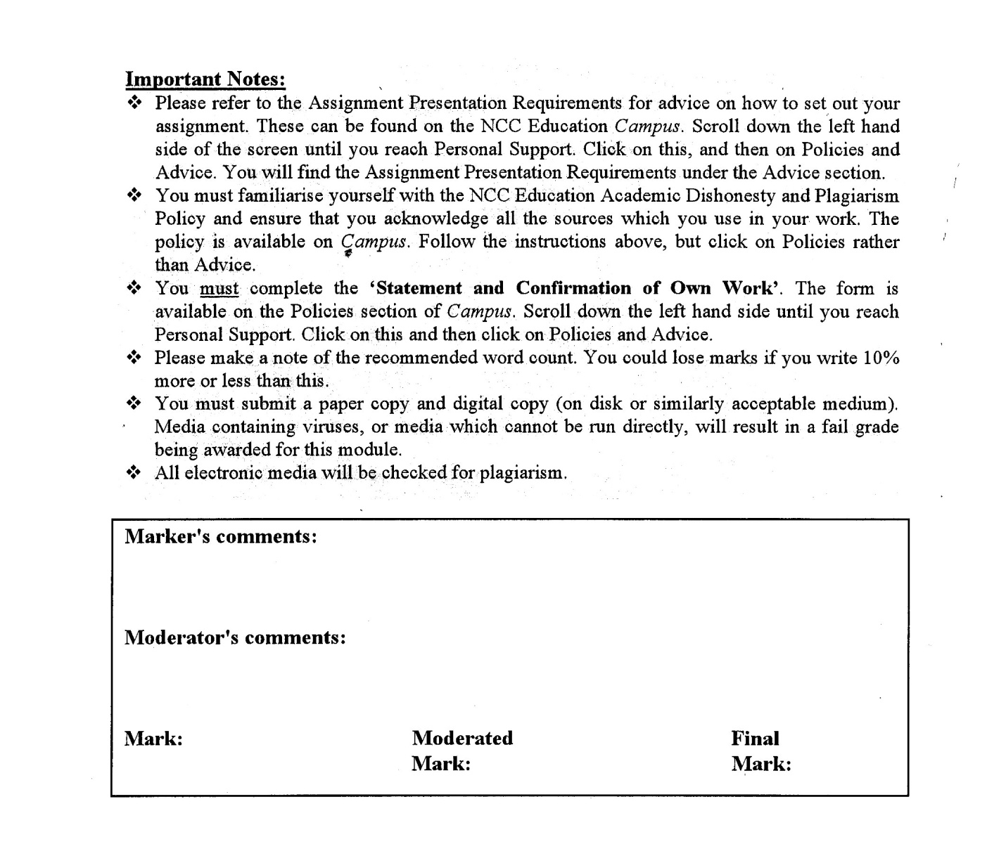



**Statement and Confirmation of Own Work**

**Programmed/Qualification name: Level 5 Diploma in Computing**

*All NCC Education assessed assignments submitted by students must have this statement as the cover page or it will not be accepted for marking. Please ensure that this statement is either firmly attached to the cover of the assignment or electronically inserted into the front of the assignment.*

**Student declaration**

I have read and understood NCC Education’s Policy on Academic Dishonesty and Plagiarism.

I can confirm the following details:

**Student ID/Registration number : P00**

**Name : KHINE ZAR THWIN**

**Centre Name : KMD Computer Centre (Yangon)**

**Module Name : Dynamic Websites**

**Module Leader : AYE AYE KYAW**

**Number of words : 1250 Words**

I confirm that this is my own work and that I have not plagiarized any part of it. I have also noted the assessment criteria and pass mark for assignments.

**Due Date : 30-OCT-2023**

**Student Signature :** khine

**& Submitted Date** **: 15-OCT-2023**

Table of Contents

Introduction 5

Task 1 HTML 7

Two Different Browsers that can be ran by GWSC 78

Chrome 78

Microsoft Edge 98

Responsive Images and Text In GWSC 117

Search Bar 119

Location Maps 122

Slide Show 124

Interactive Navigation Bar 127

Number of Views Counter 127

Footer 128

Relevant Text and Images all across all pages 128

Contact form (required Login) 132

RSS 134

Contact Us form including Privacy and Policy 135

Wearable Technology while Camping in Features Page 137

Two of Web Services in GWSC 138

Task 2 140

CSS 140

Database 231

Personal Details of Customer 250

Pitch Type and Availability 250

Login Fails 253

Task 3 Critical Evaluation of GWSC 257

Web Services in GWSC 257

Usage of HTML for GWSC 257

Design the GWSC Web Pages with CSS 258

Meets The Objectives In The Scenario 258

Task 4 261

Reflection of GWSC 261

References 262

Candidate Checklist 263

# Introduction

The reports on how the GWSC website was constructed using HTML, CSS, Javascript, MySQL, and PHP are presented in this documentation. This resulted in a dynamic website with an appealing user interface. The requirements of the assignment were adhered to when creating this website. Additionally, two different browsers and two different screen sizes were used to assess the responsiveness of this website. Additionally, reports describe how the website is standardized through the usage of HTML and CSS. Additionally, there are comprehensive descriptions regarding web pages.

Task 1

HTML

# Task 1 HTML

Information listing of Admin

**Admin**

**Sign In**

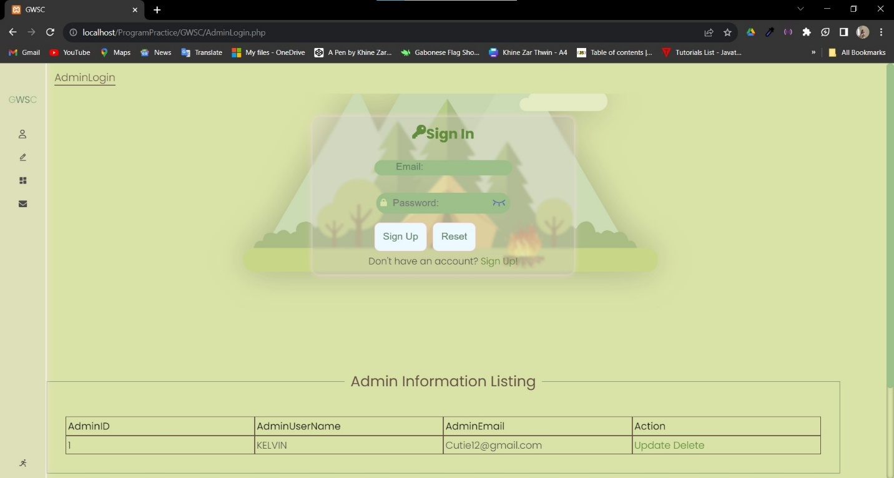

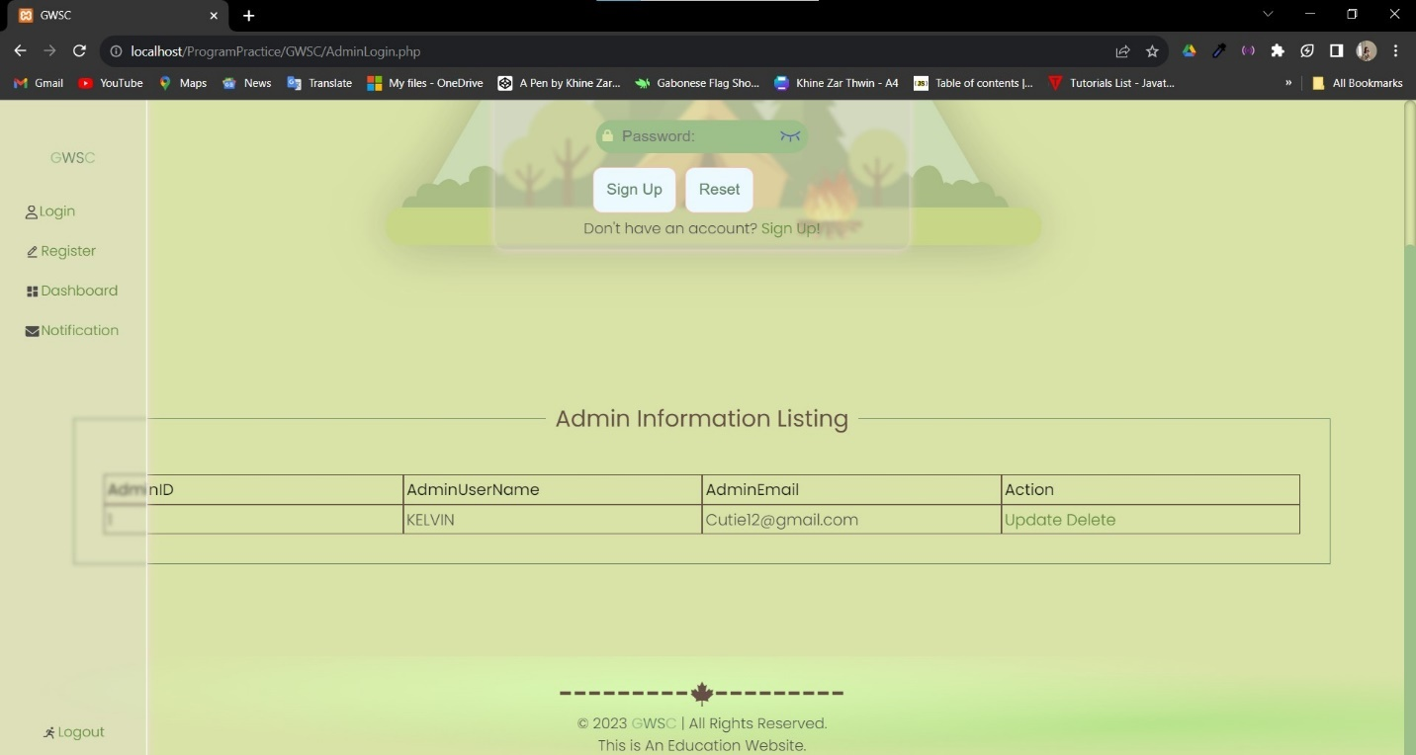

Update or delete the existing data

The side bar of navigation of admin

**Update the Existing data**

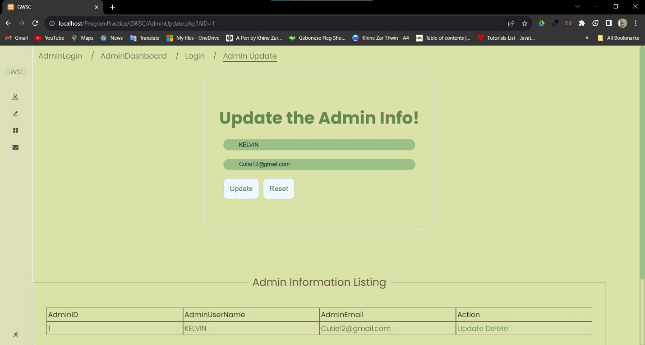

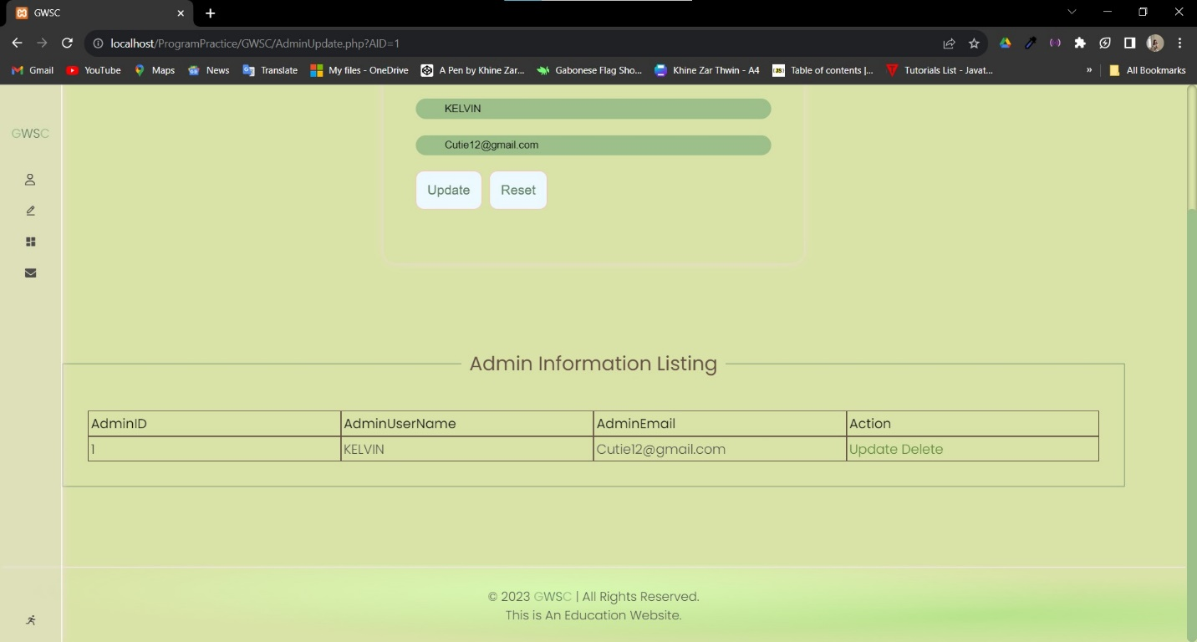

**Mobile Views of Sign In**

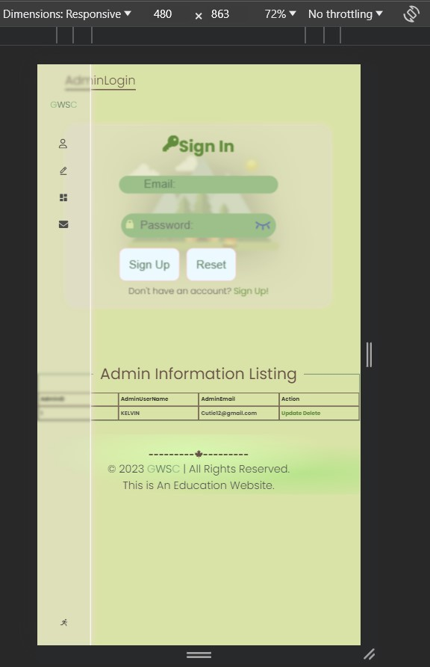

**Sign Up**

Password Validator

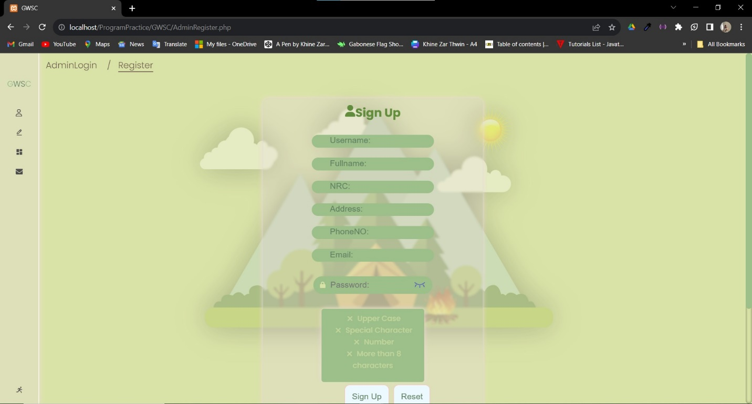

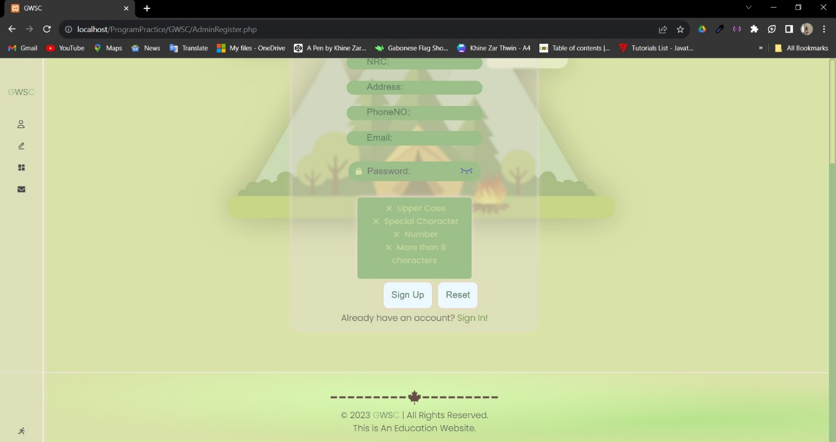

**Mobile View of Sign Up**

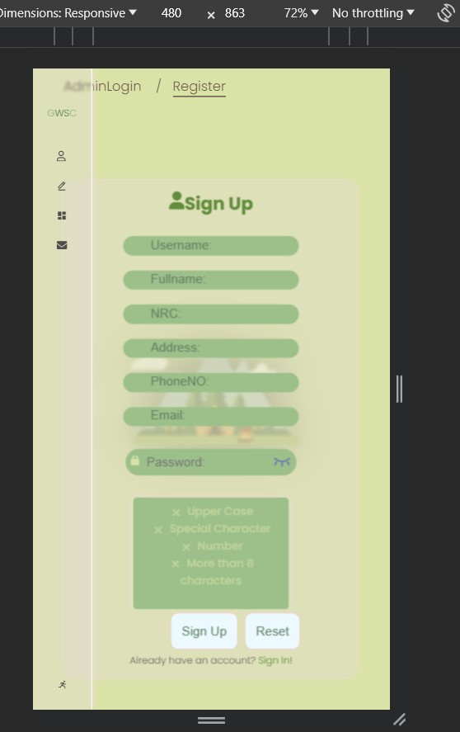

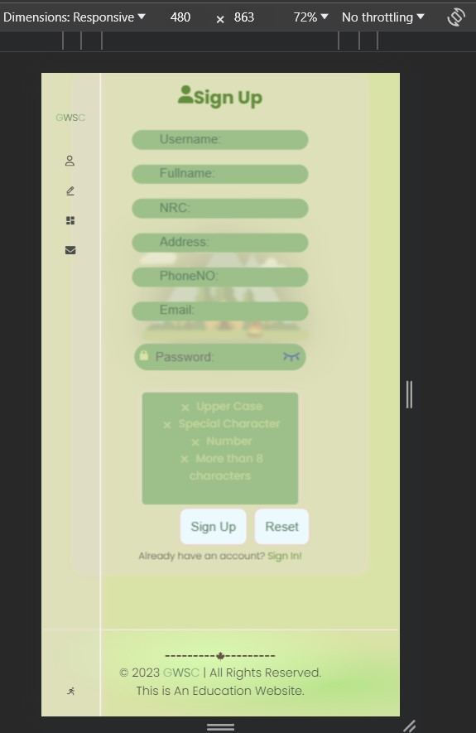

DashBoard

Links button with hover pop up design to related pages

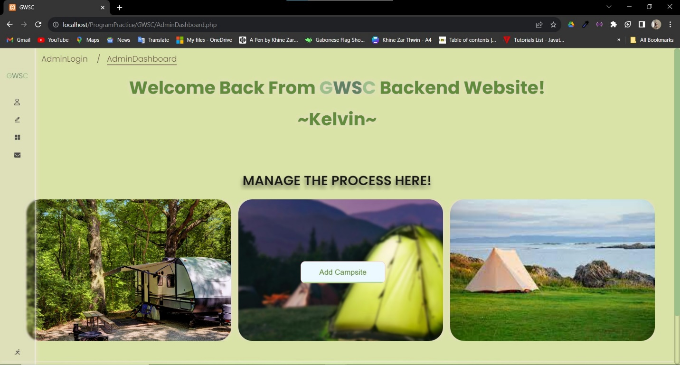

This is where Admin can mange which he will manage PitchType,Campsite or Pitch

**Mobile View of Dashbaord**

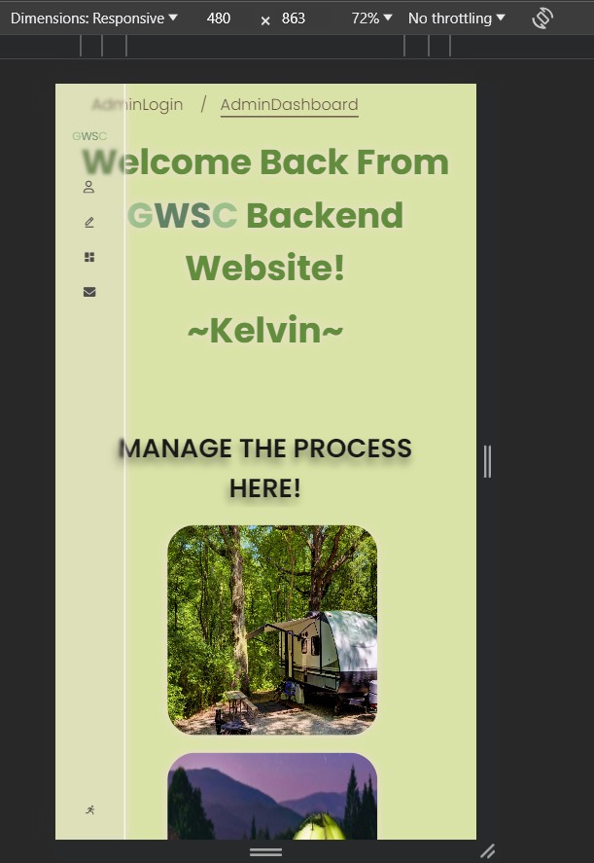

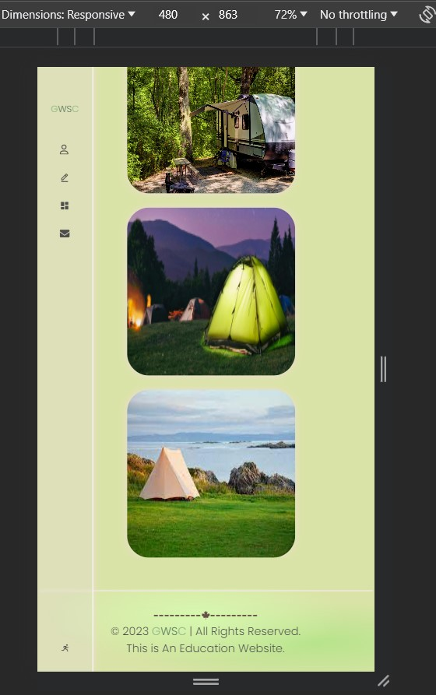

**Pitchtype**

Admins can add the data of Pitch Type from here and can view form the info listing

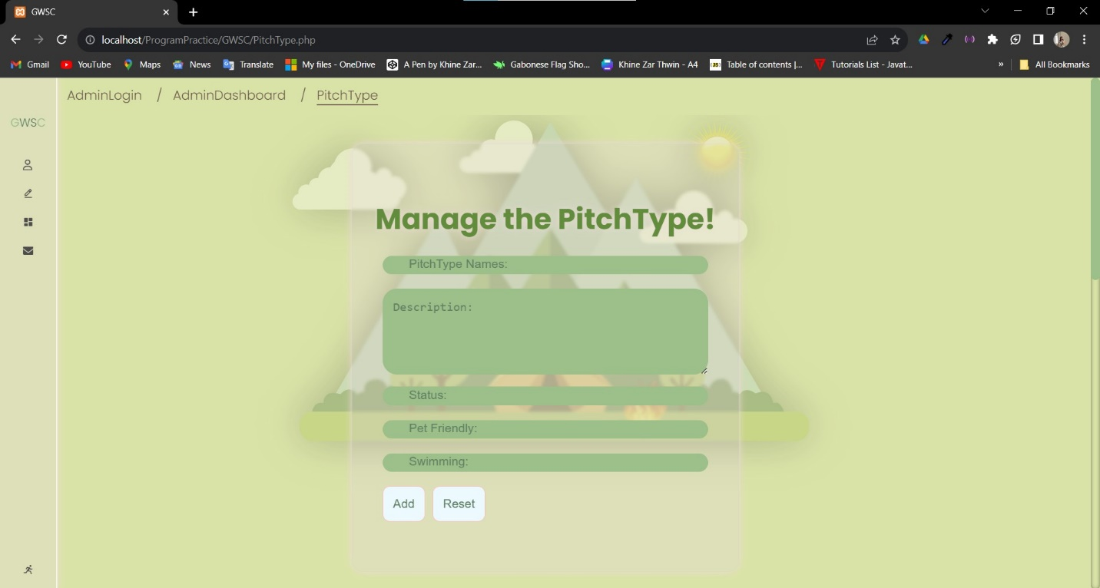

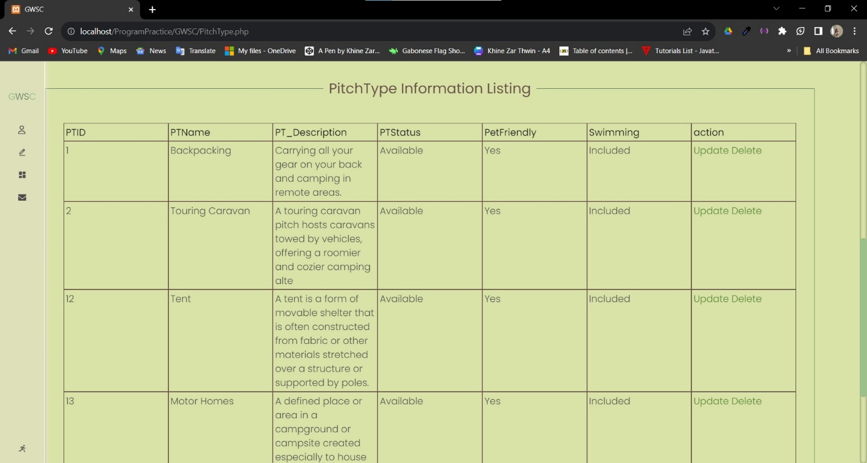

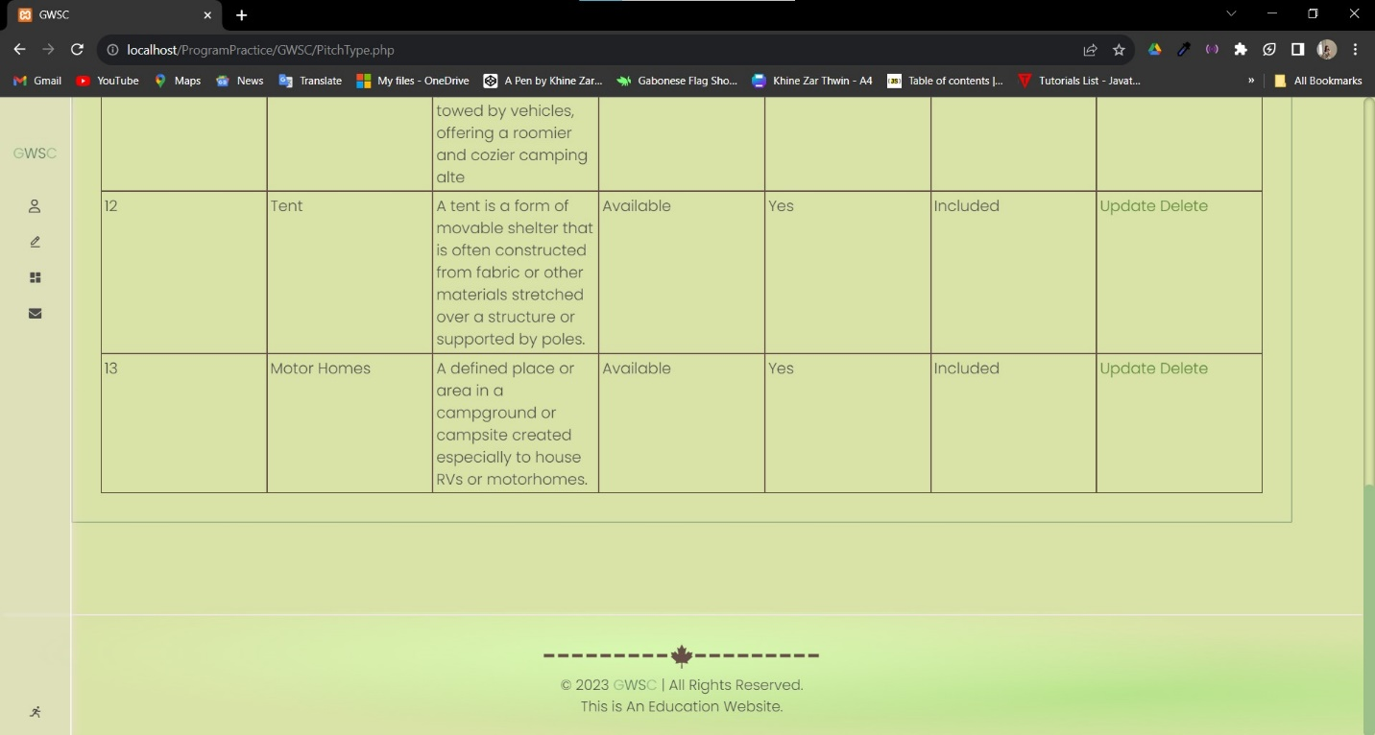

**Update Existing Data**

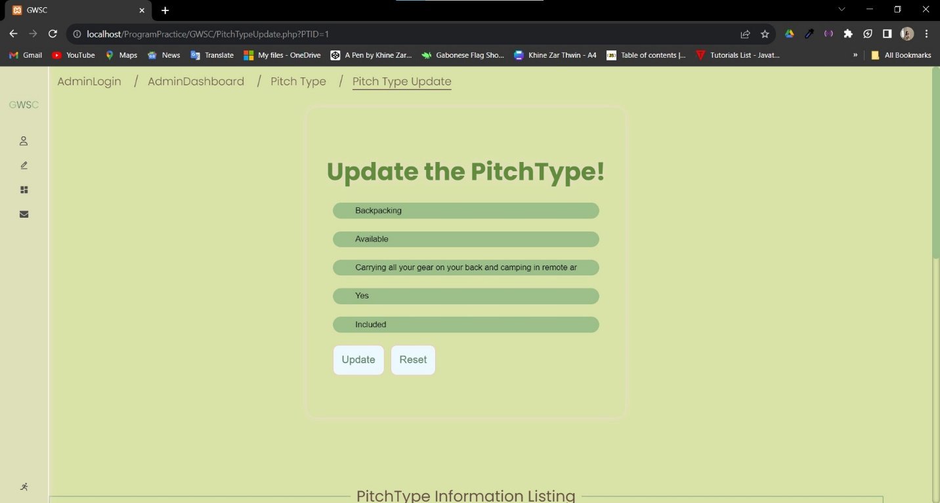

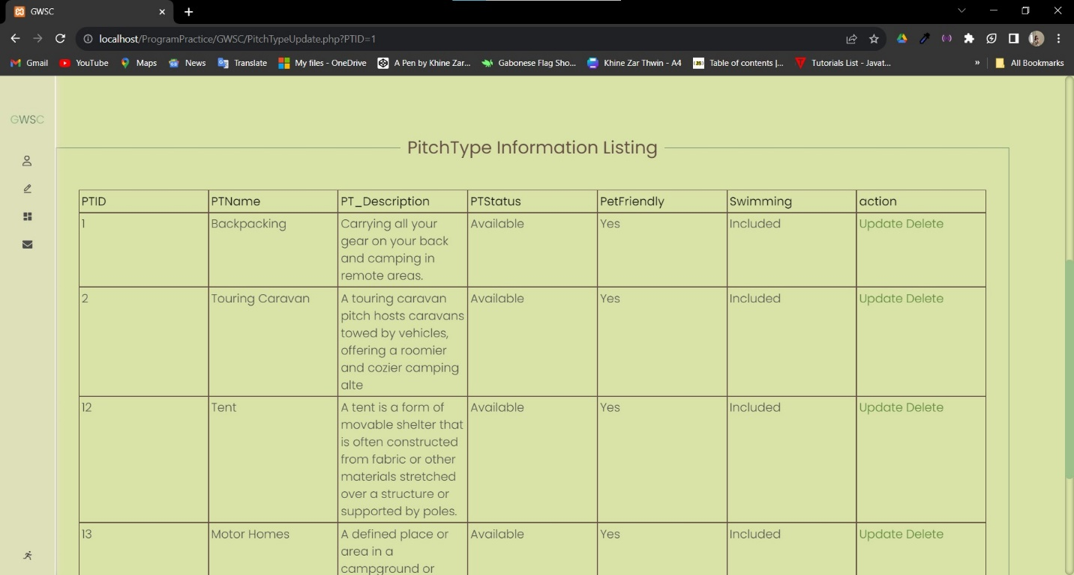

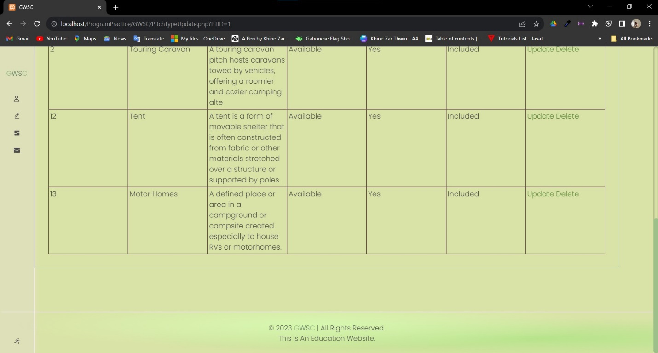

**Mobile View of PitchType**

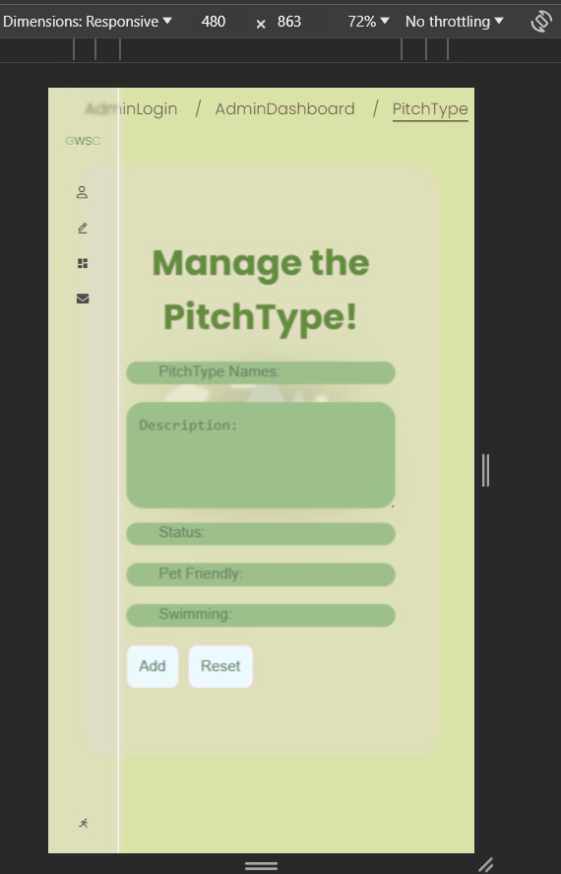

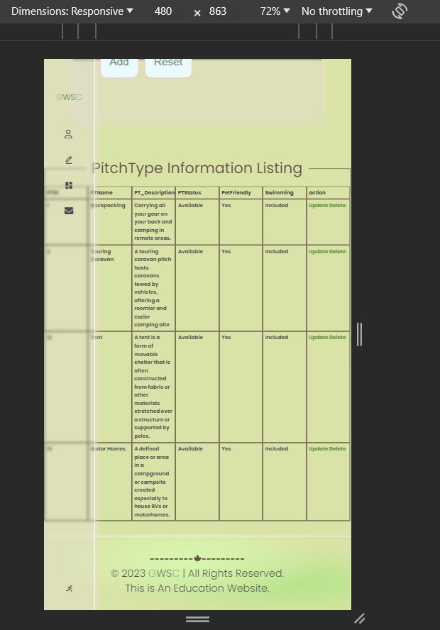

**Campsite**

Add or view the data of campsite from here

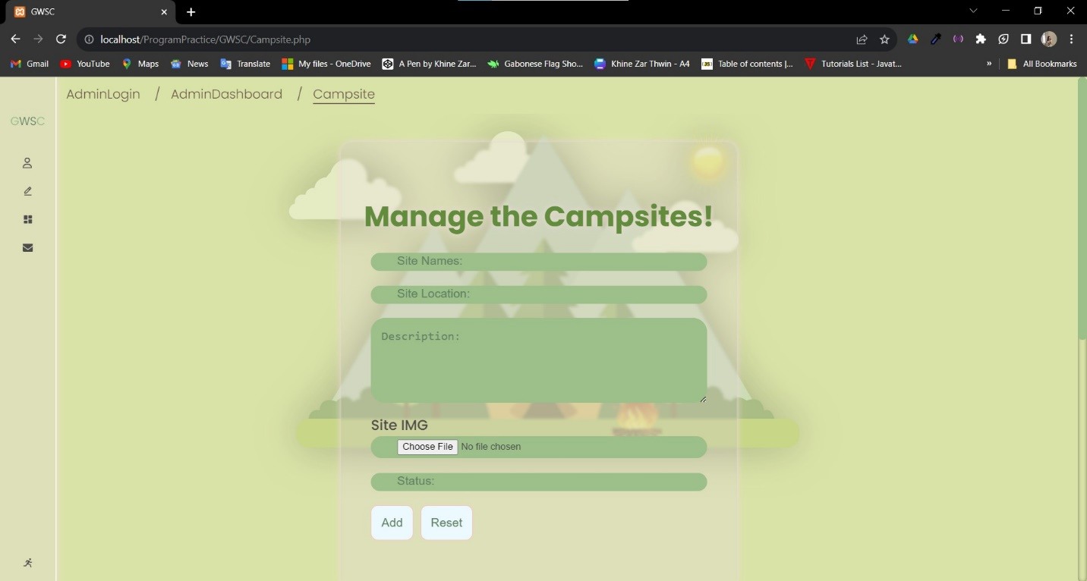

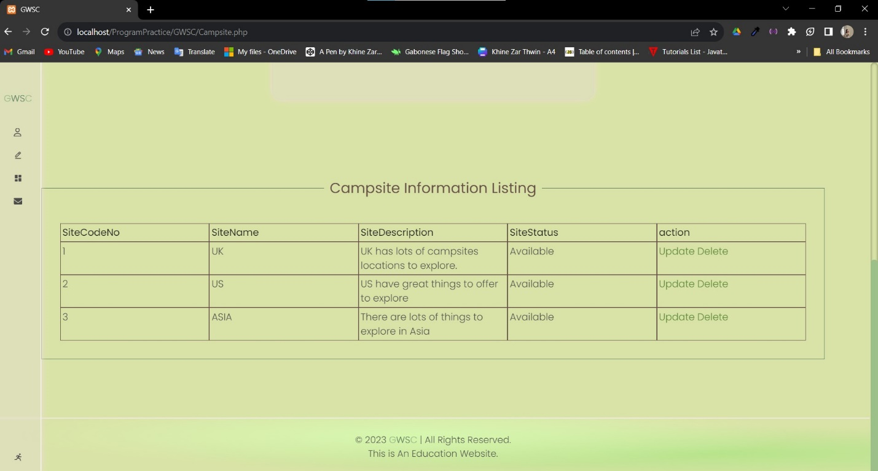

**Update existing data**

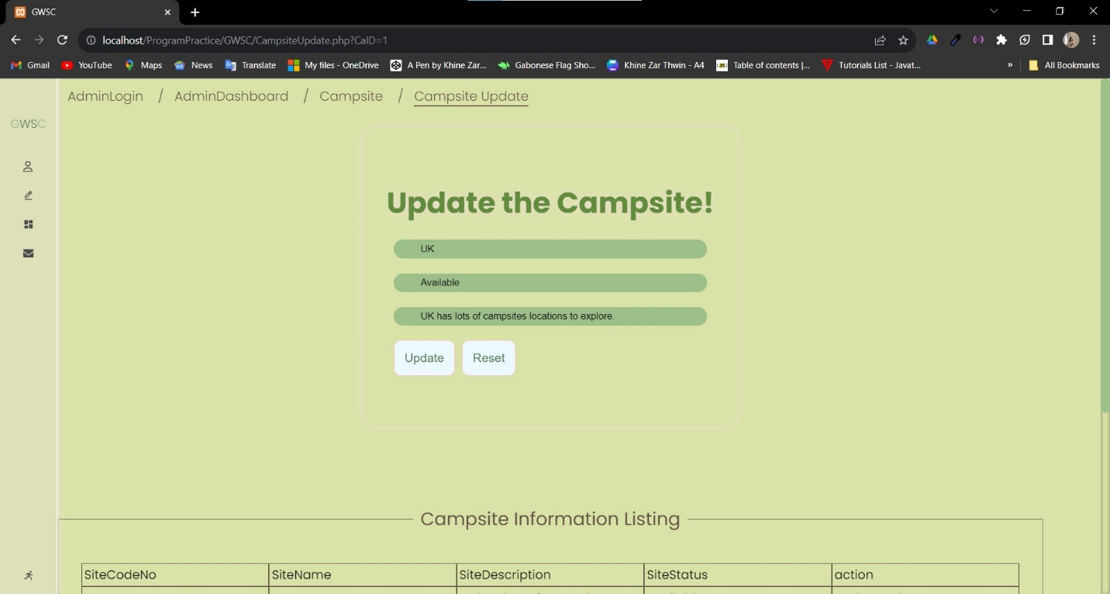

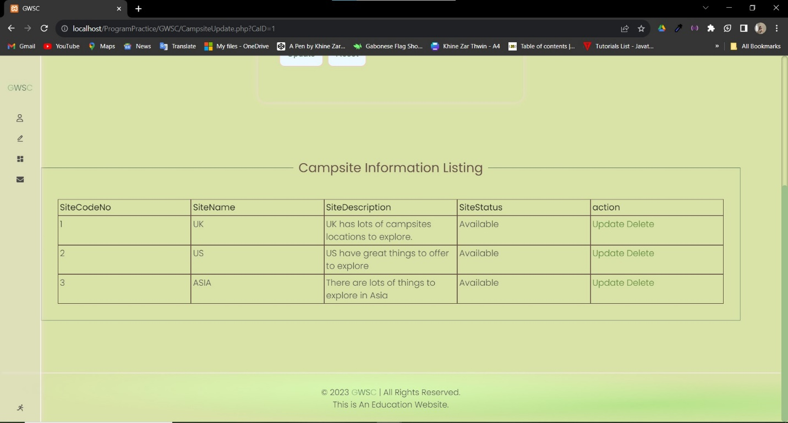

**Mobile View of Campsite**

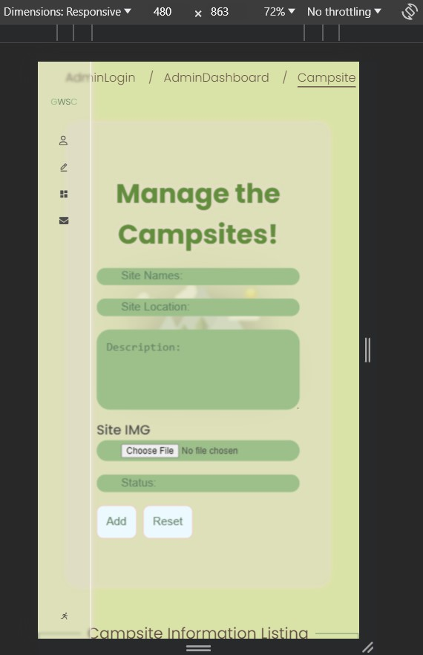

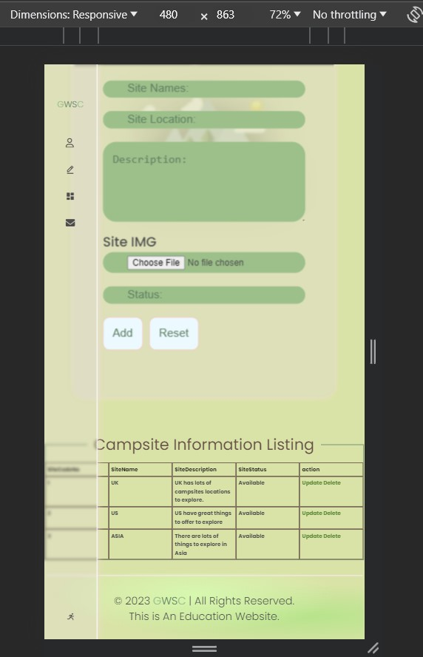

**Pitch**

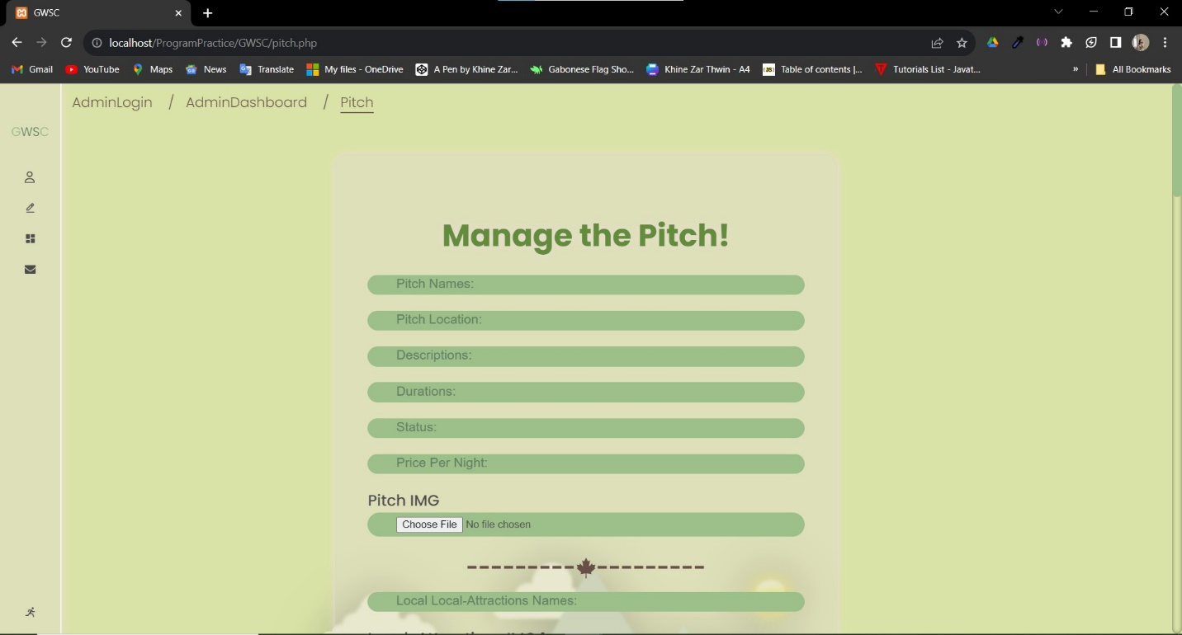

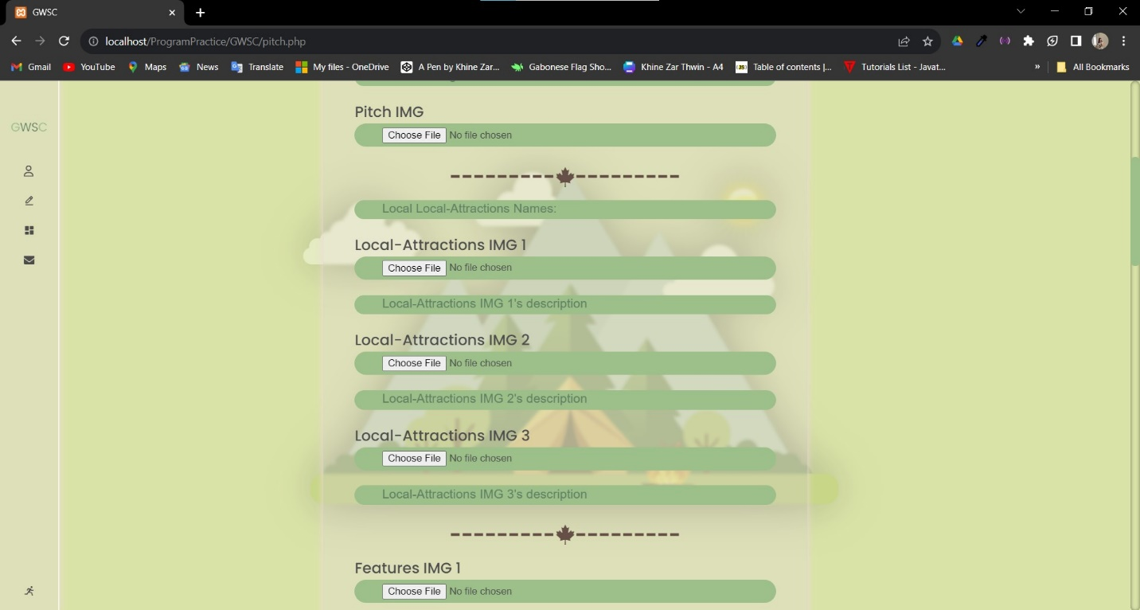

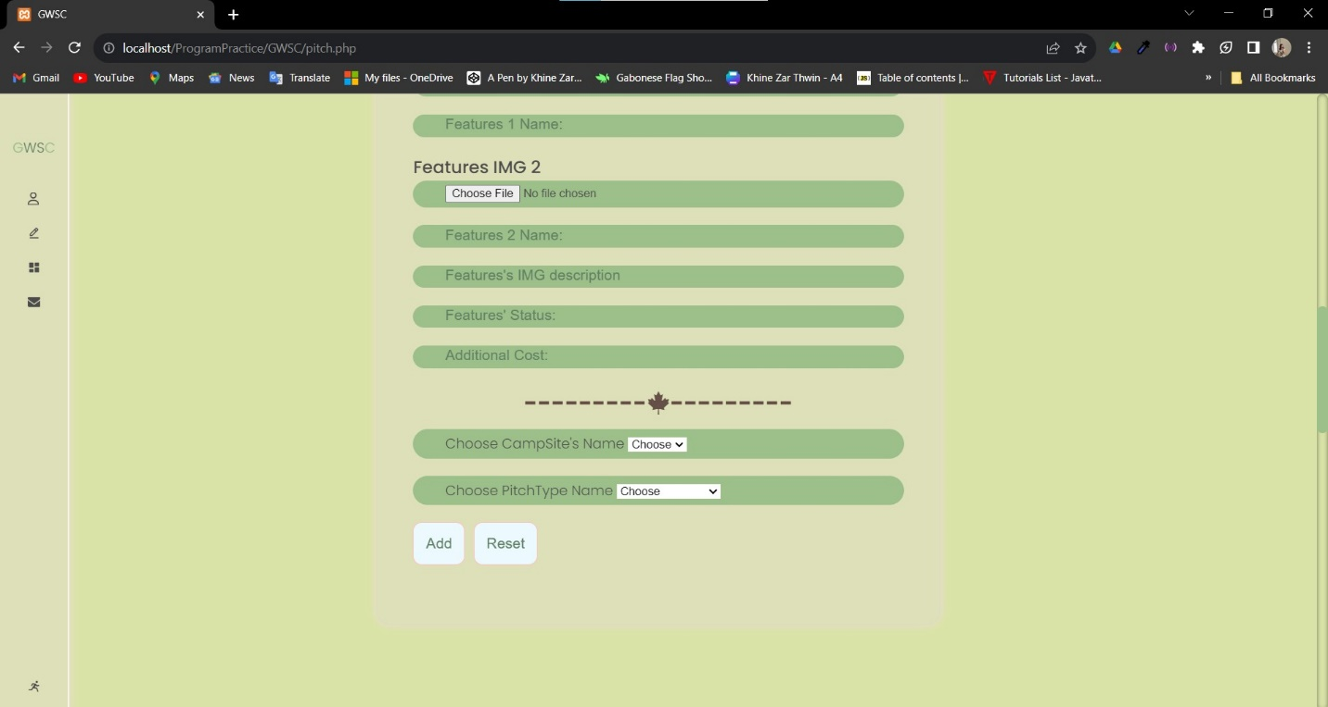

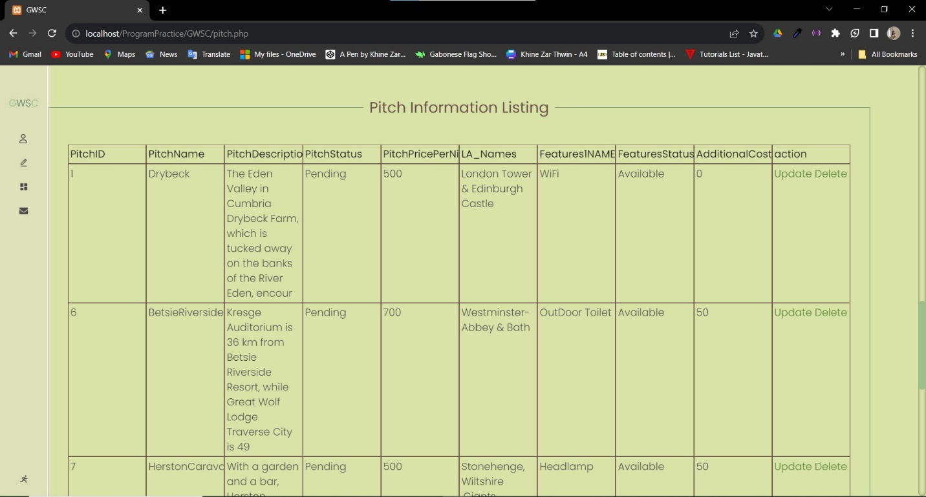

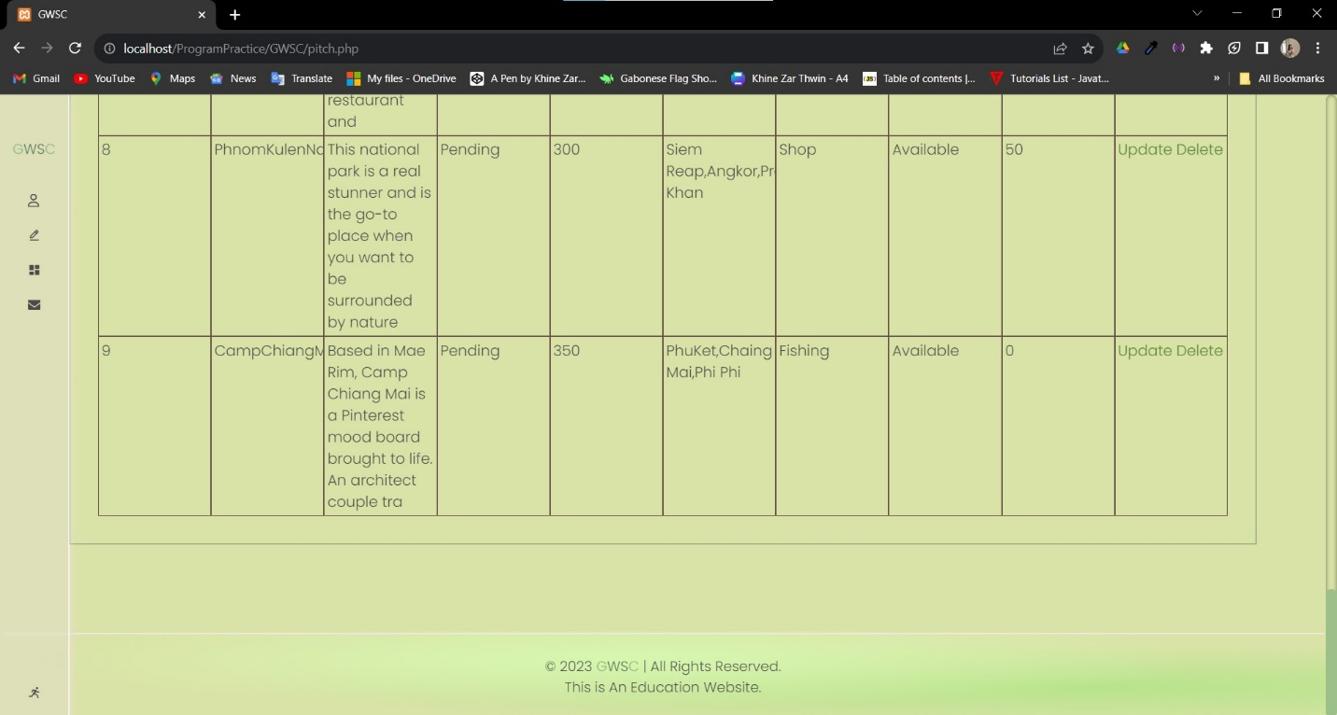

**Updating Existing Data**

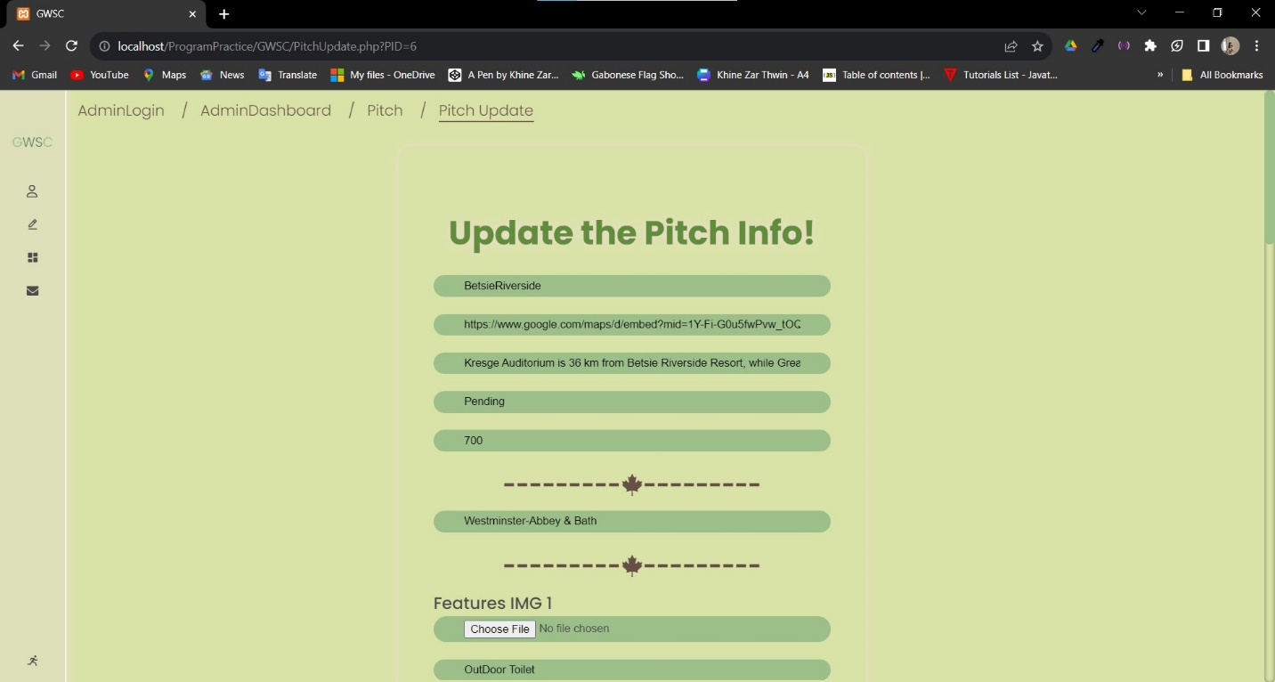

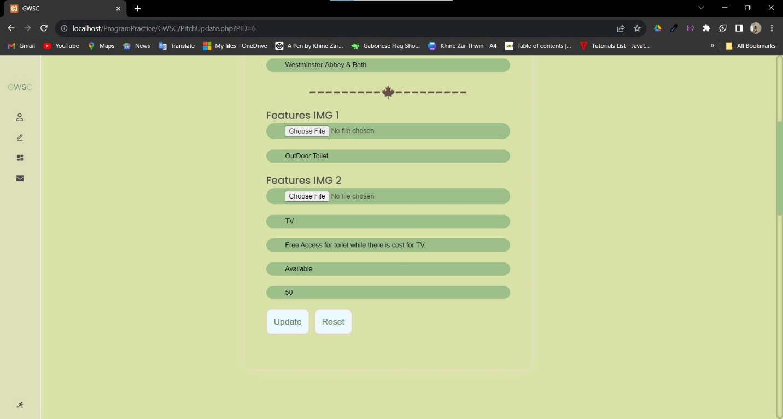

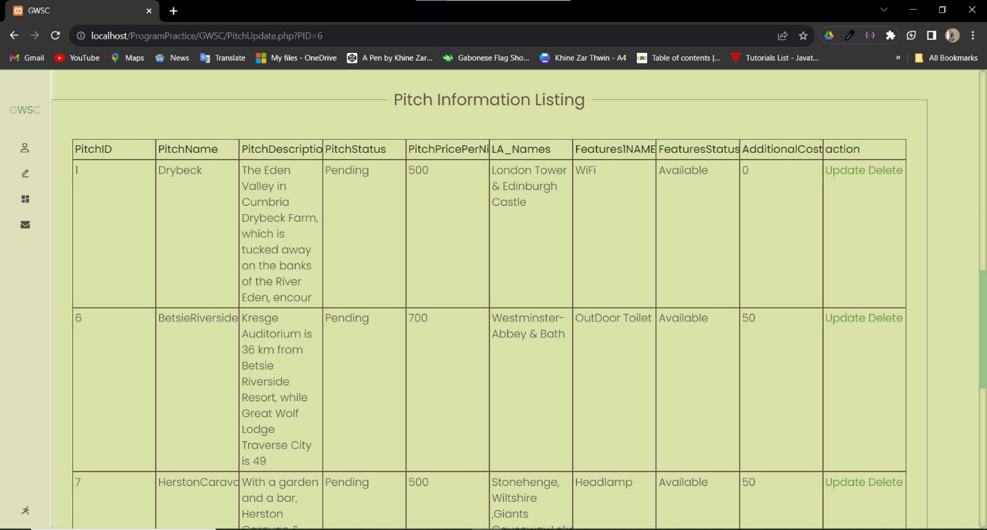

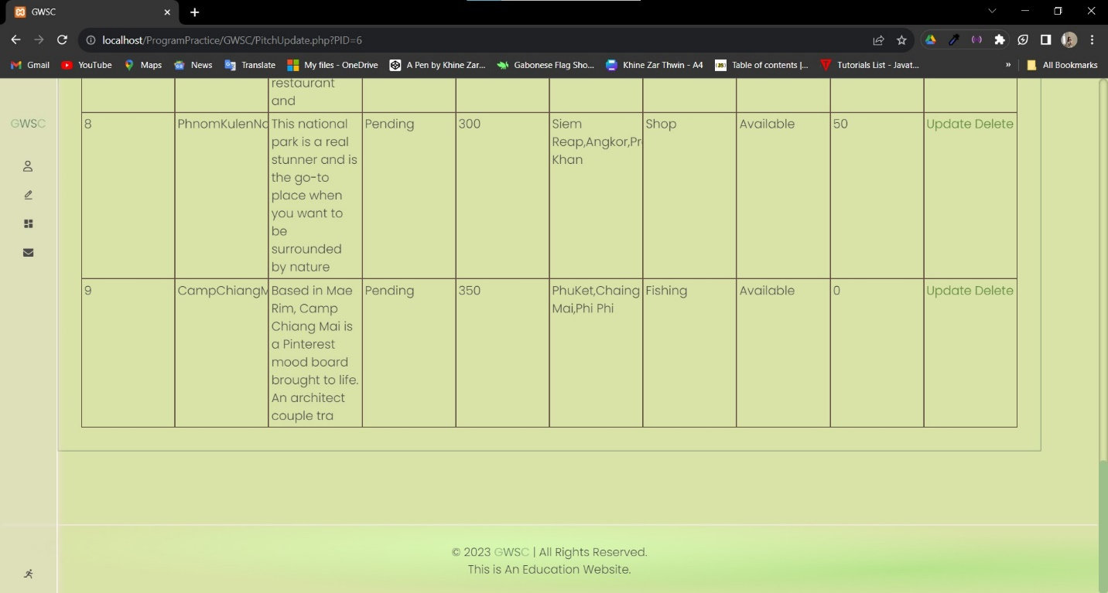

**Mobile View of Pitch**

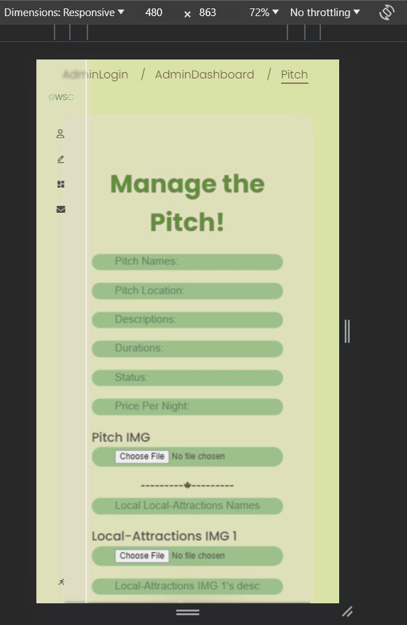

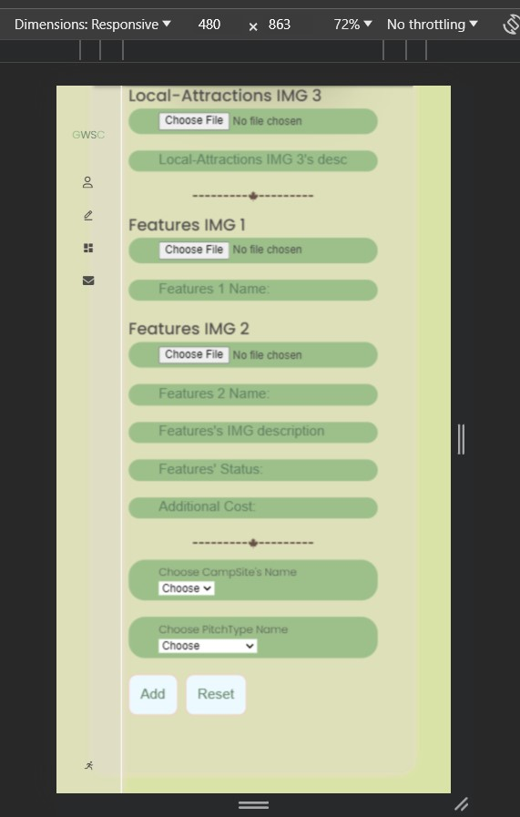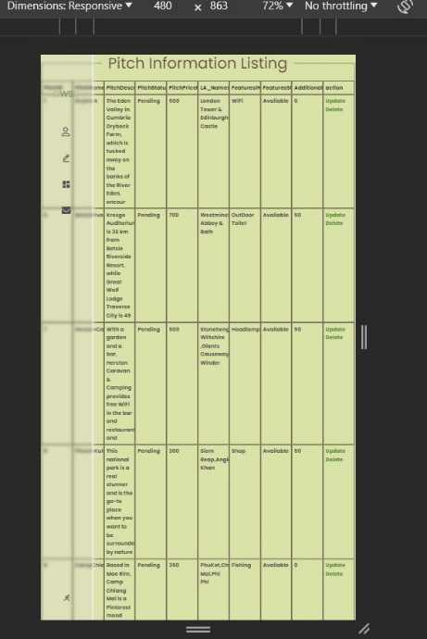

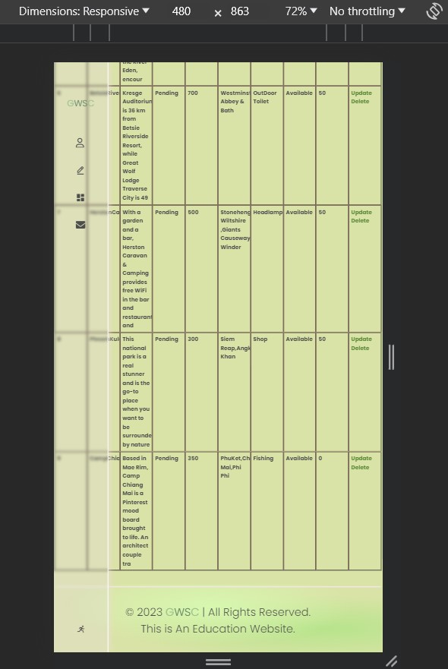

**Notifications(View the submitted Contacts)**

The admin can view the submitted forms of customer here

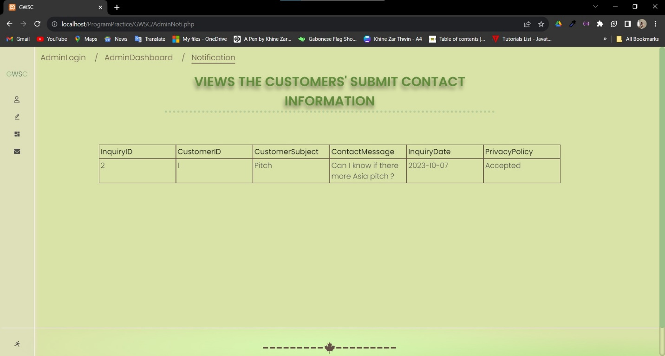

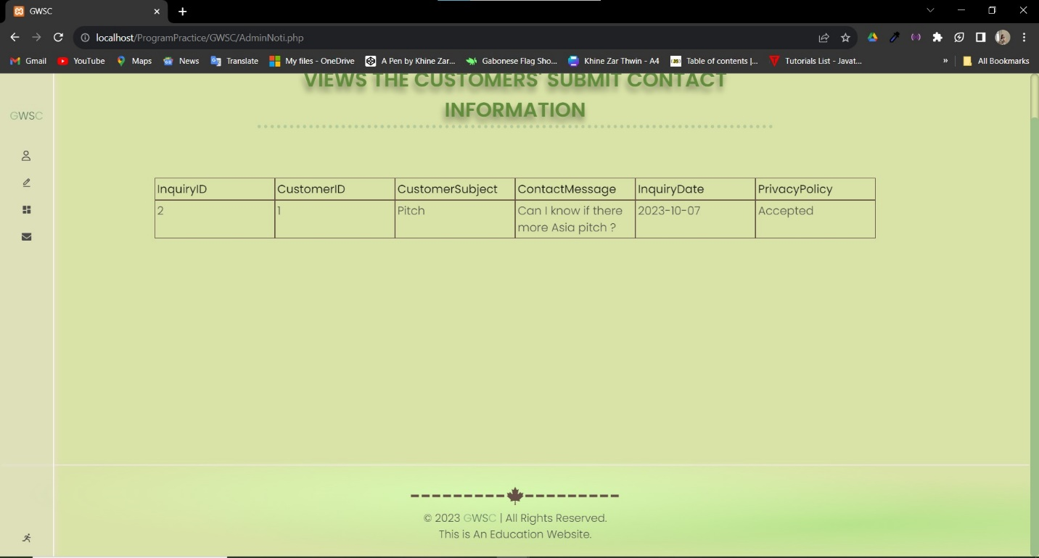

**Mobile Views Of Notification**

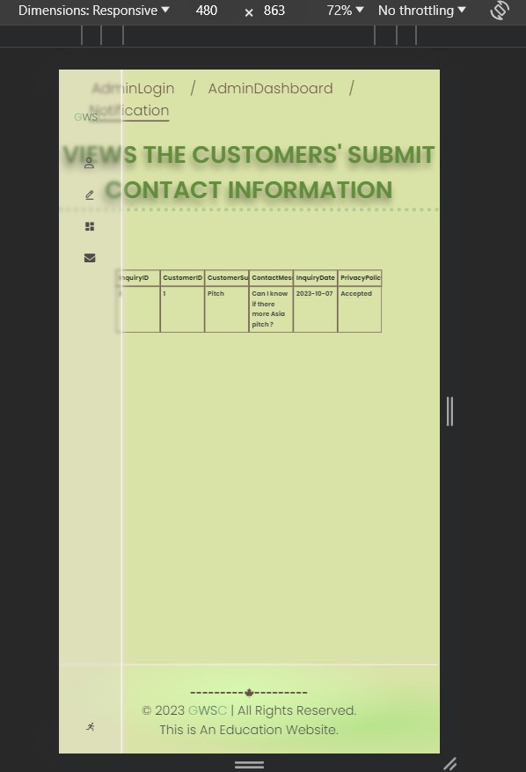Seven pages Of GWSC

**Cookie**

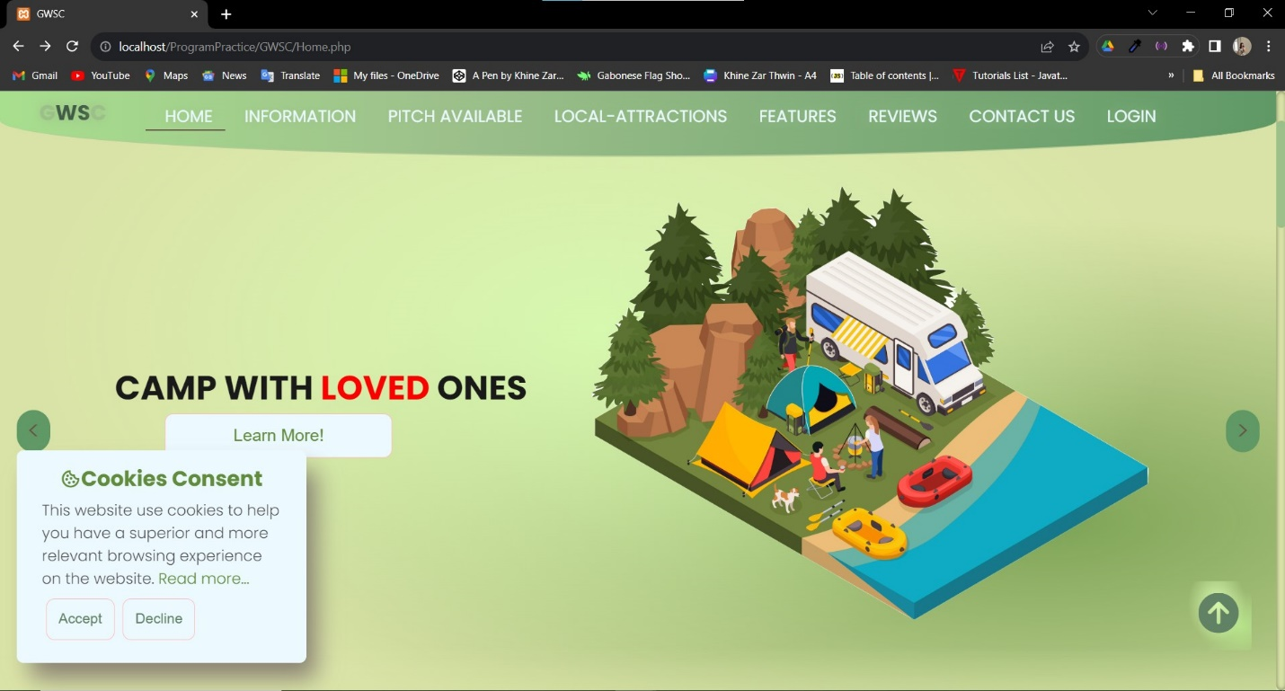

Readmore will lead to policy page

If it is accepted, this will disappear.

Navigation Bar

ViewCounts and RSS feed

**Home**

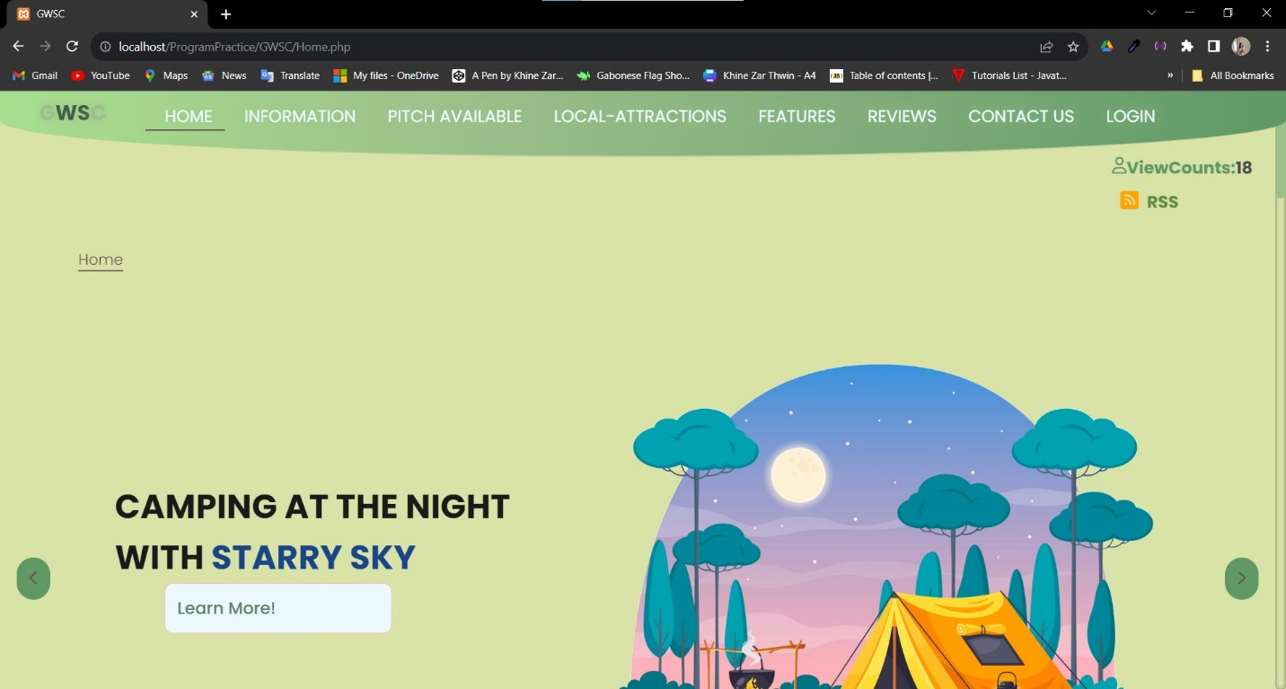

BreadCrumbs with links

Slideshow and slider

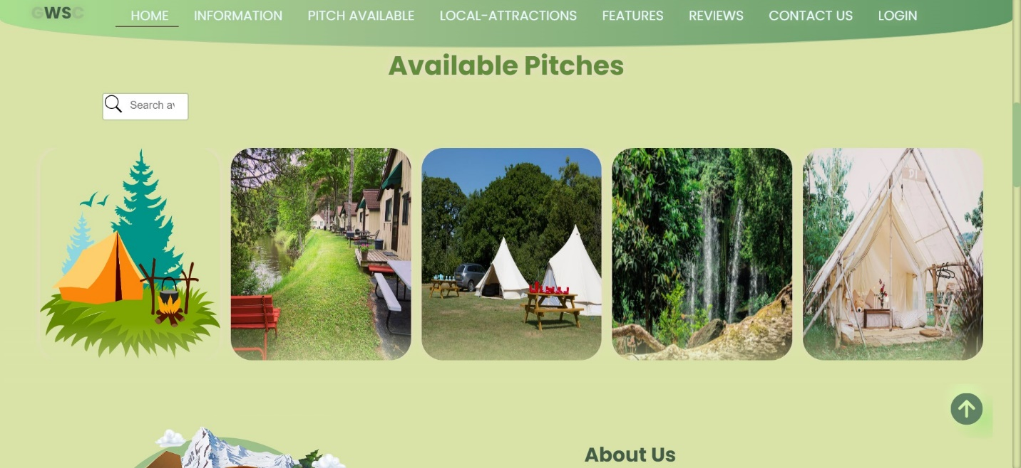

Interactive Search Bar which will lead to Information Page

Available Pitch from database and with hover pop up design

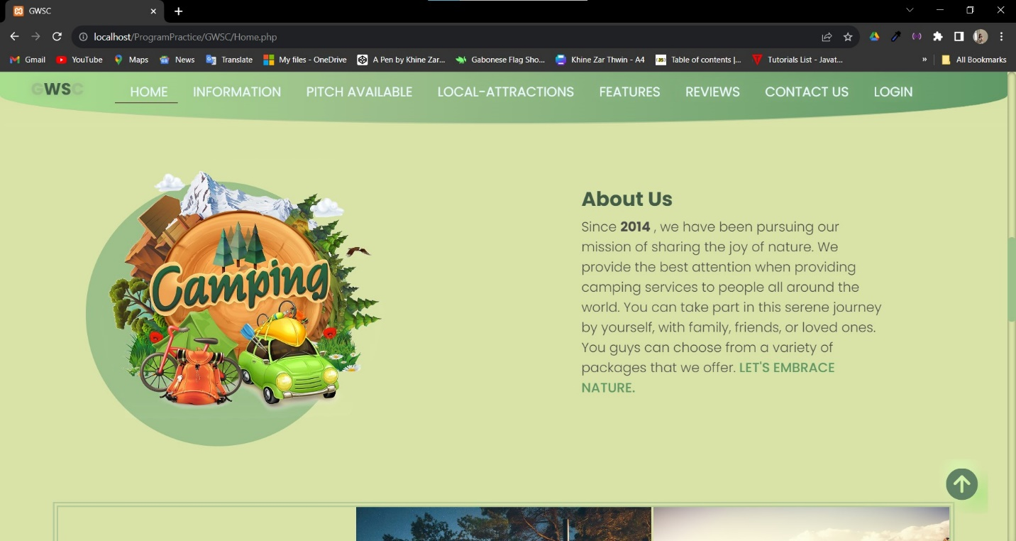

Scroll up to Top button

About Us section with relevant image and minimal text

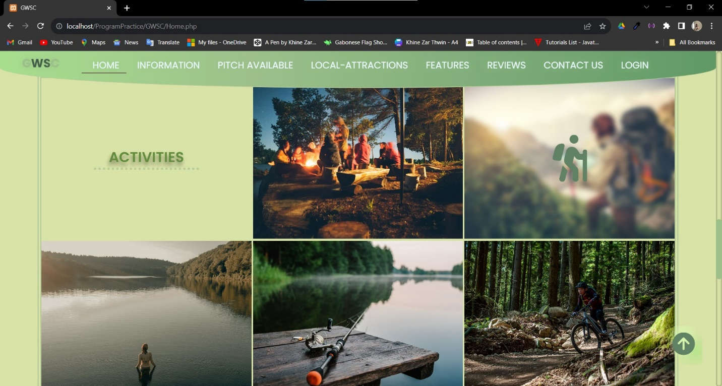

Animation of heading

This is Activities section with relevant images with icon hover design

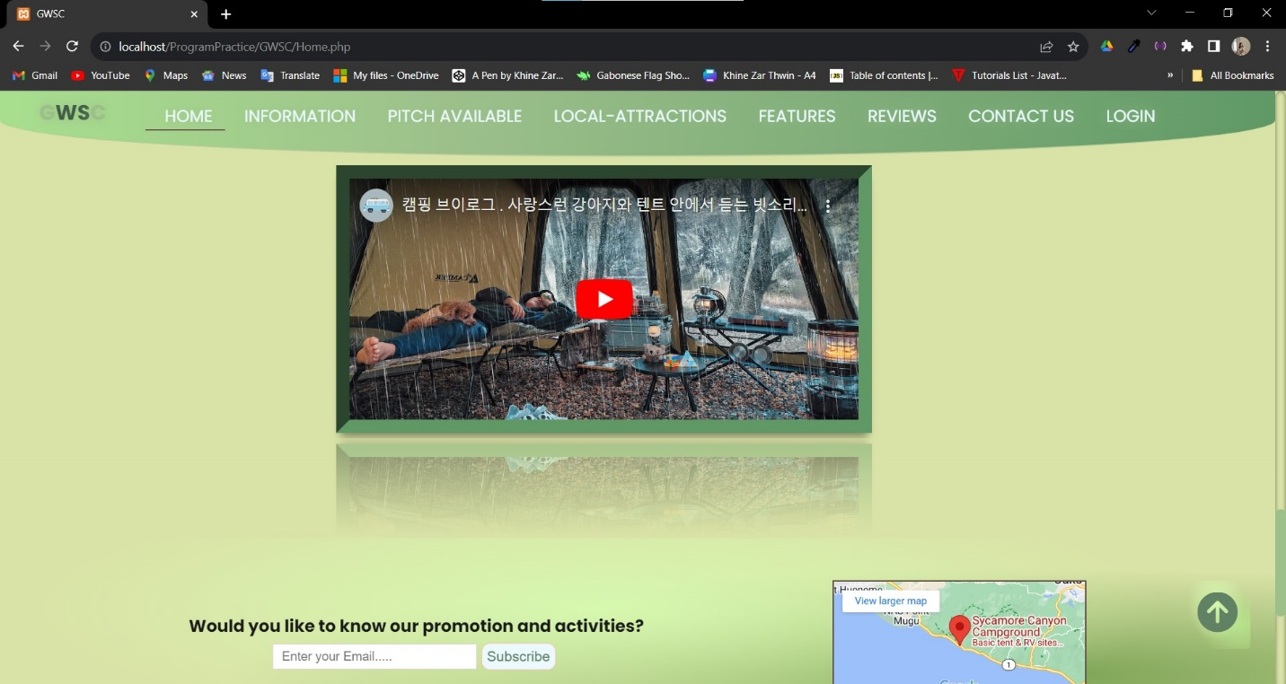

The webservice of embedded YouTube video

Location Map

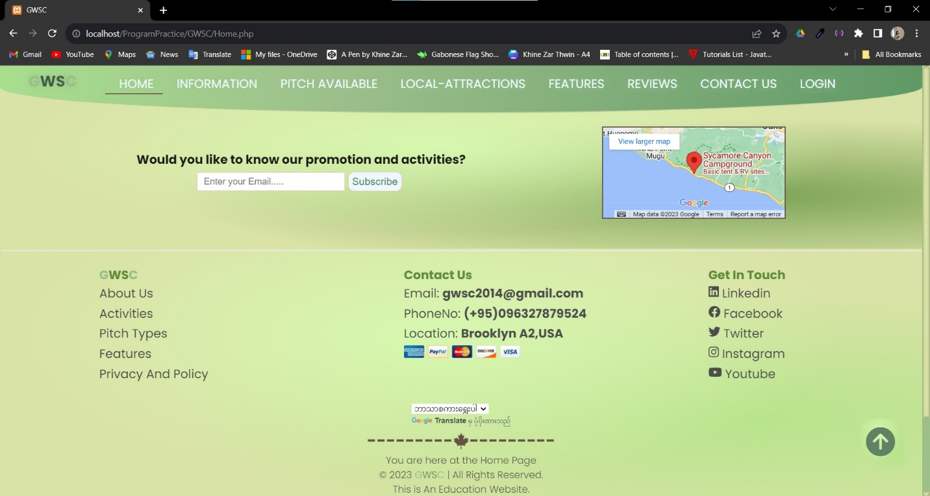

Google Translate widget for webservice

You are here (page) with All rights reservation

Social Icons in the footer section

Subscribe section of input bar and animated button

**Mobile View of Home**

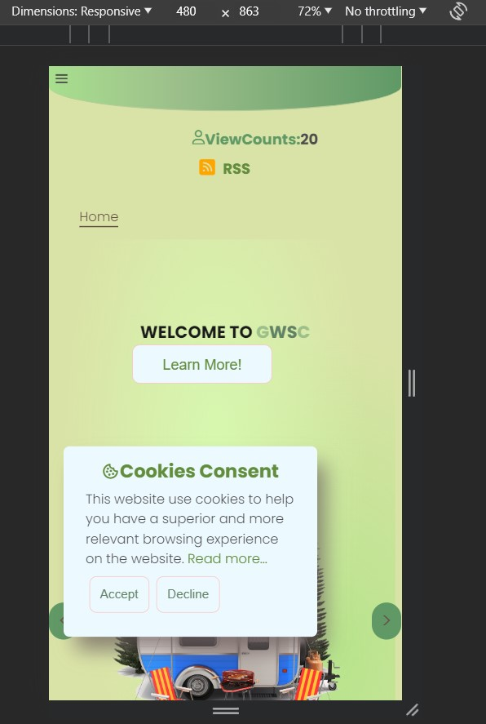

Hamburger menu for Mobile View

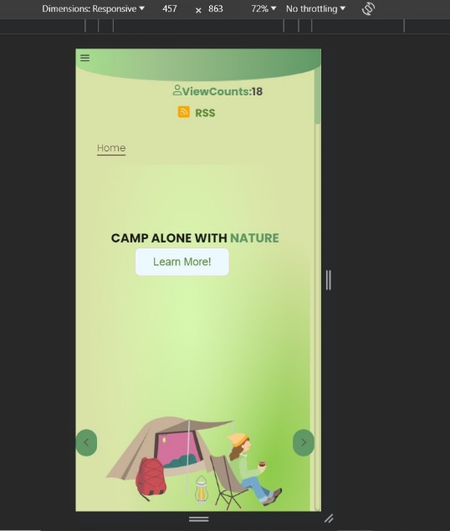

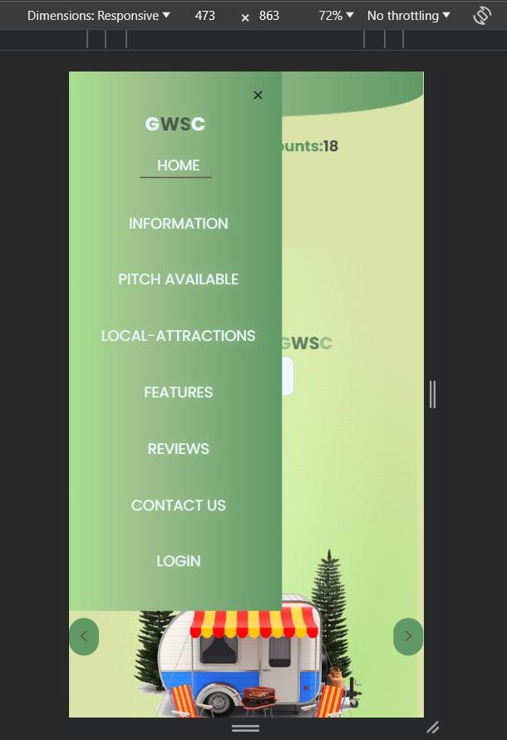

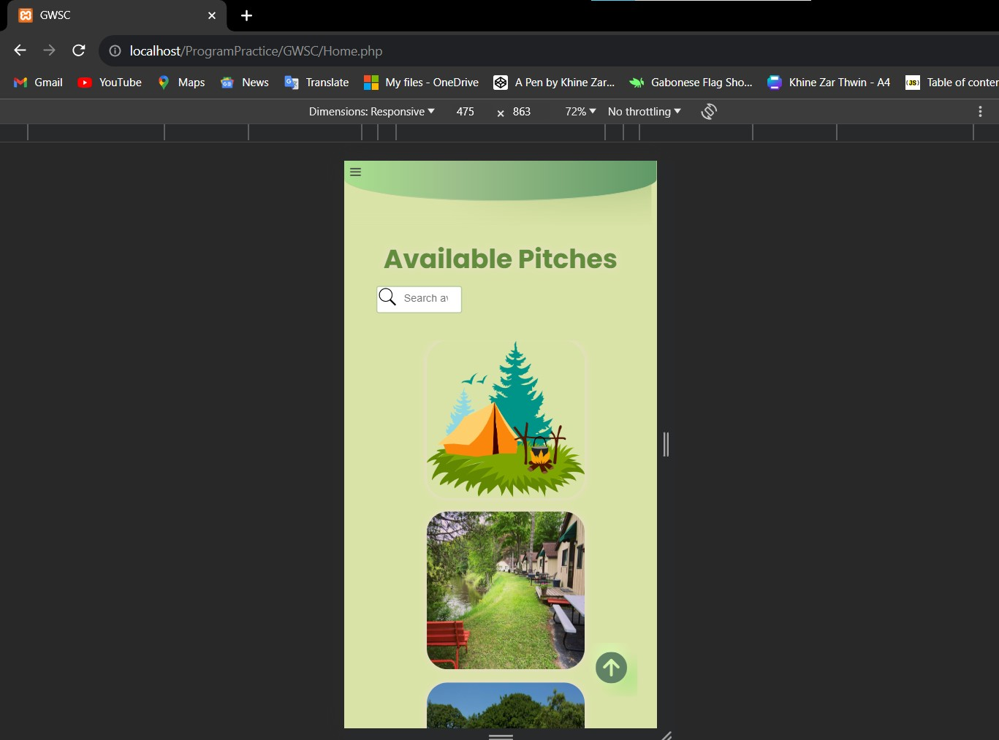

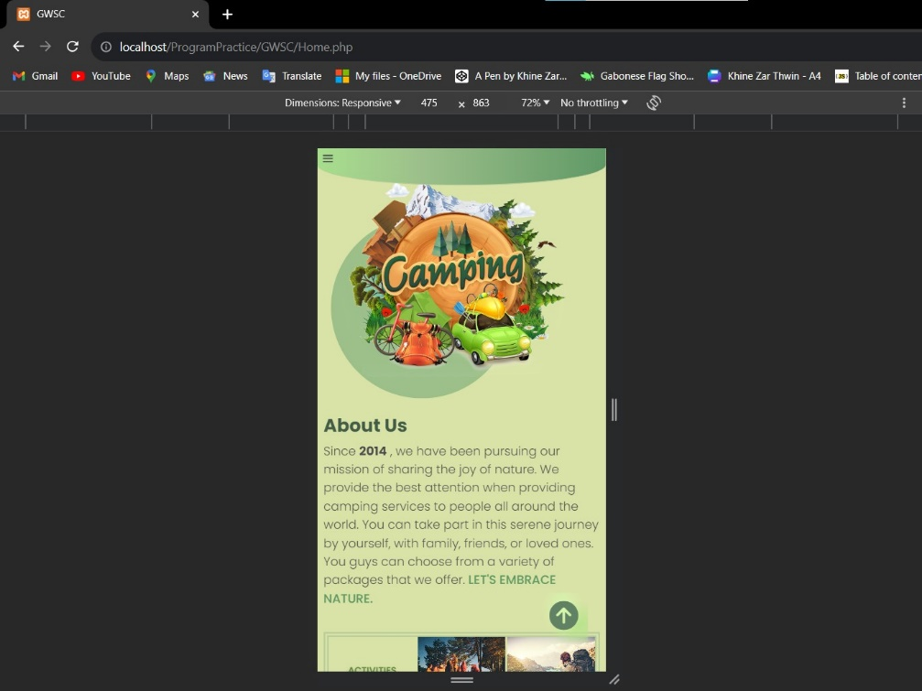

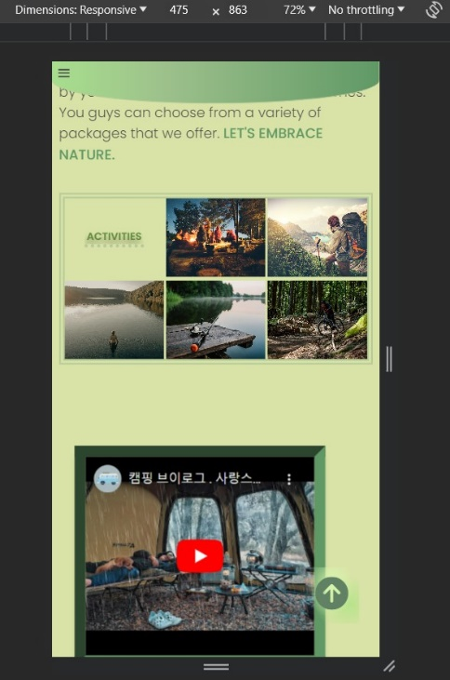

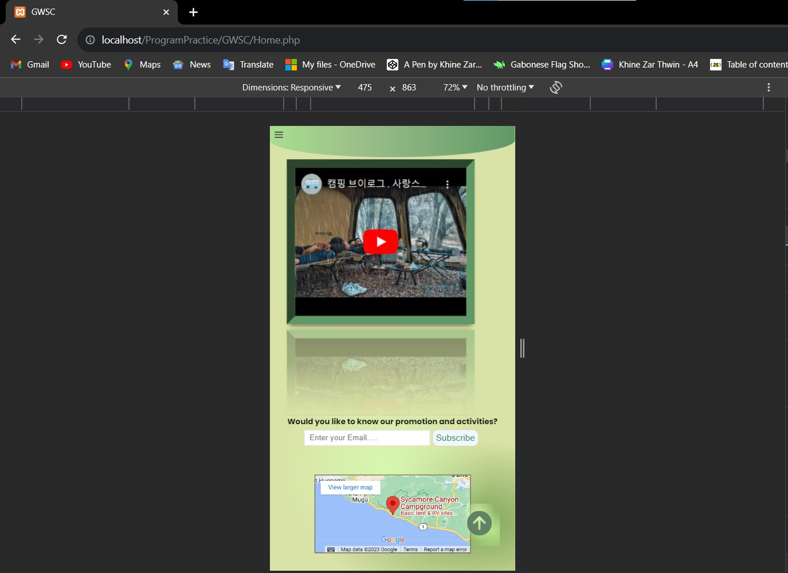

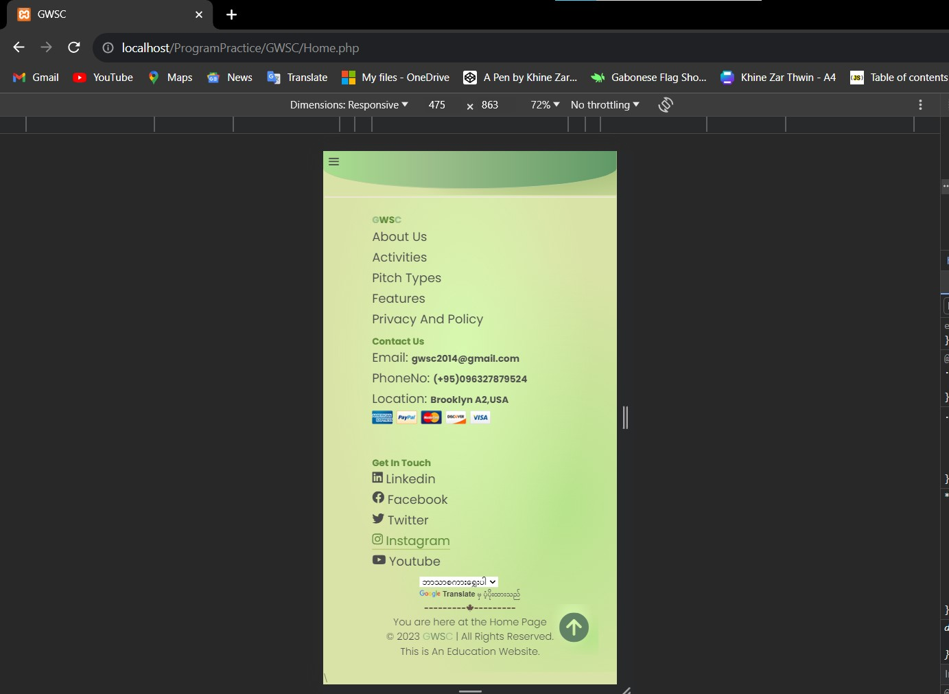

Information

Animated Heading

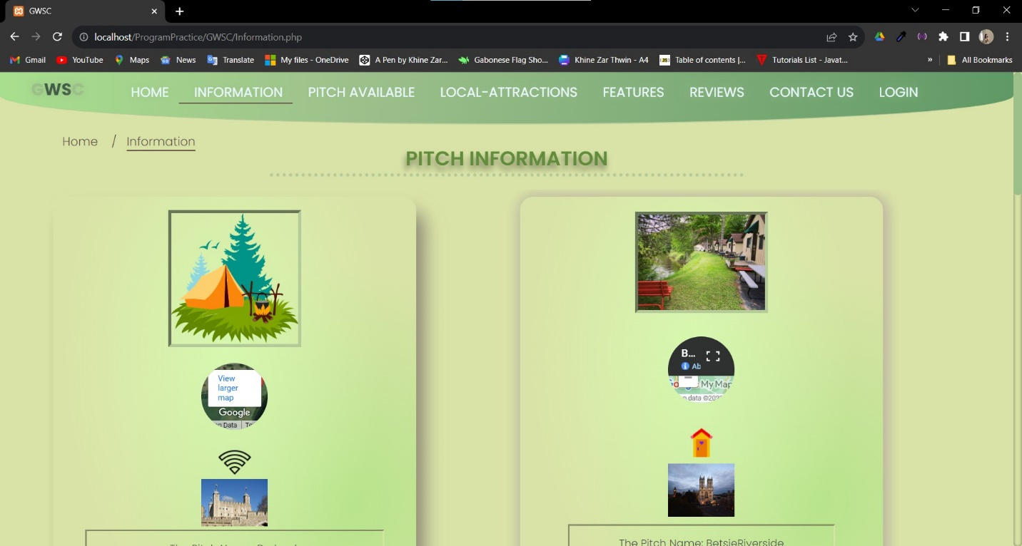

The pictures and location of pitch

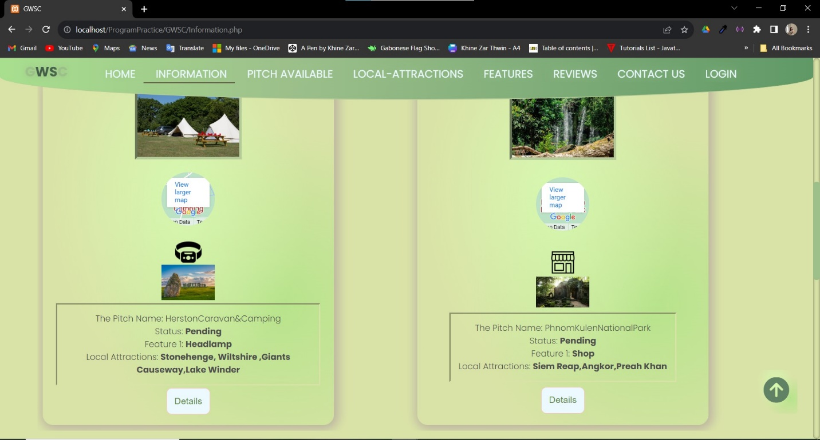

The information of the pitch and when users click the Details Button , will be directed to Details Page

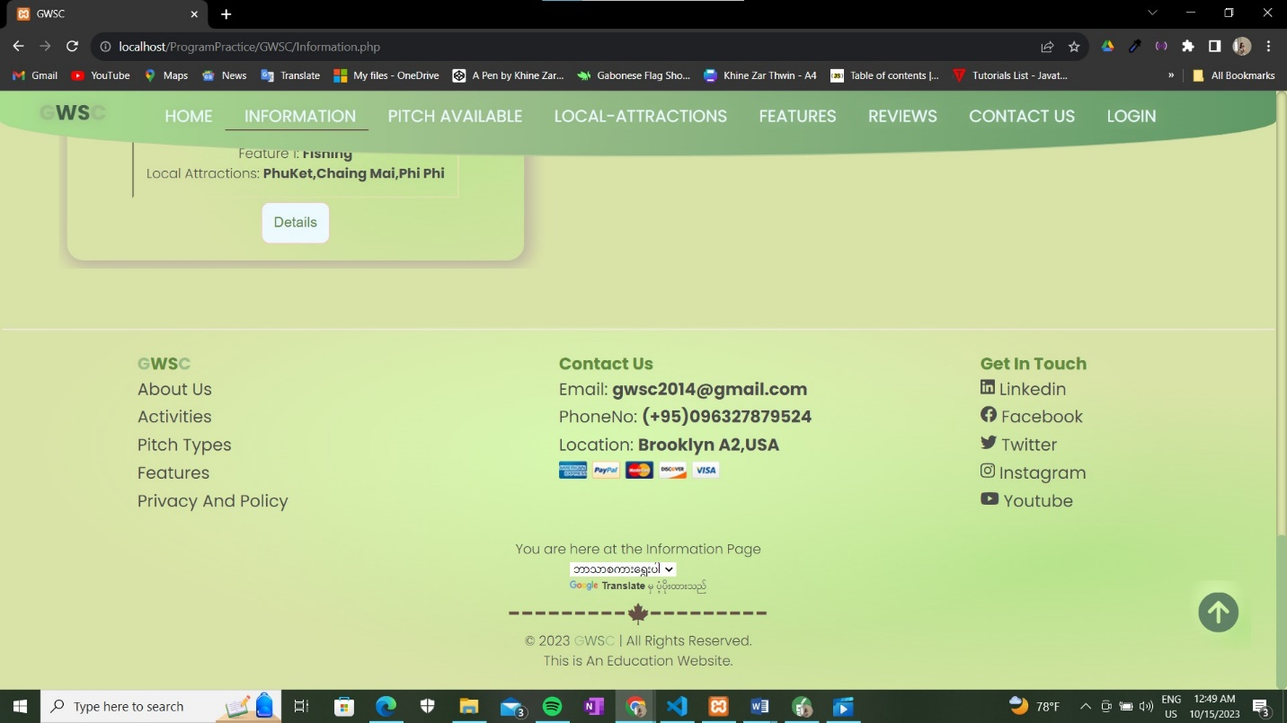

Mobile View of Information

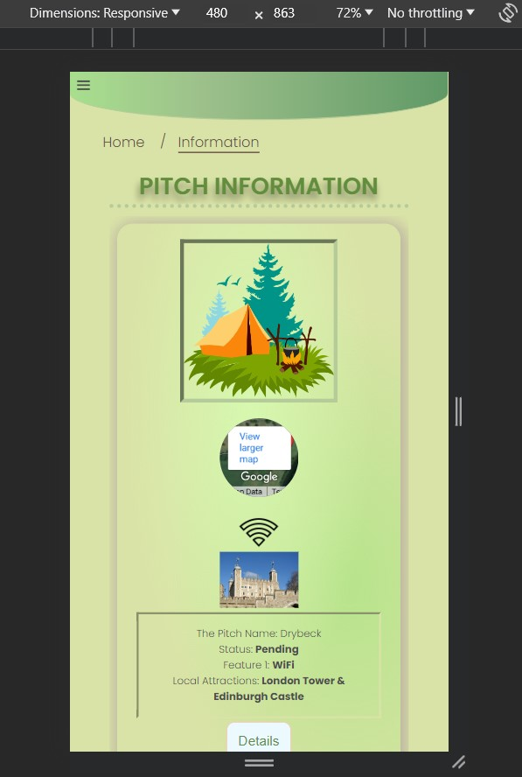

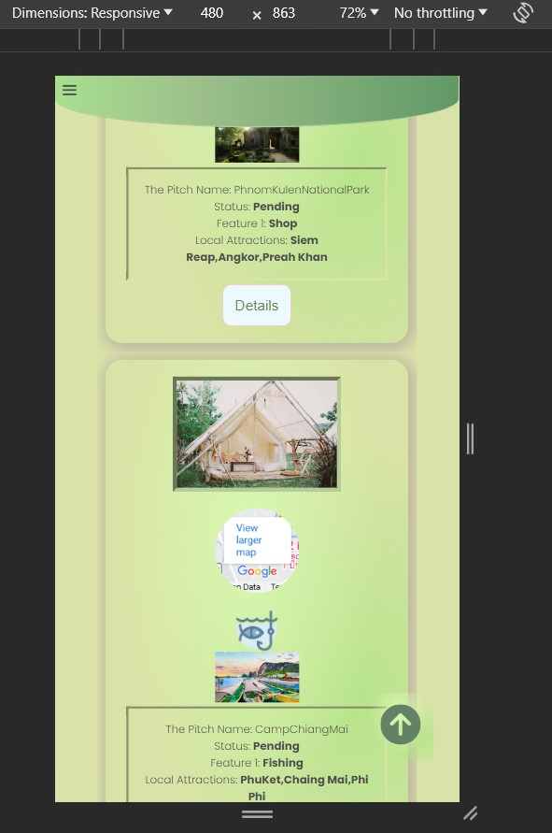

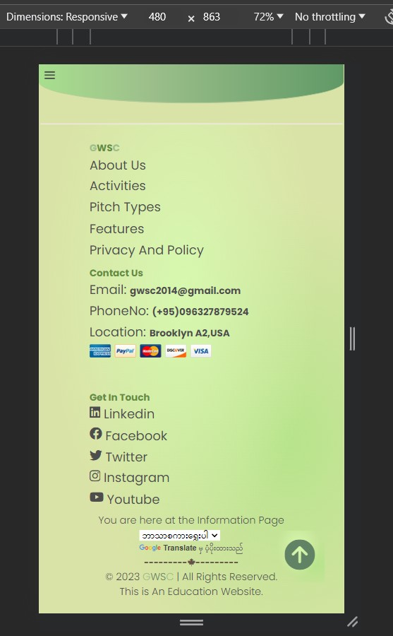

Details

Related information of pitch user choose

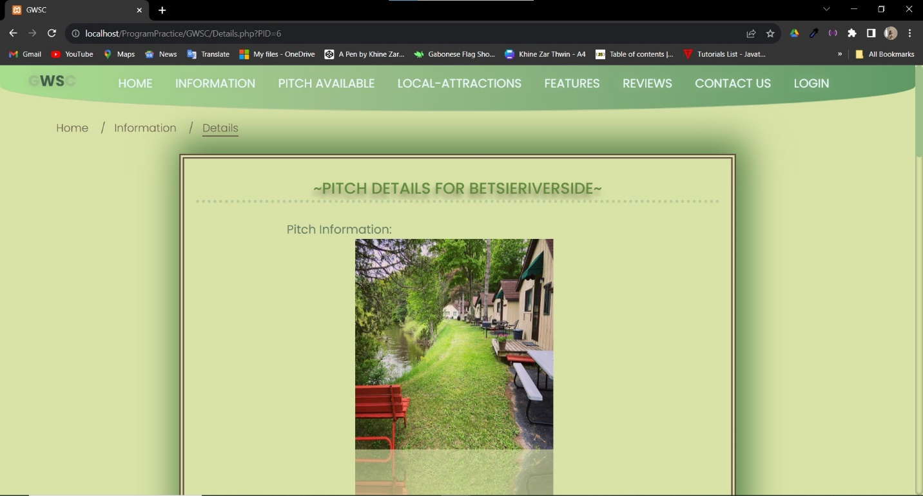

Pitch Details

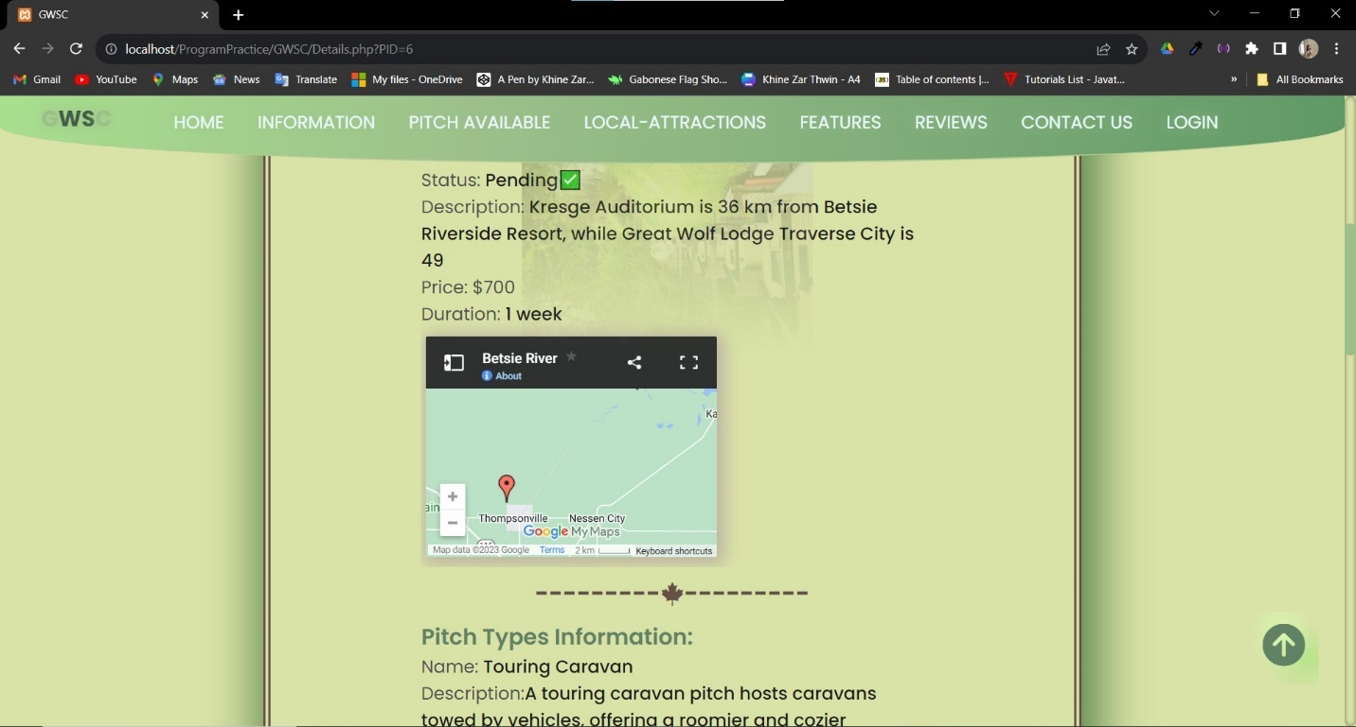

Location Map of related Pitch of user have chosen

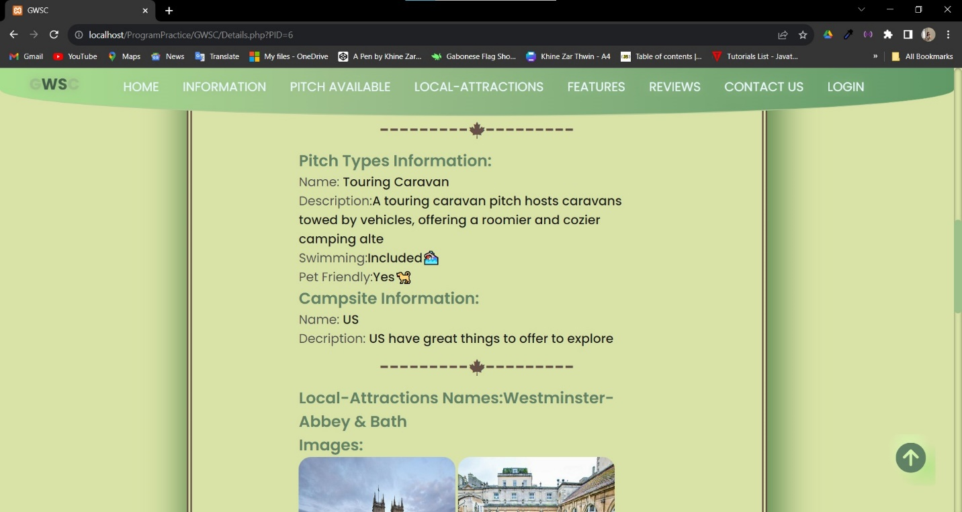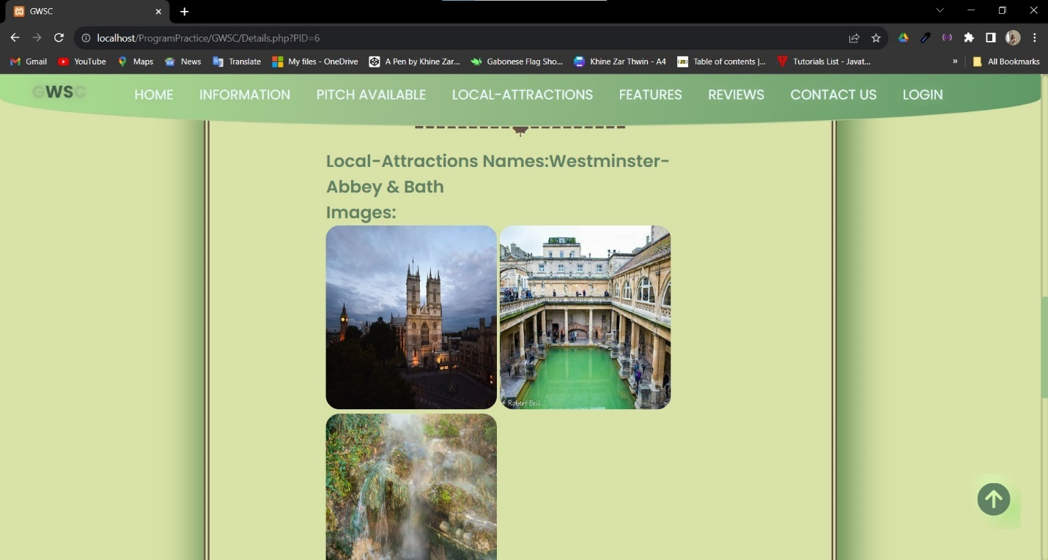

Local-Attraction of related pitch

Pitch Type information of related pitch

Campsite information of that pitch

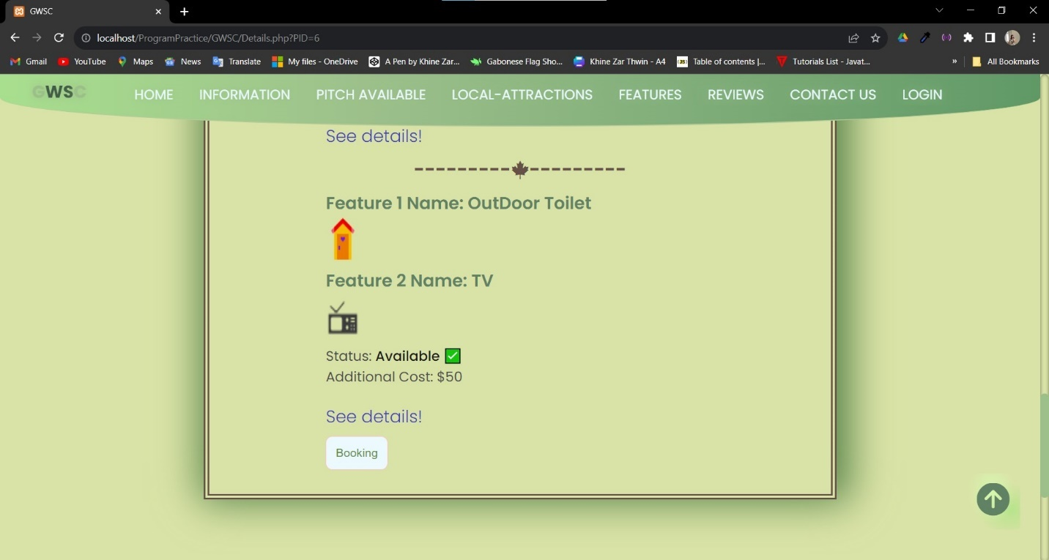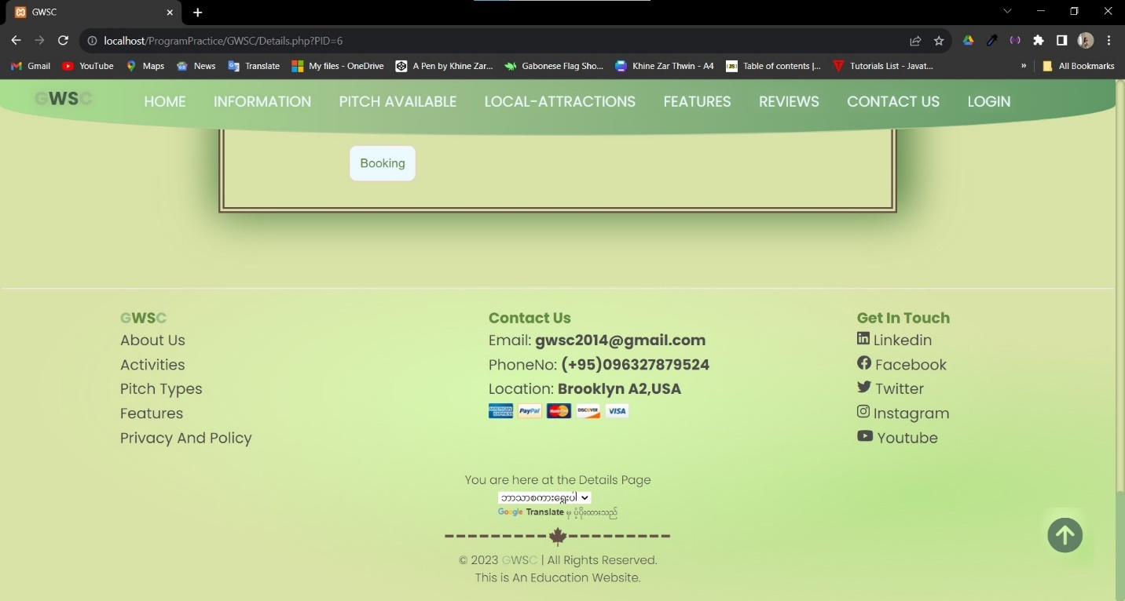

Lead to Booking Page

This will lead to the page of Features

Features’ images of related pitch

Mobile View of Details

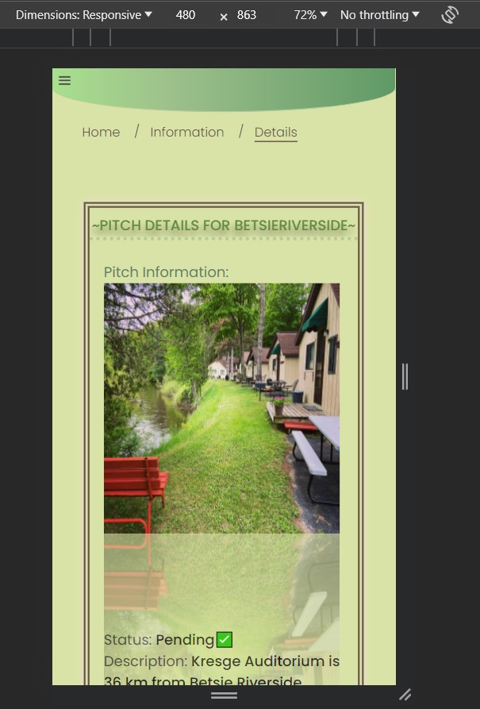

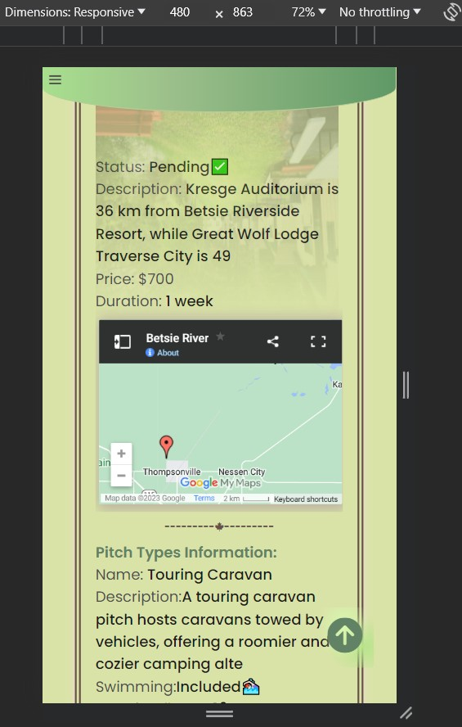

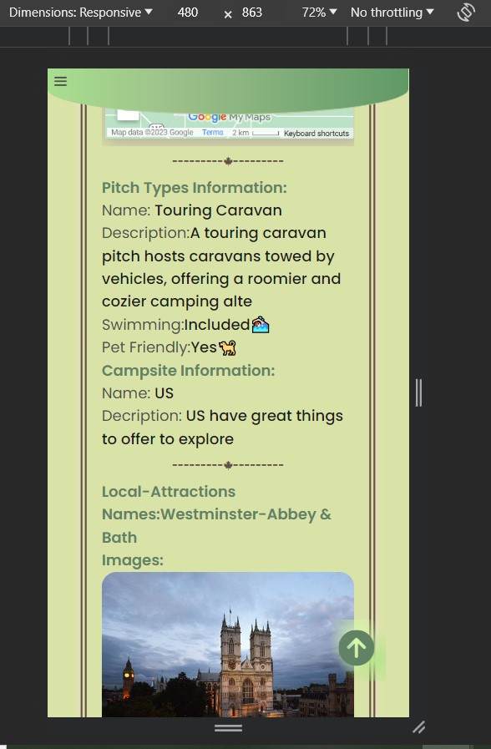

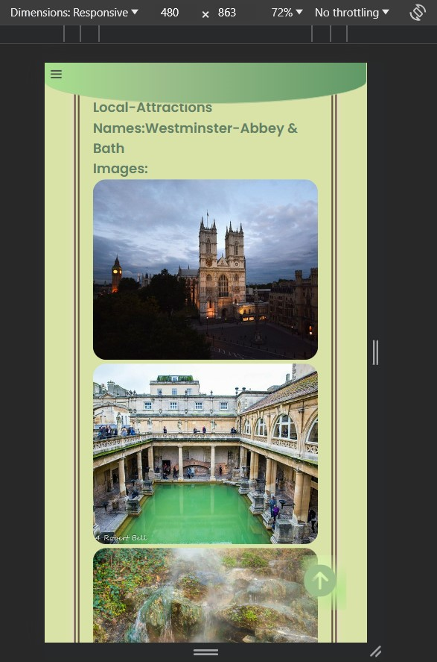

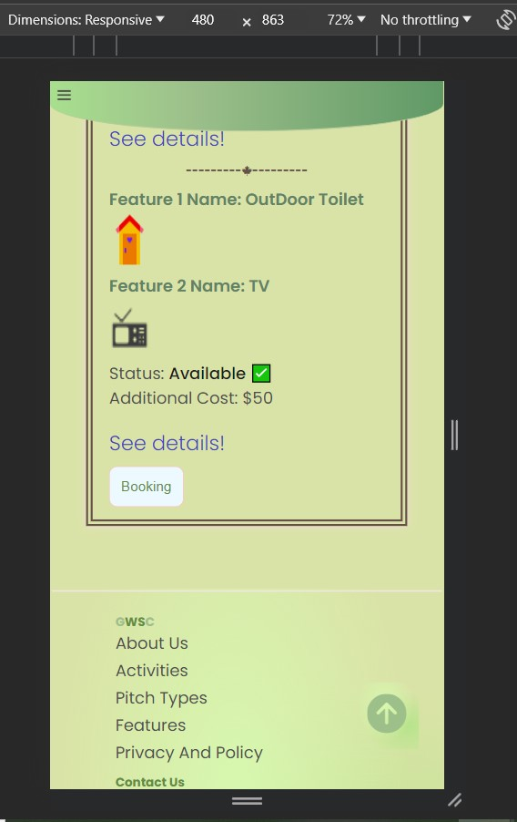

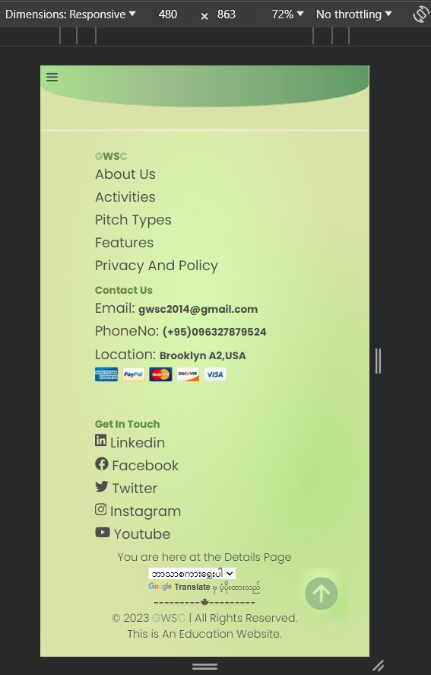

Booking

Booking form to book the pitch that user choose

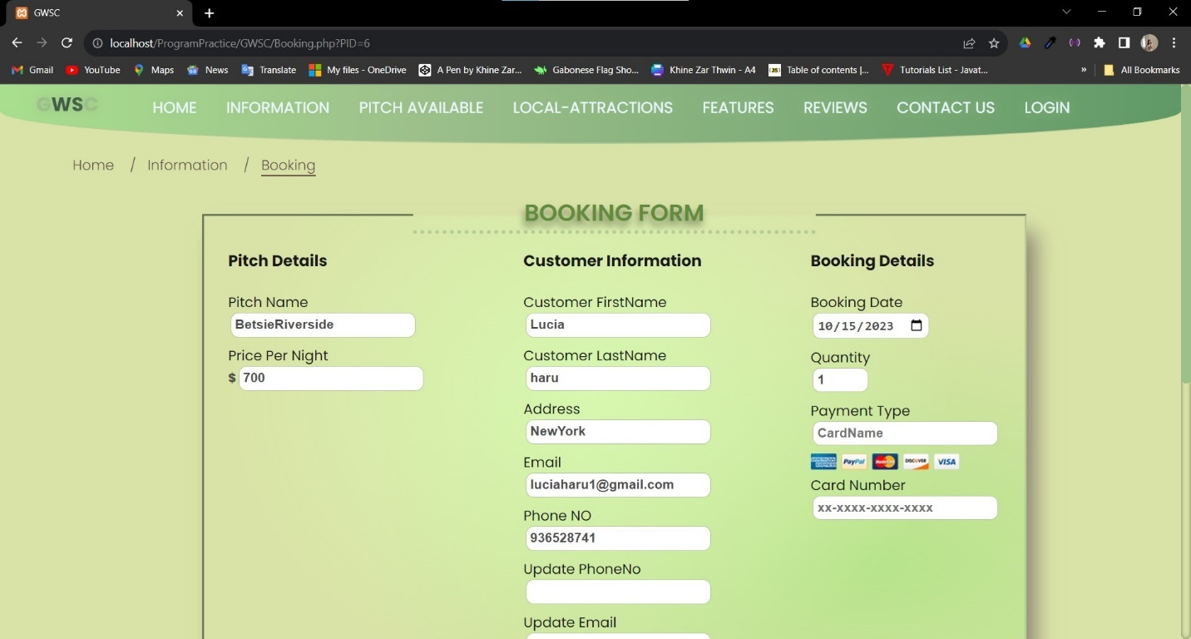

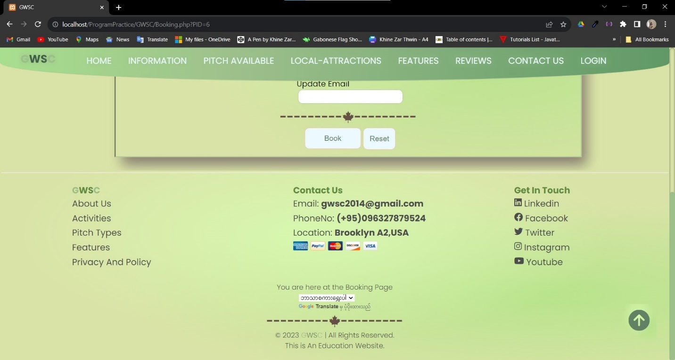

Mobile View of Booking

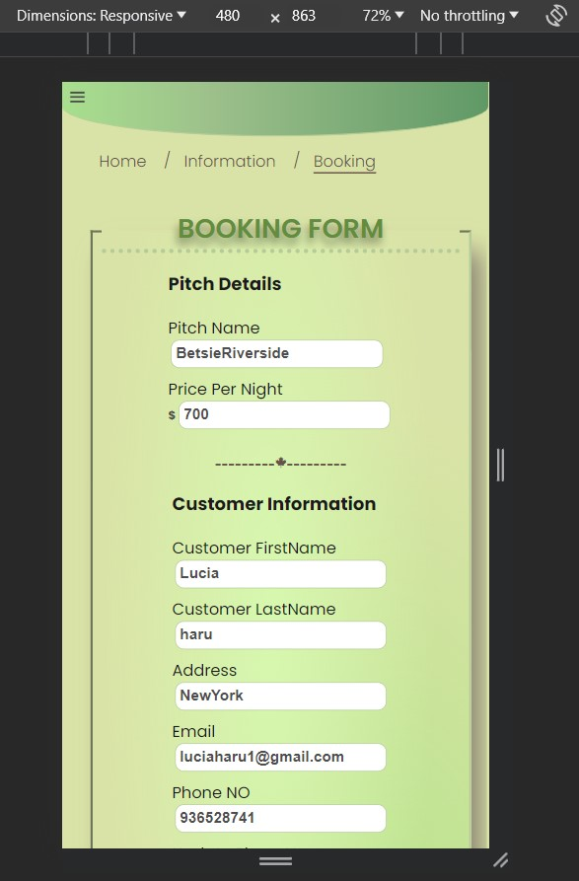

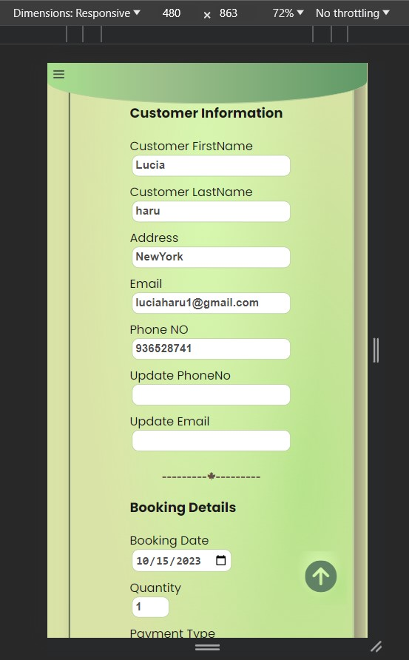

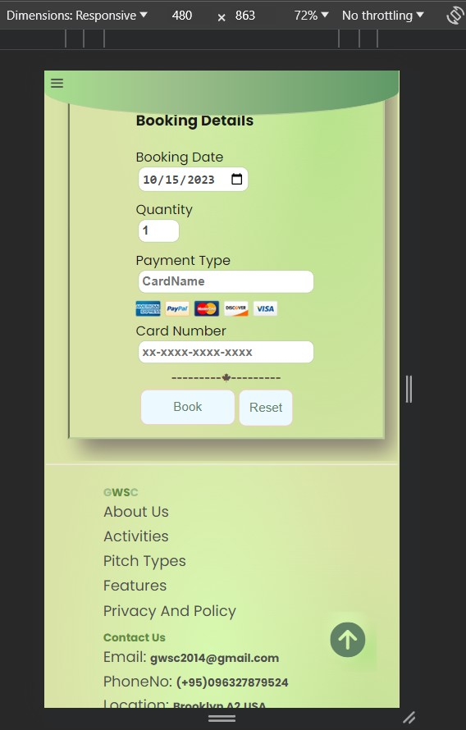

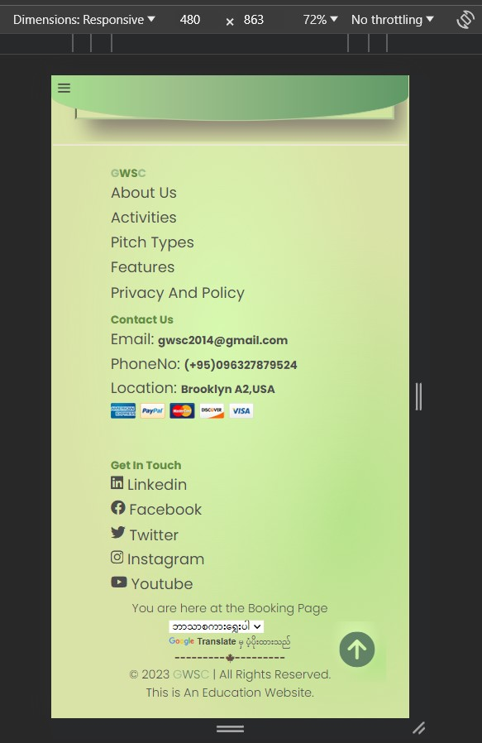

Pitch Type and Availability

Users can search the pitch name from here

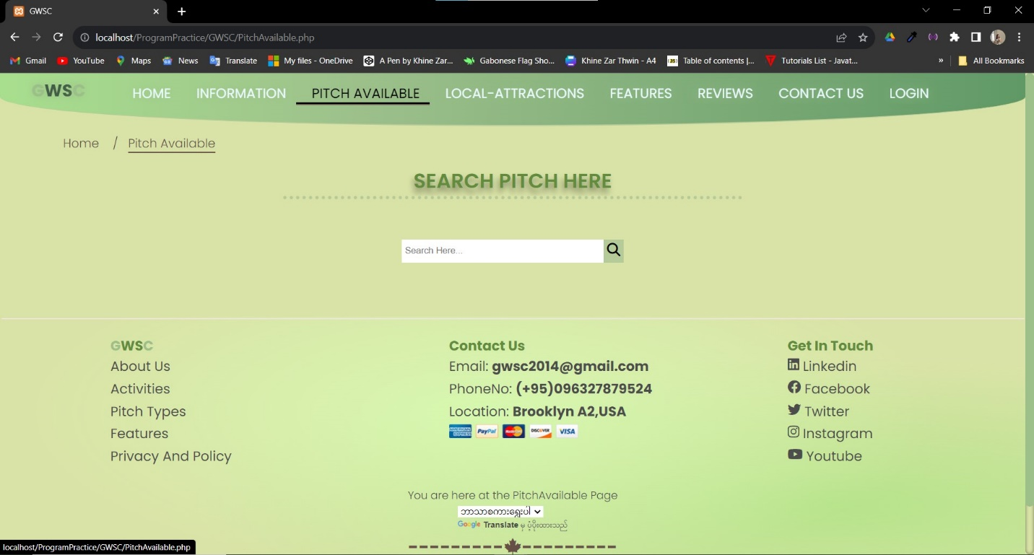

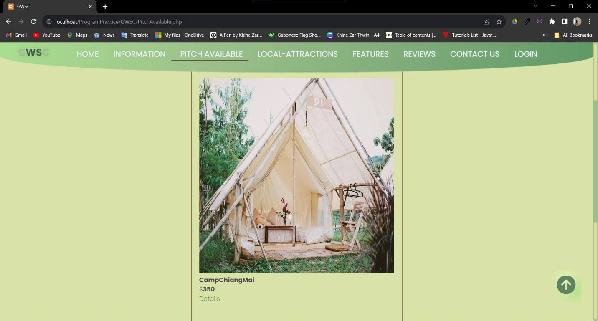

The Search Result

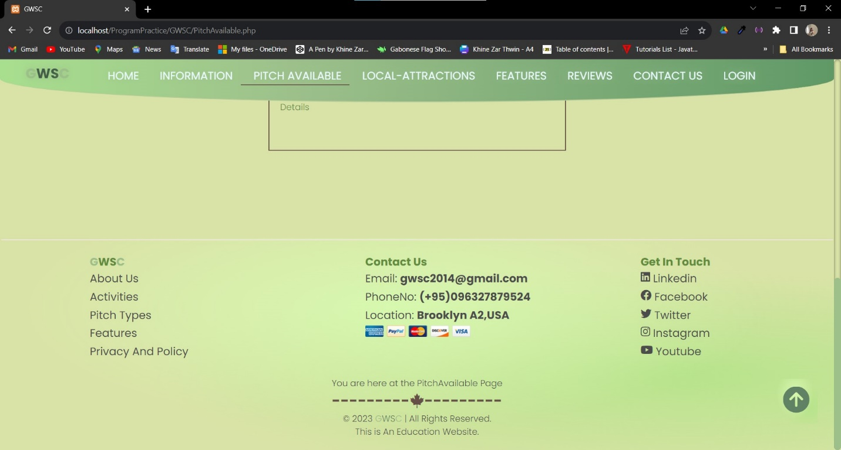

Mobile Views of Pitch Type and Availability

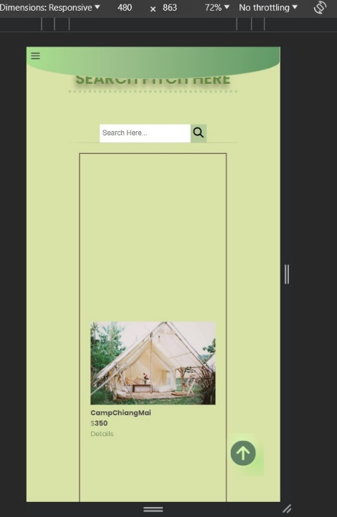

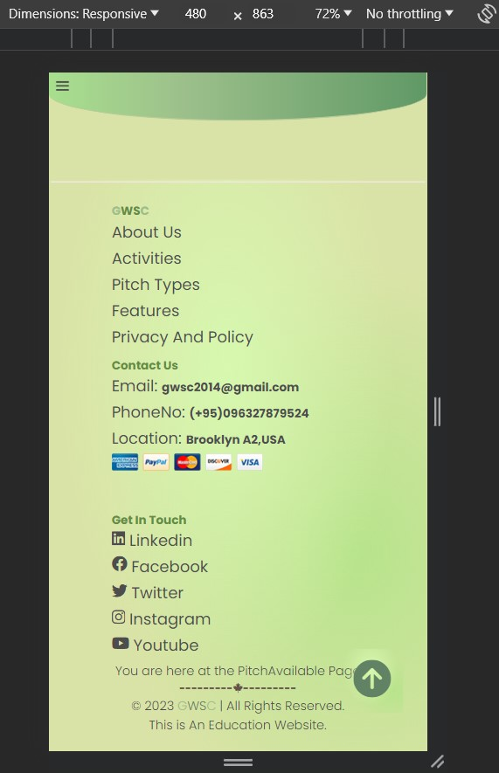Local-Attraction

The details of local attraction of all pitches

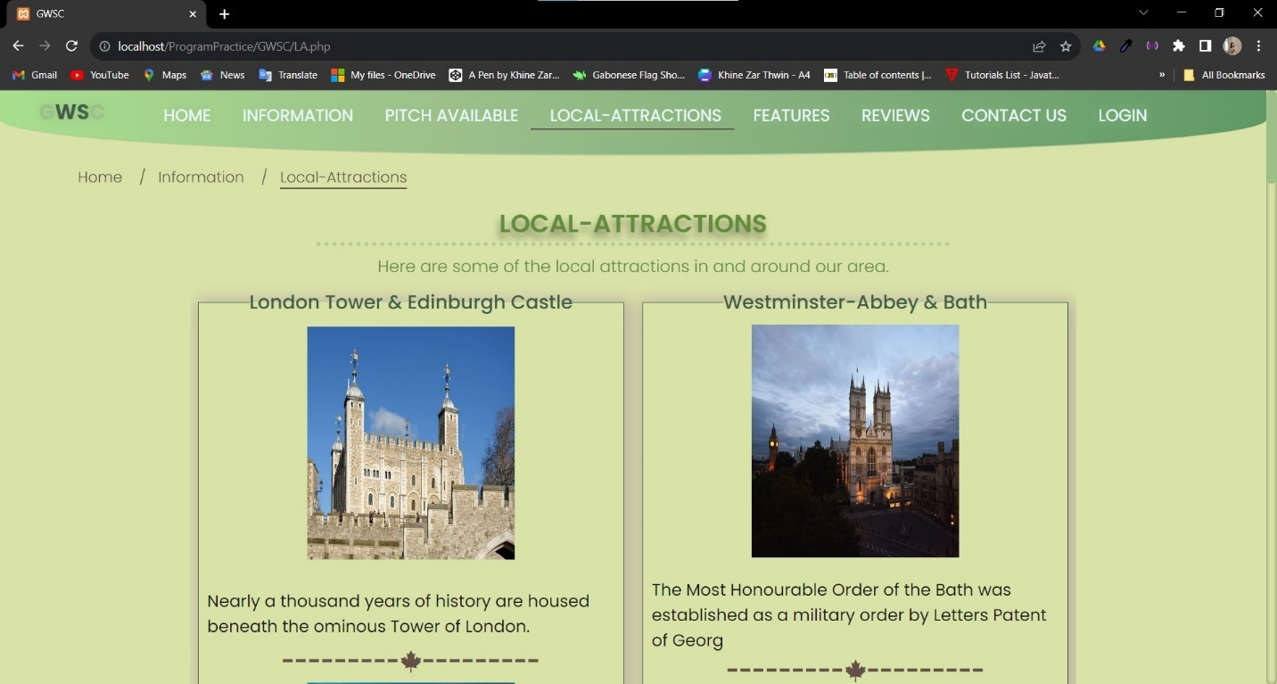

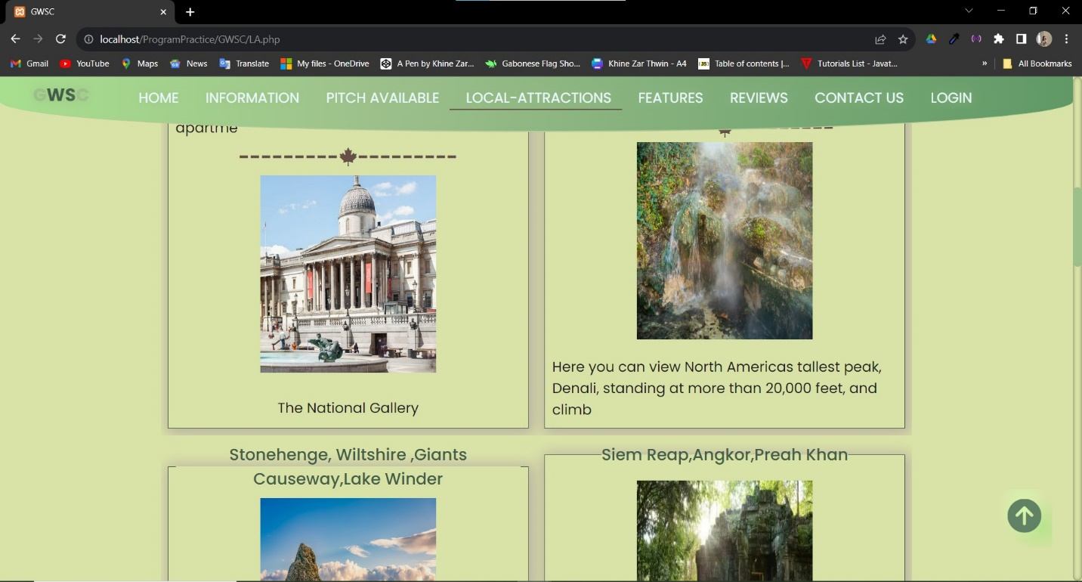

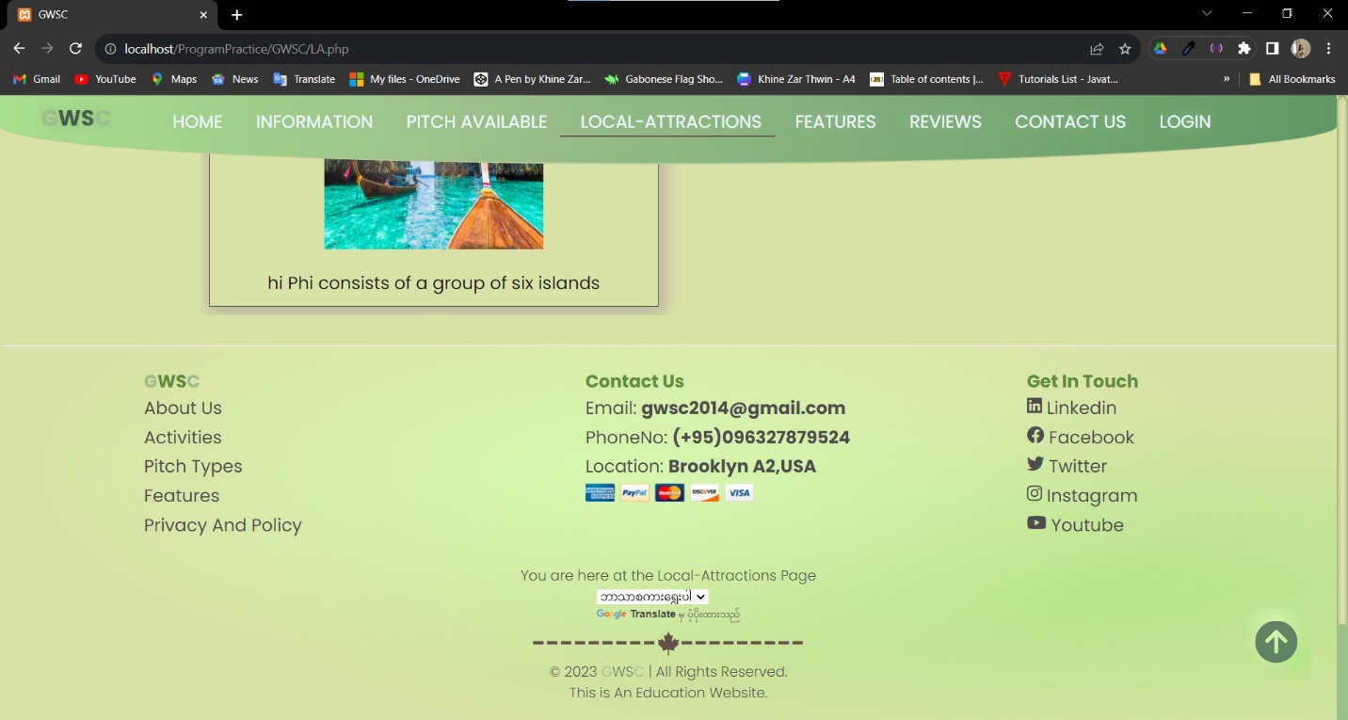

Mobile View of Local-Attraction

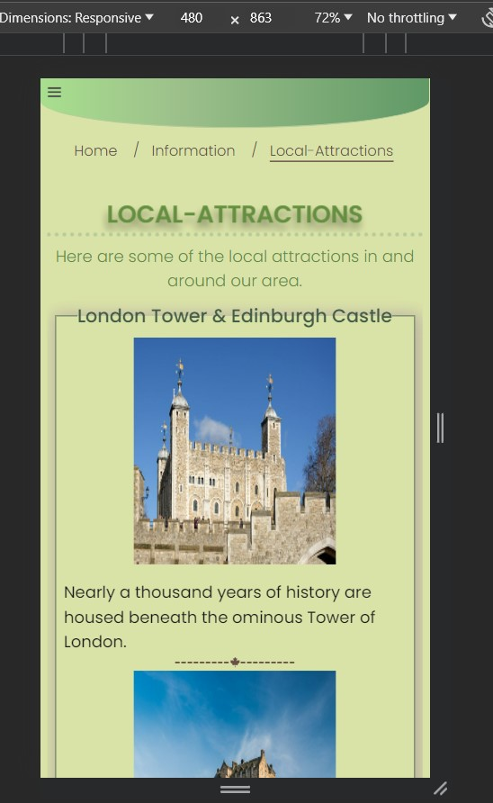

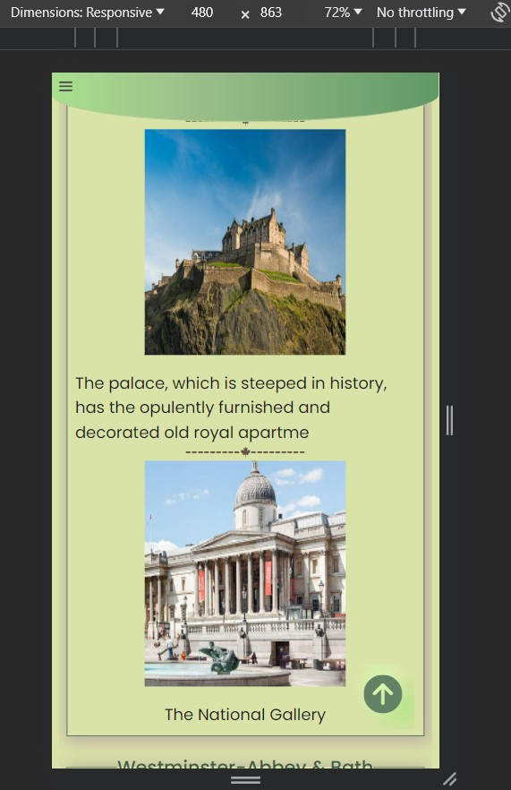

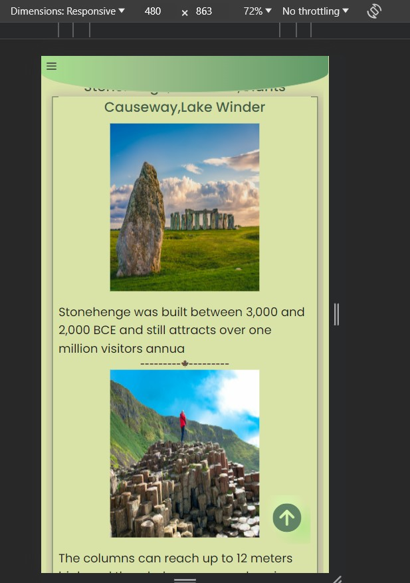

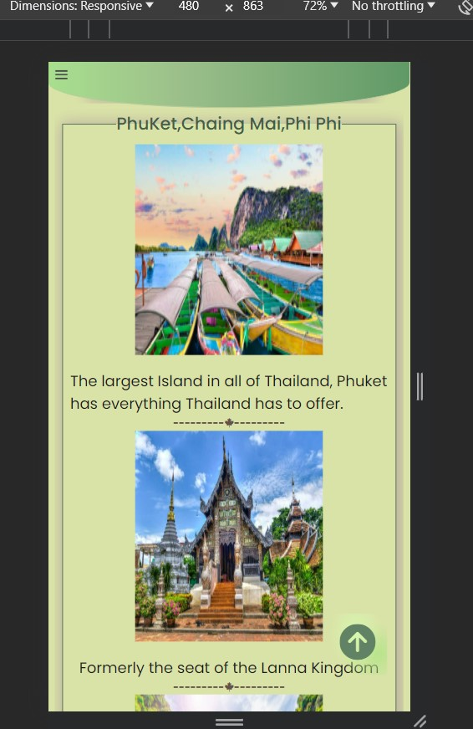

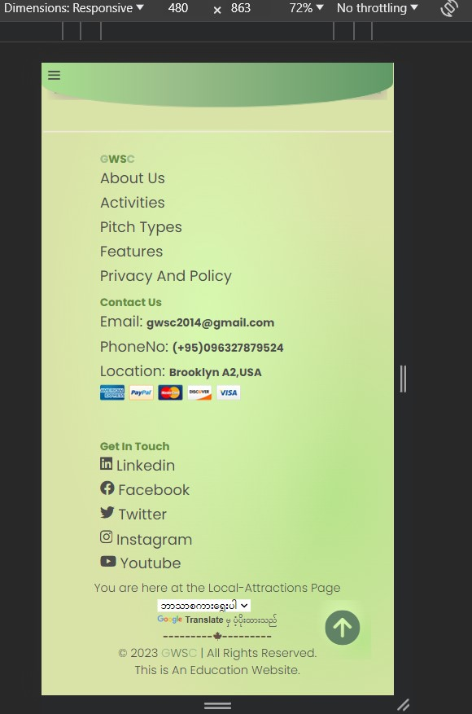

Features

All features of every pitch

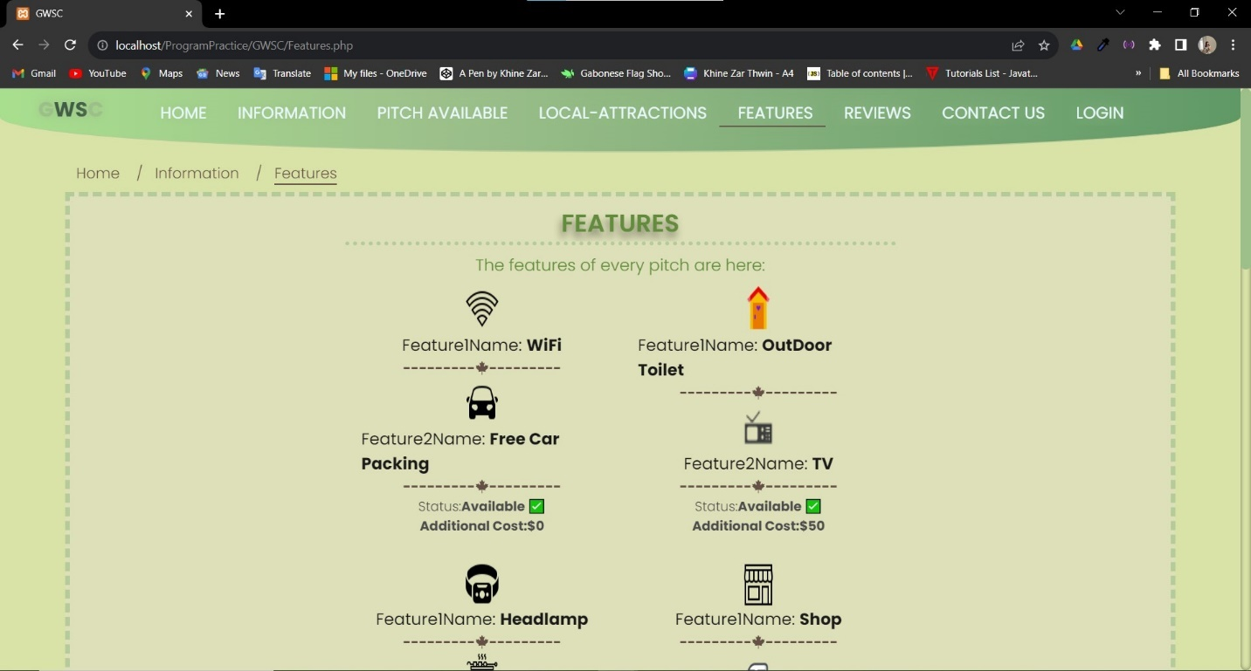

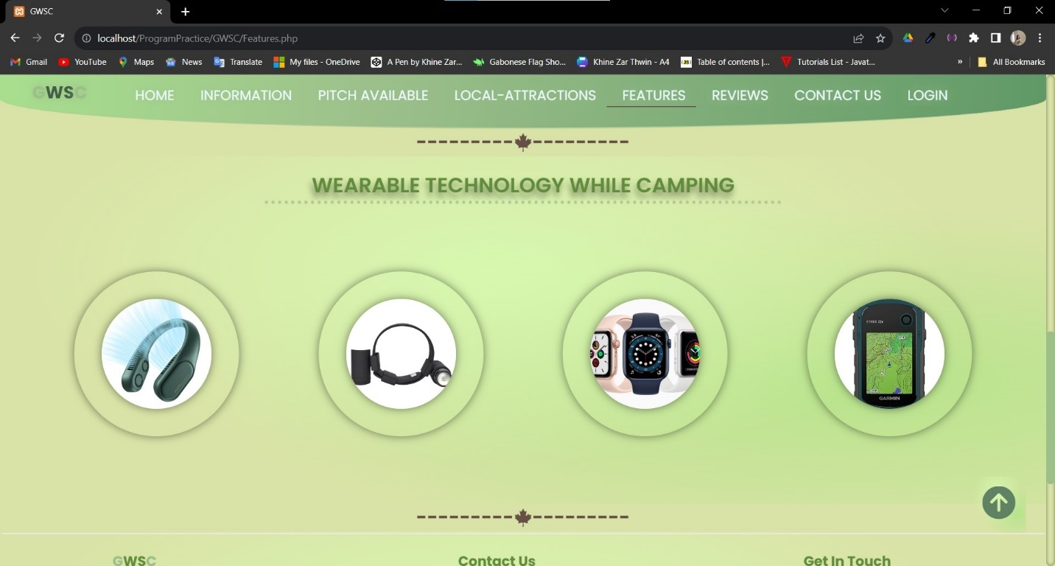

Wearable Technology in camping with hover pop up design

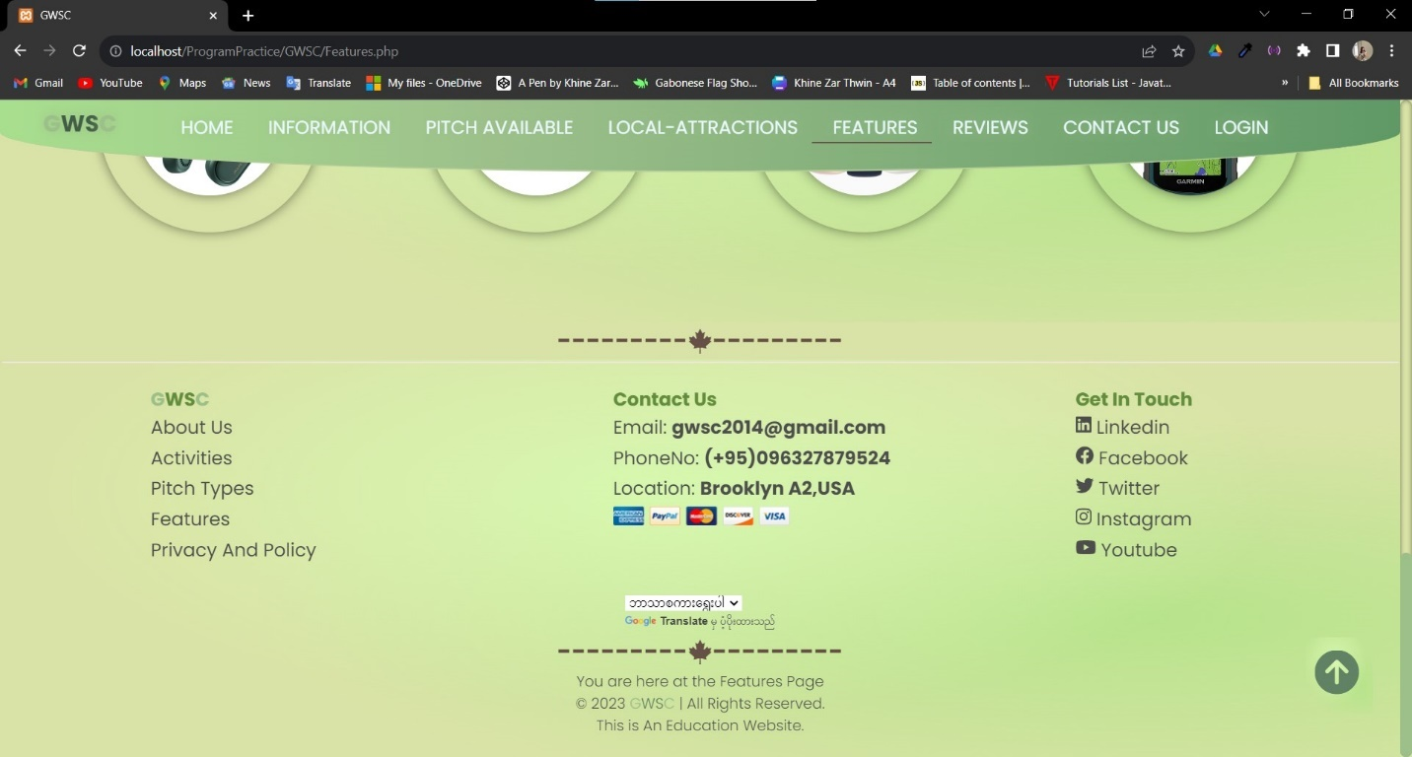

Mobile View of Features

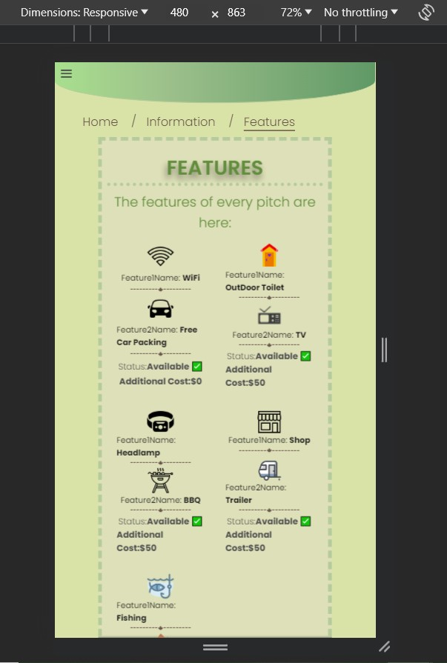

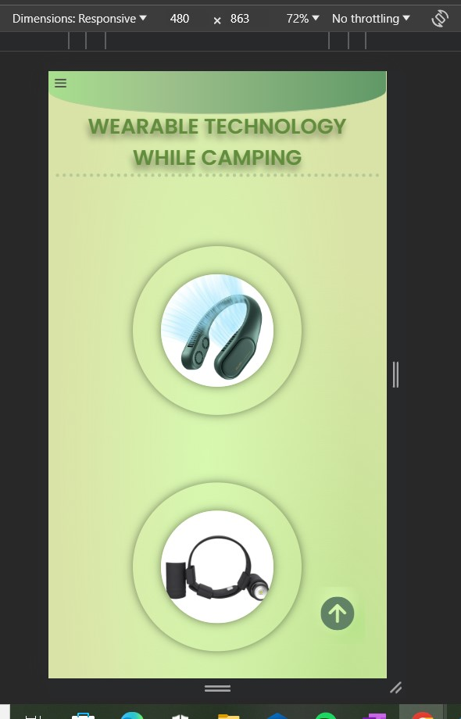

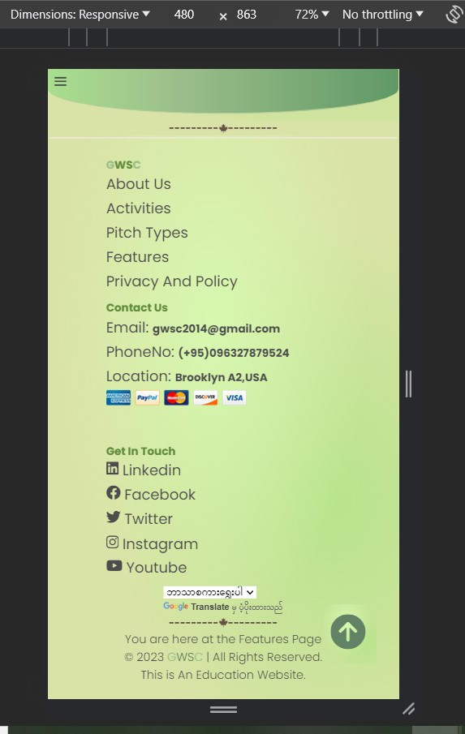

Reviews

The submitted feedback from customers

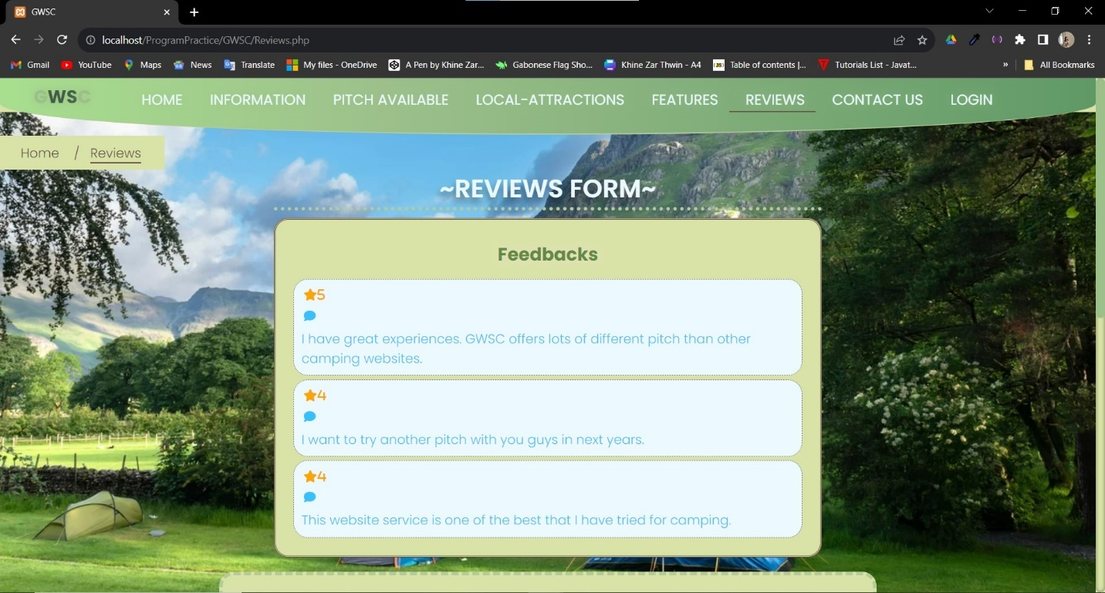

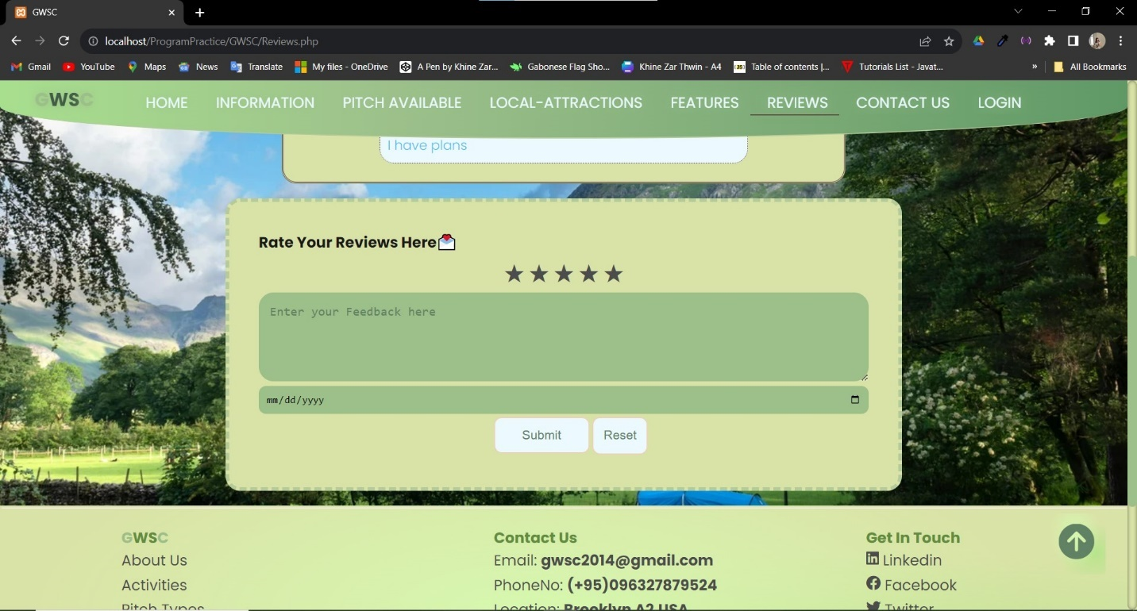

Customers rate the reviews here after login to their account.

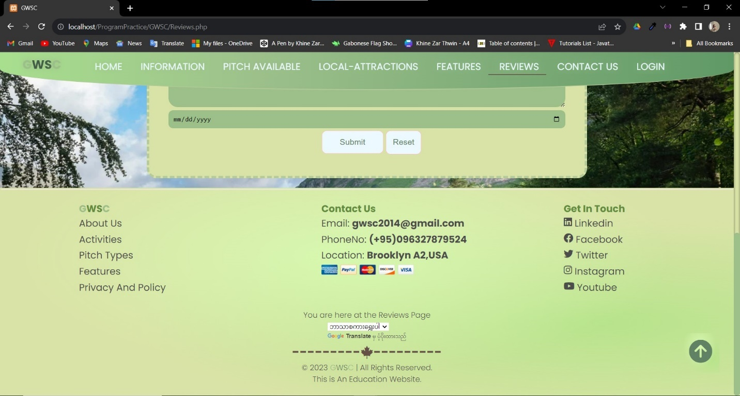

Mobile View of Reviews

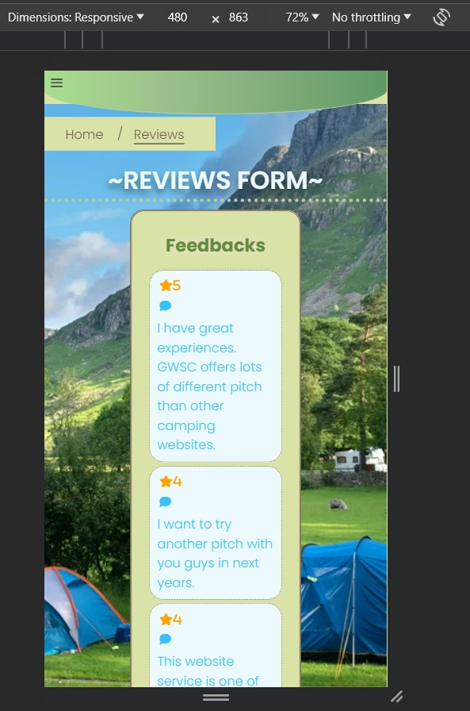

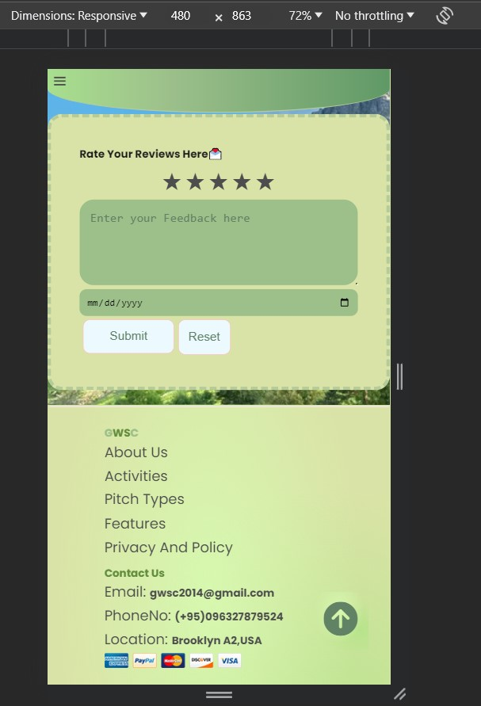

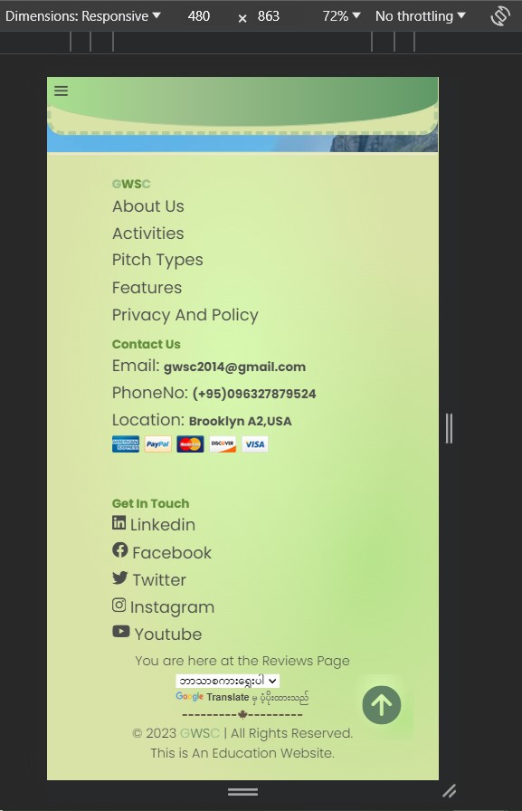

Contact Us

Customer send the inquiry after they login to their account

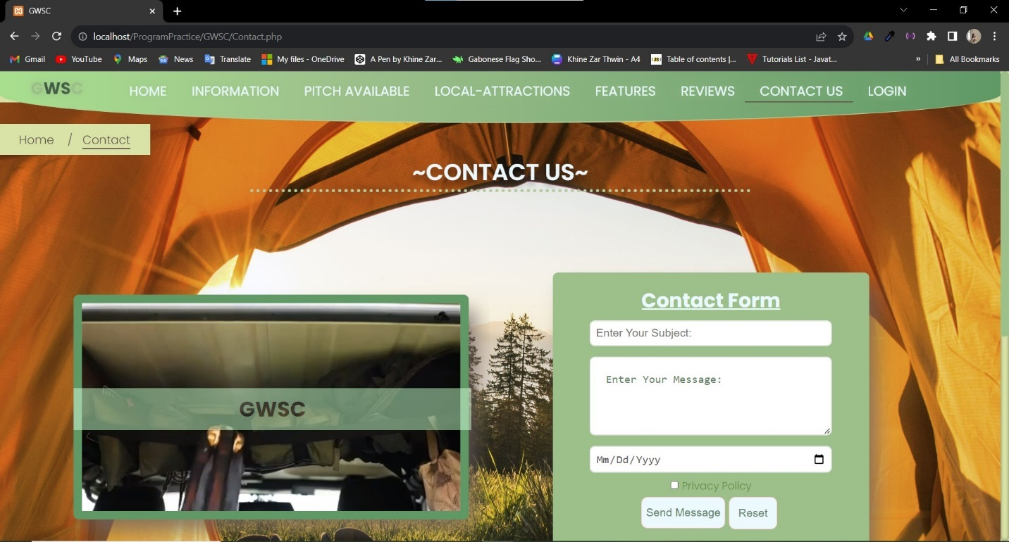

Will lead to privacy page

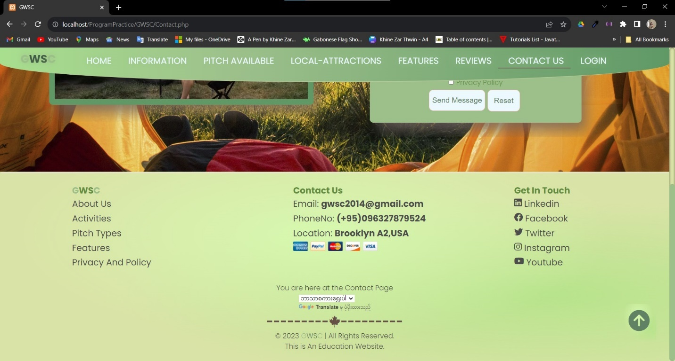

Mobile View of Contact

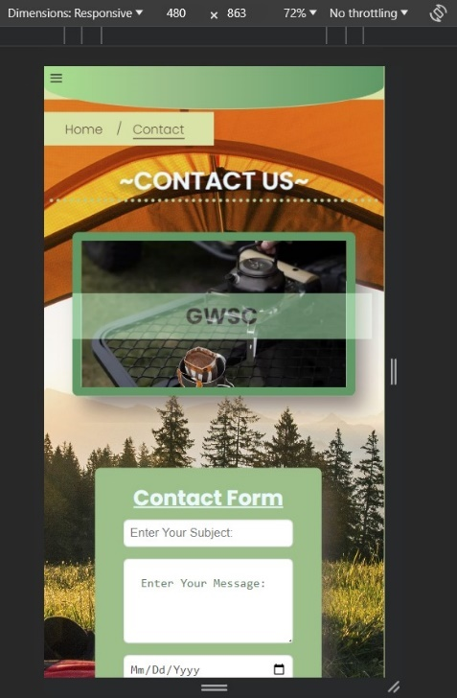

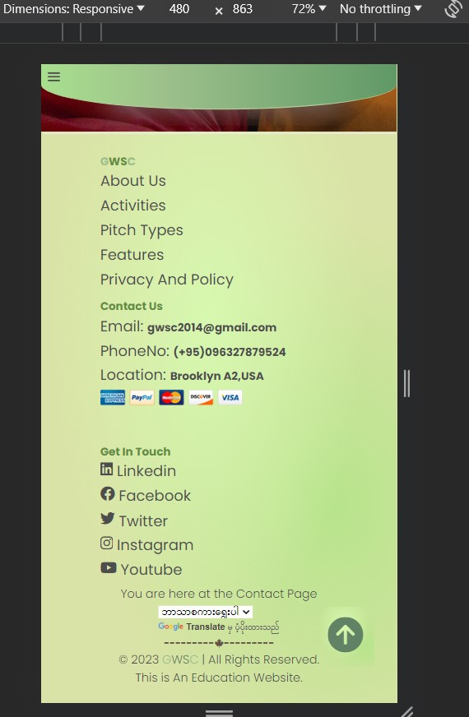

Privacy Policy

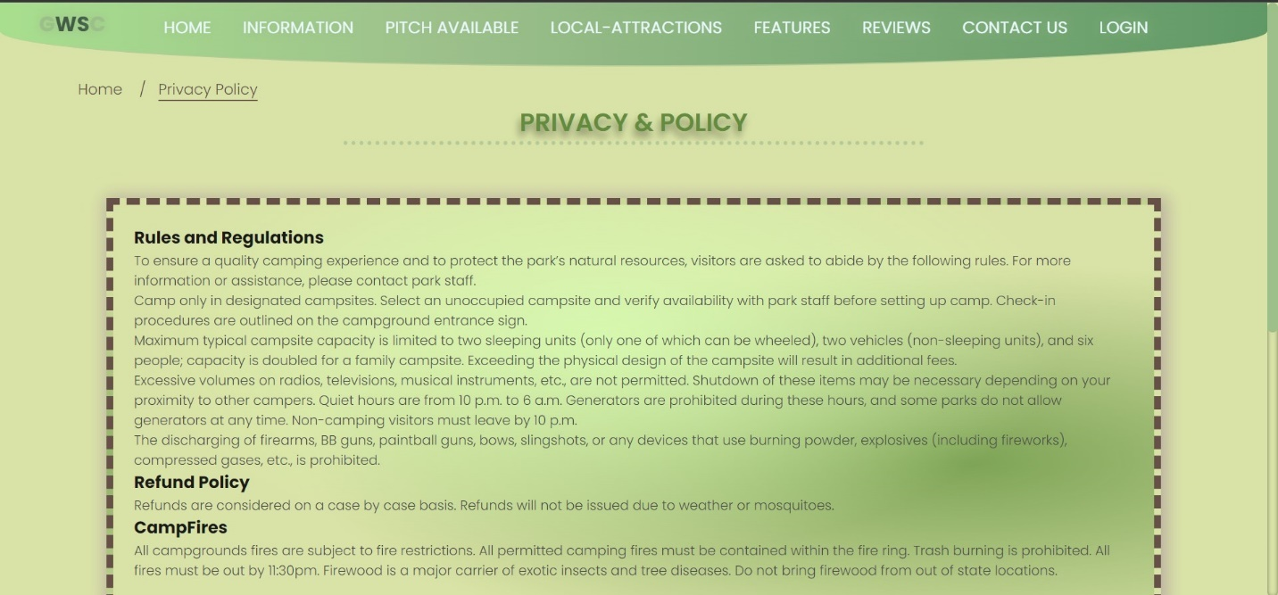

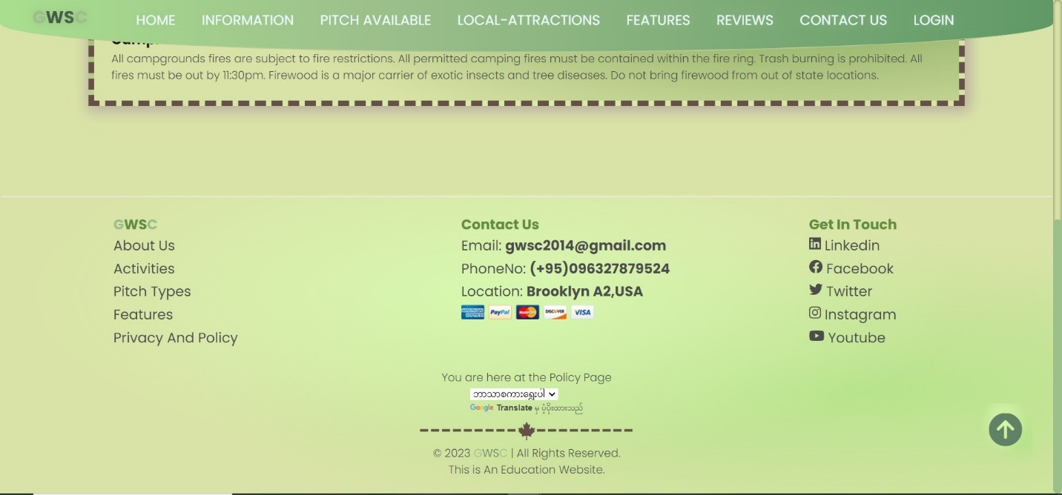

This page can be entered by clicking the privacy and policy link in Contact page or from the footer link too.

Mobile Views of Privacy Policy

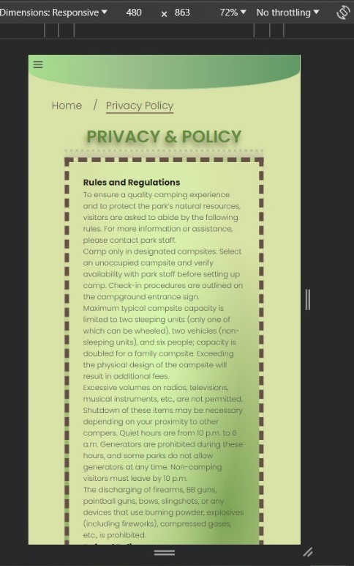

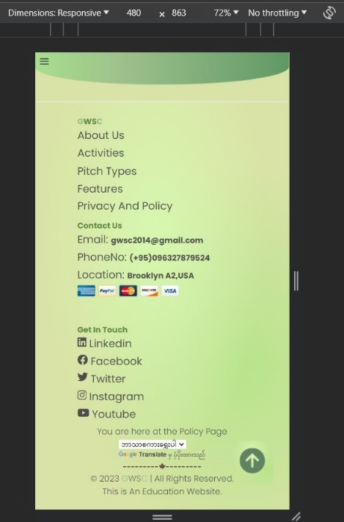

Sign In

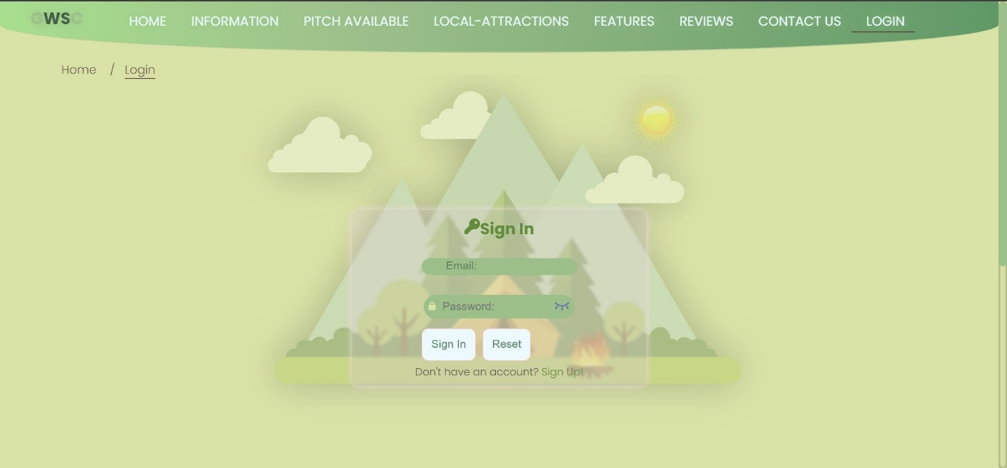

Link to Sign Up page for new customers

View Password function

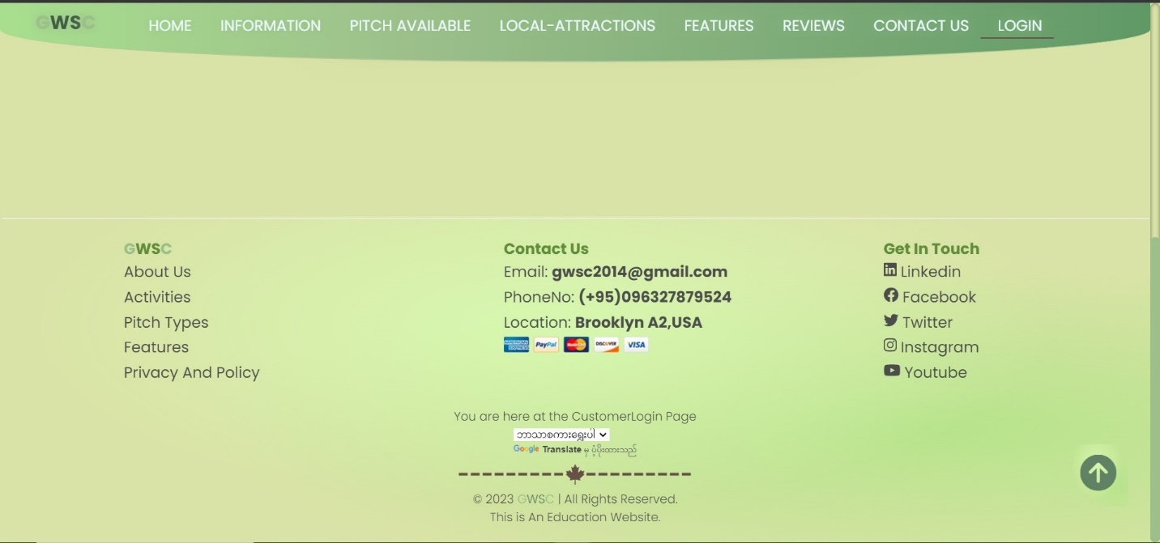

Mobile Views of Sign in

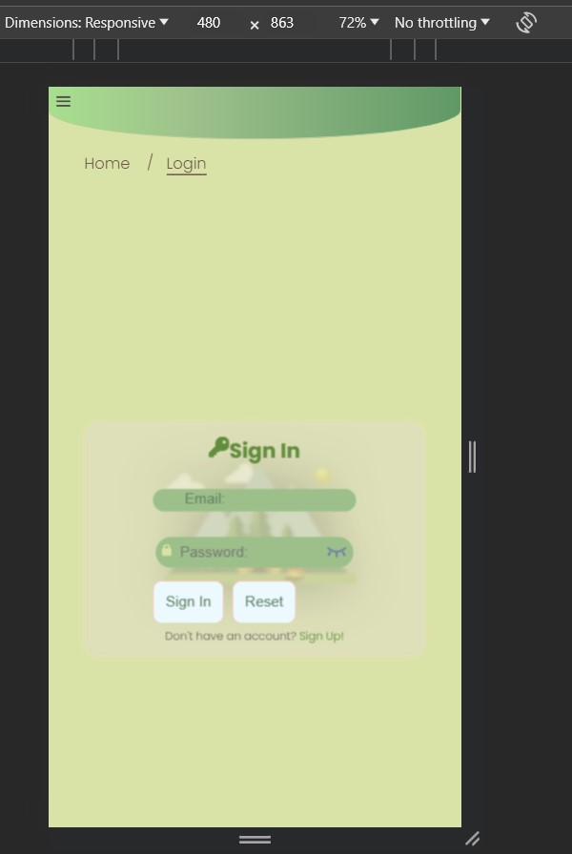

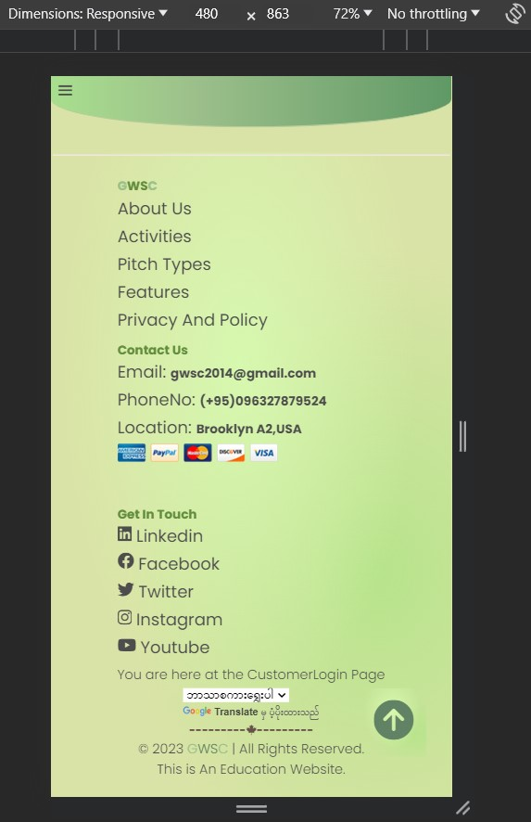

Sign Up

Sign Up page for new customers

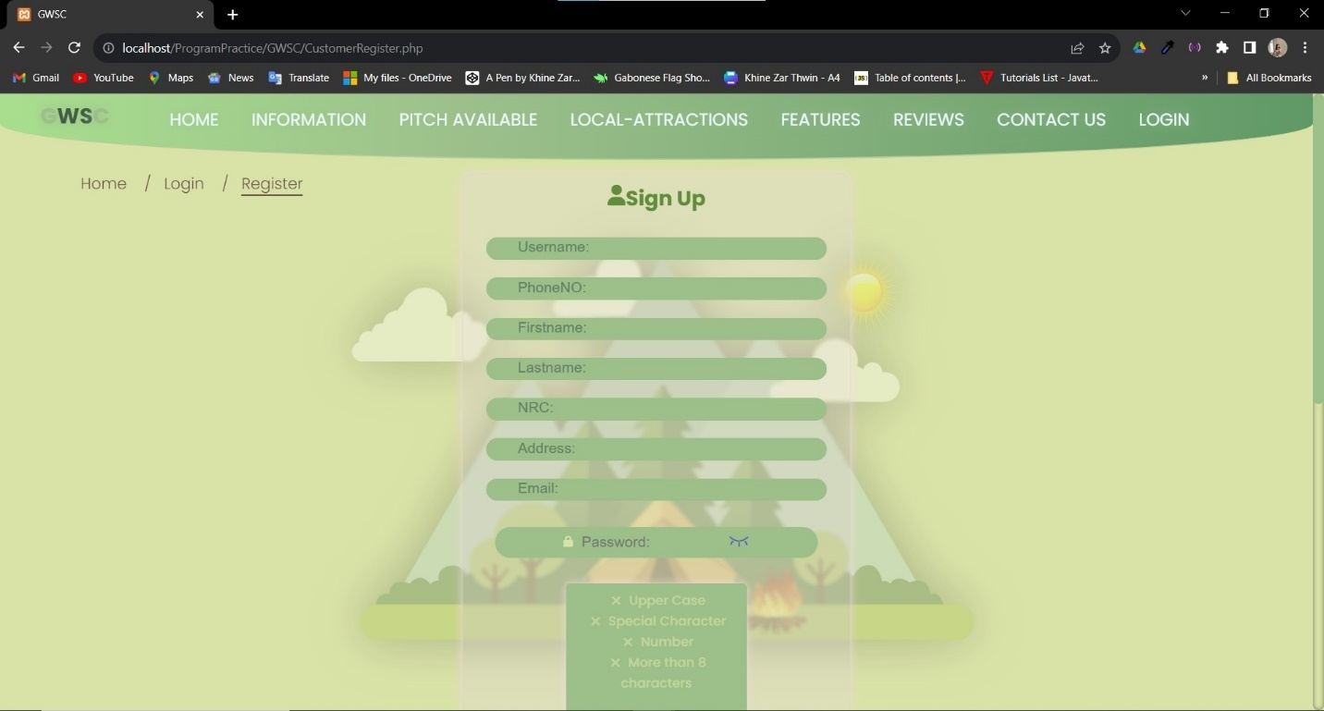

Password Validator

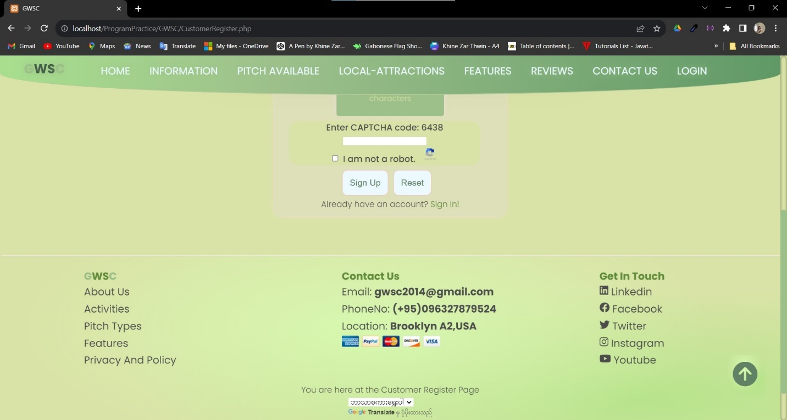

Link to Sign In page

Captcha validator

Mobile View of Sign up

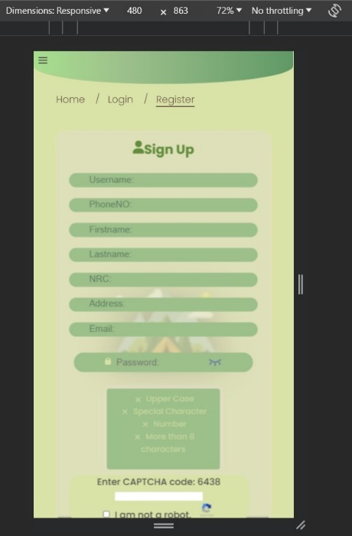

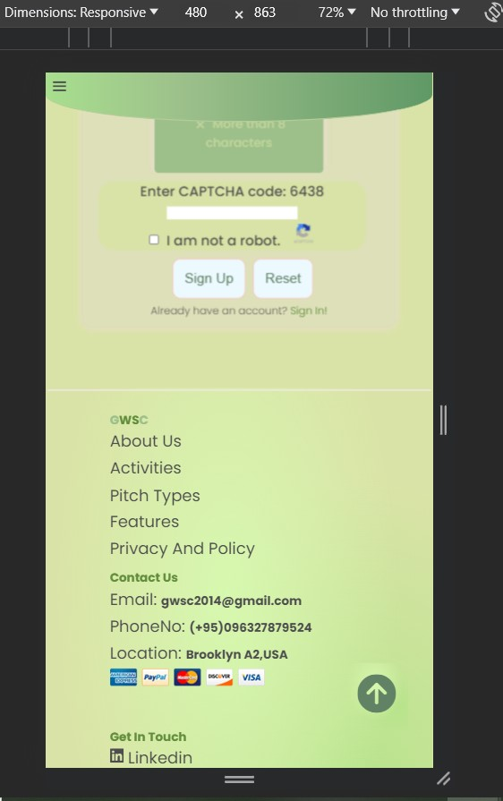

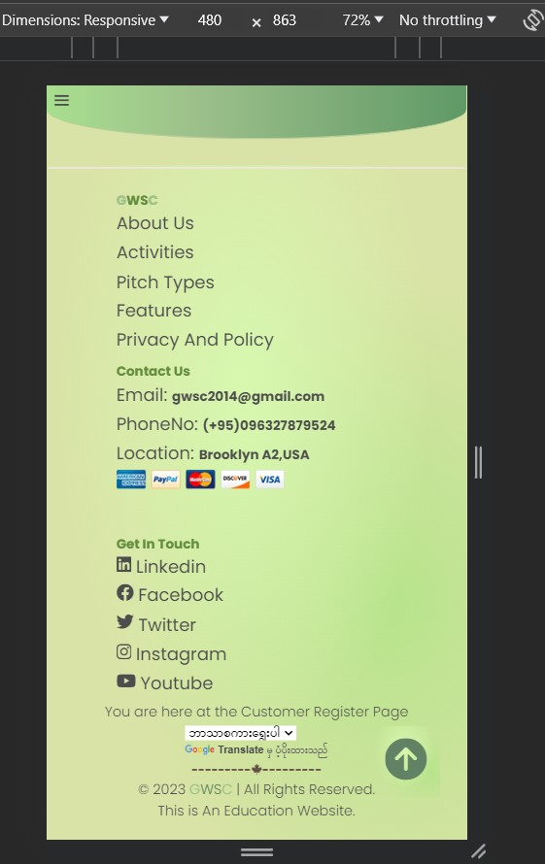

## Two Different Browsers that can be ran by GWSC

### Chrome

This website was built and tested on Version 118.0.5993.70 (Official Build) (64-bit) from the beginning on the assignment.

**Home**













Information







**Details**









**Booking**





**Pitch Type and Availability**



**Local-Attraction**







**Features**







**Reviews**







**Contact**





**Privacy Policy**





**Sign In**





**Sign Up**





### Microsoft Edge

This website is currently run on Version 118.0.2088.46 (Official build) (64-bit) and there is no changes between Chrome and Microsoft Edge. Every thing run similarly with Chrome.

**Home**

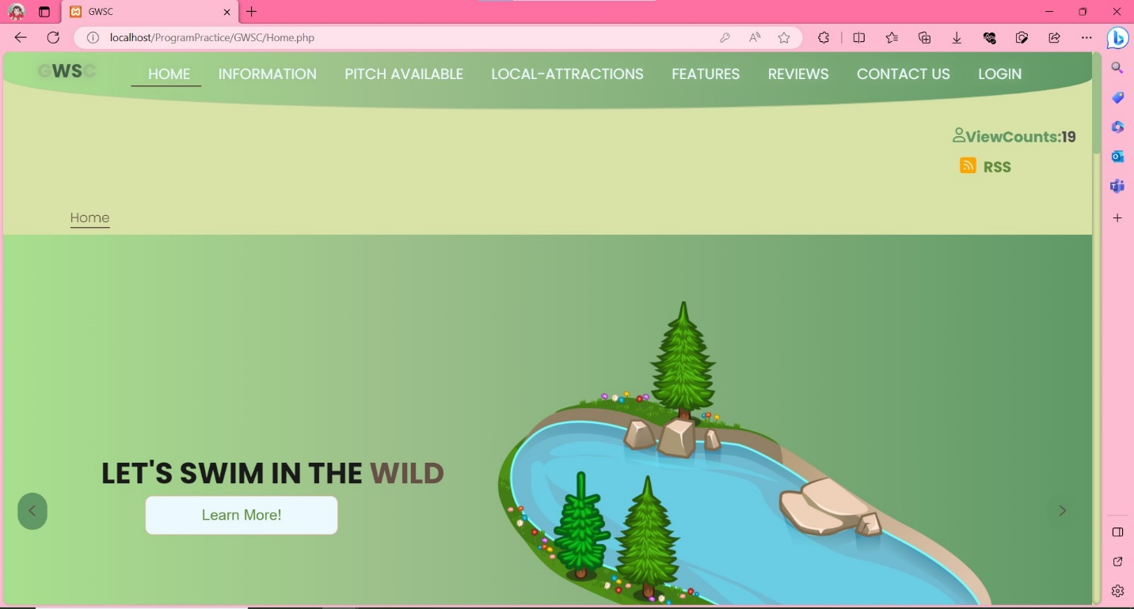

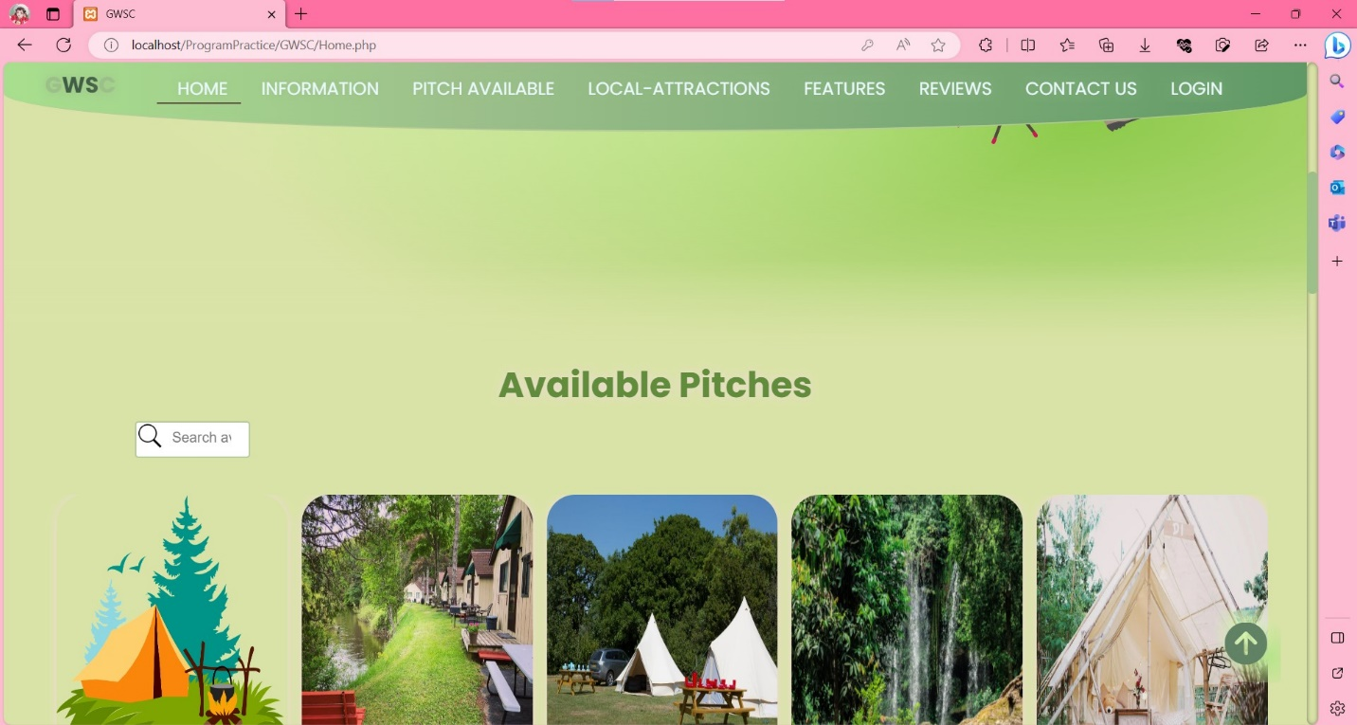

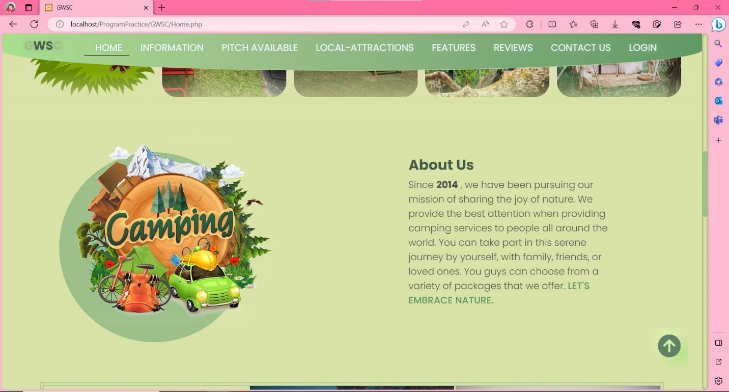

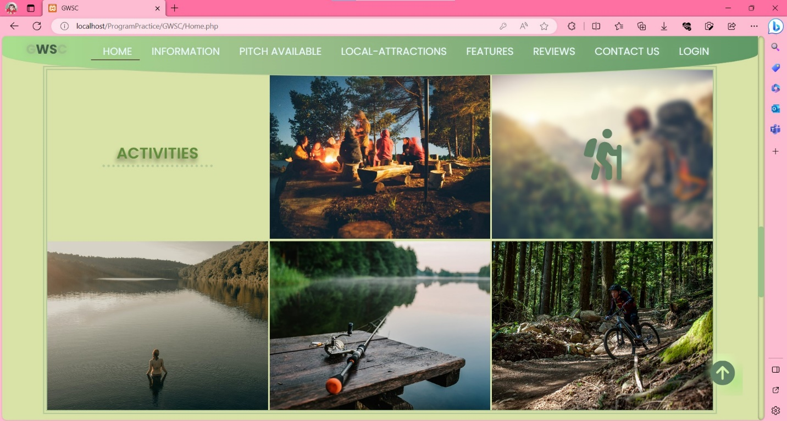

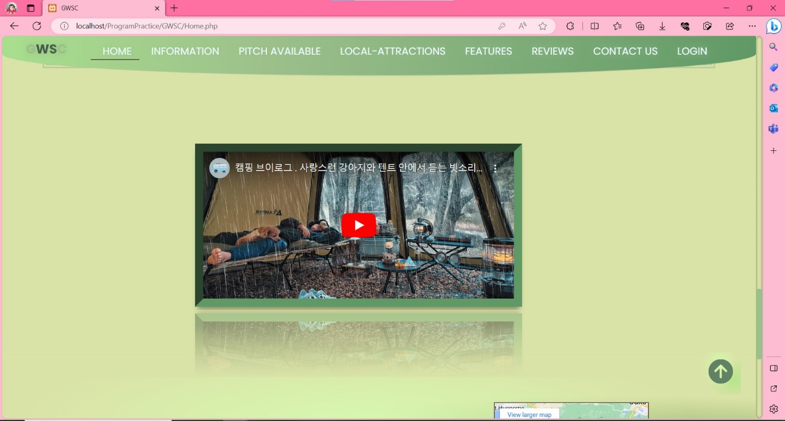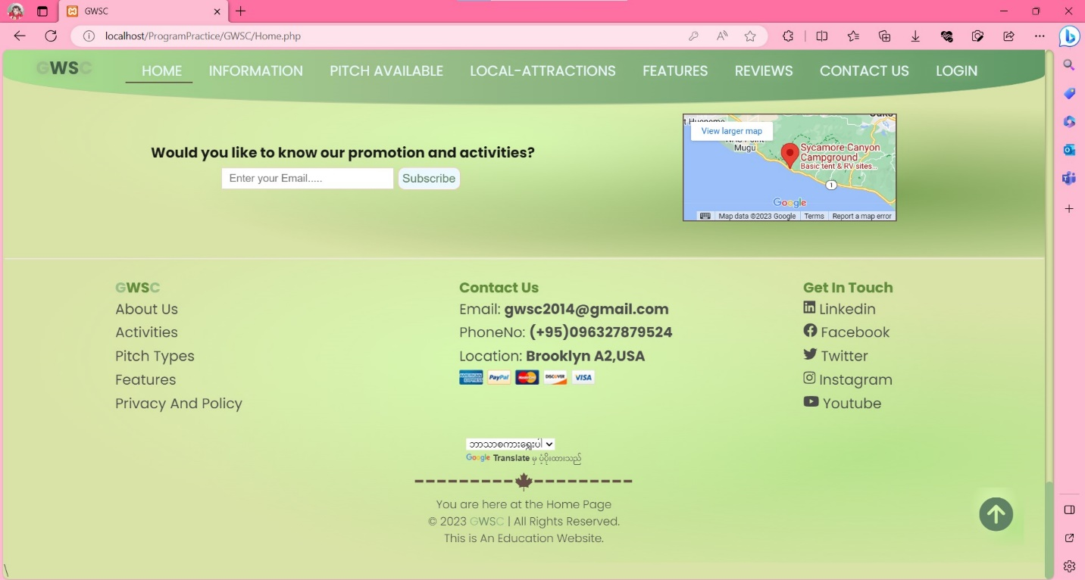

**Information**

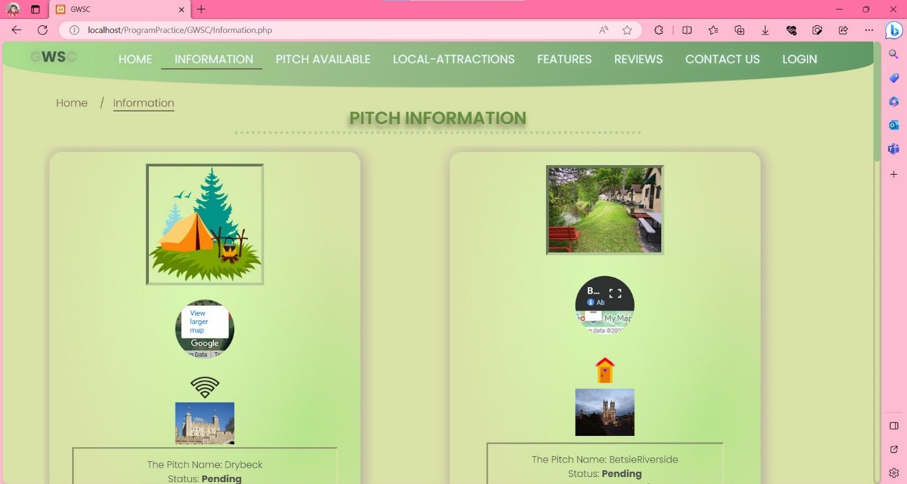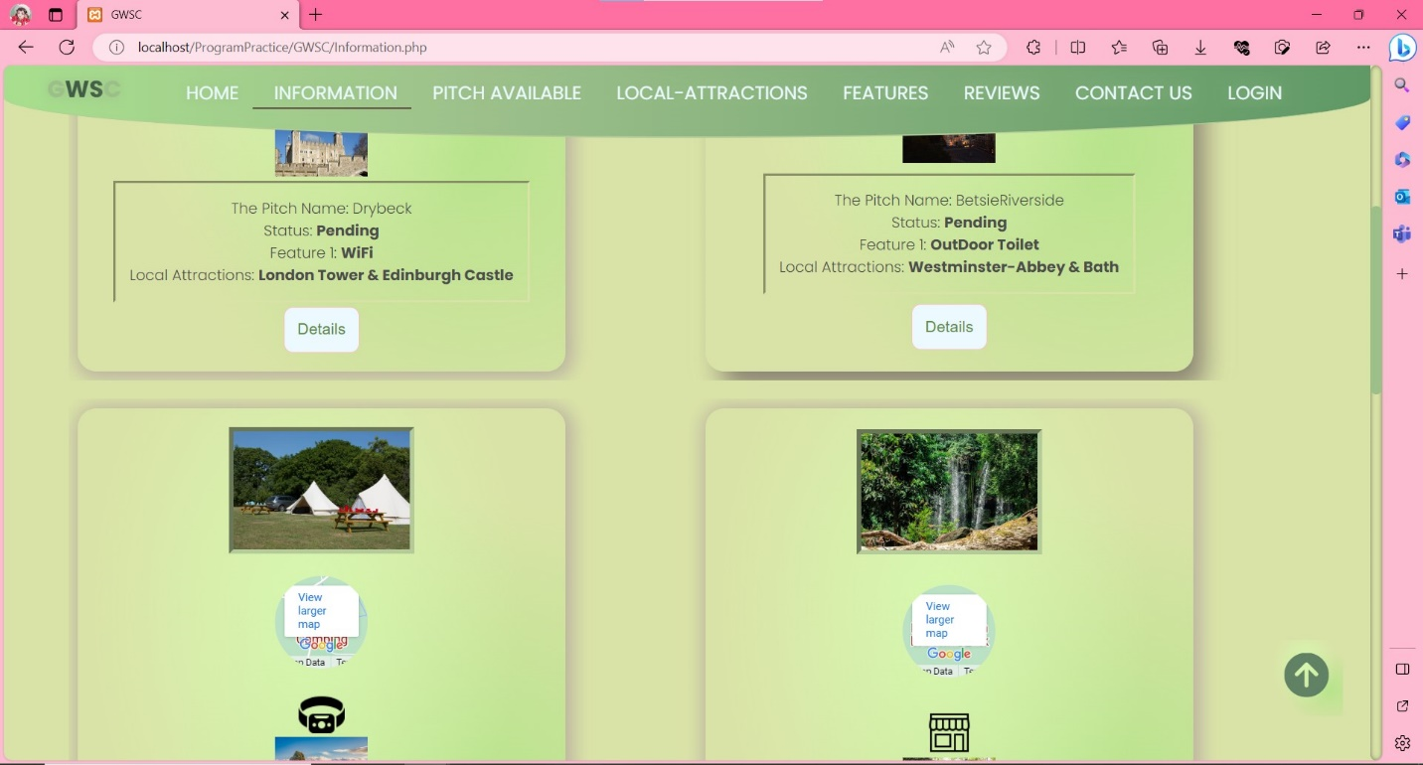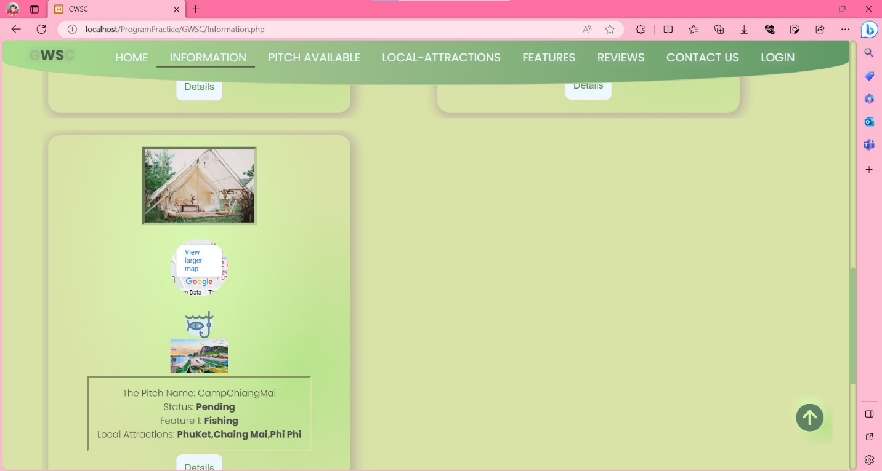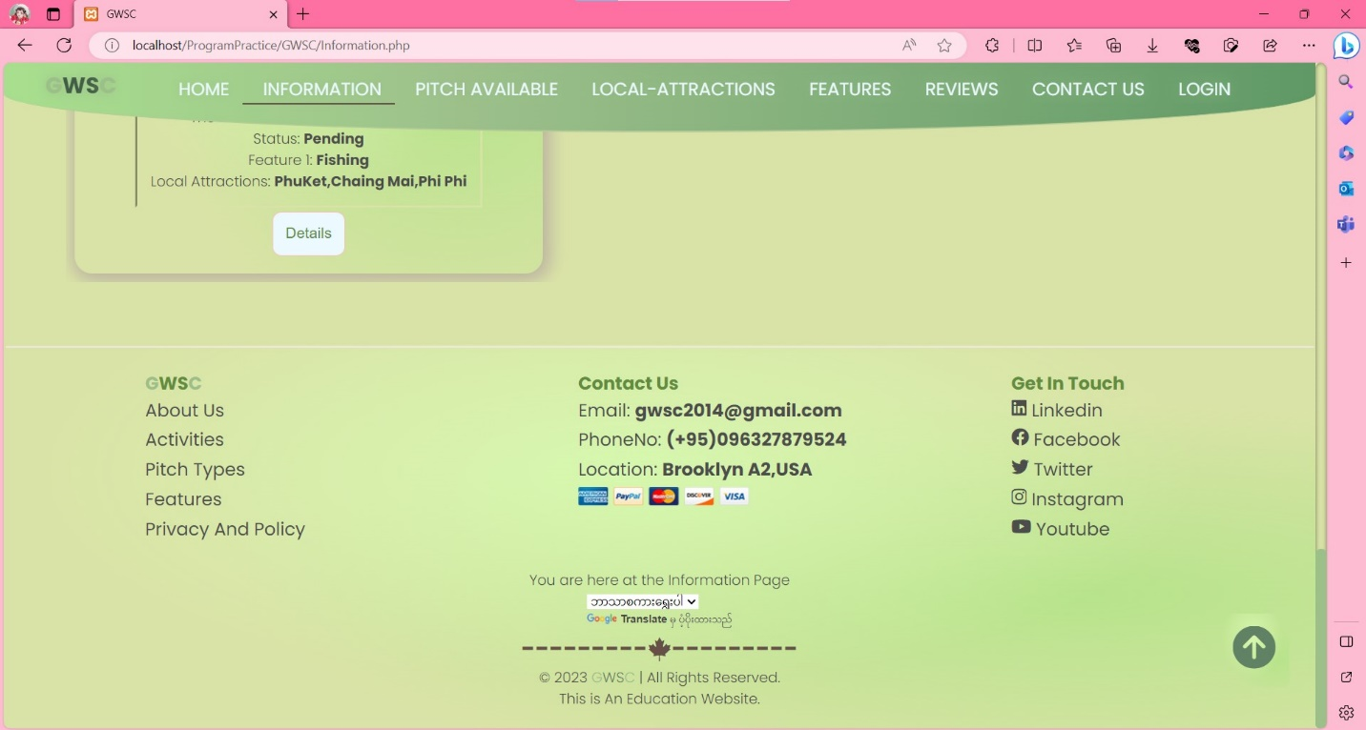

**Pitch Type and Availability**

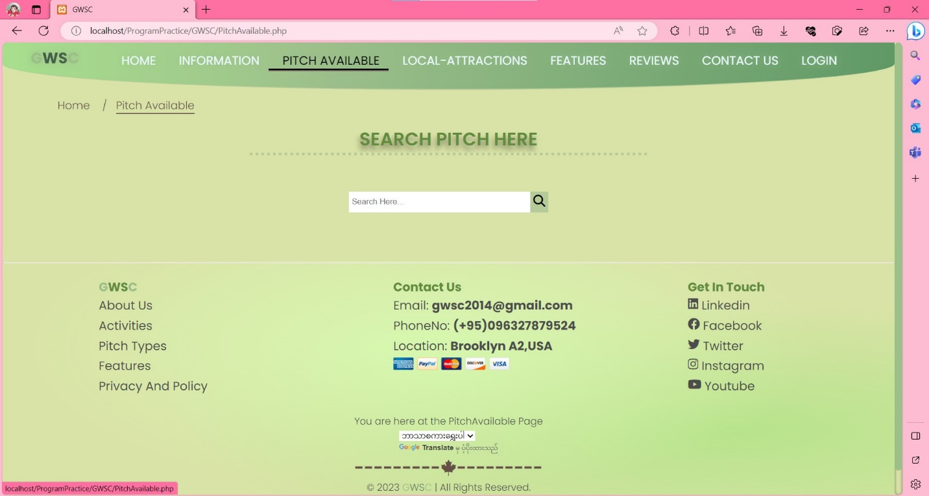

**Local-Attractions**

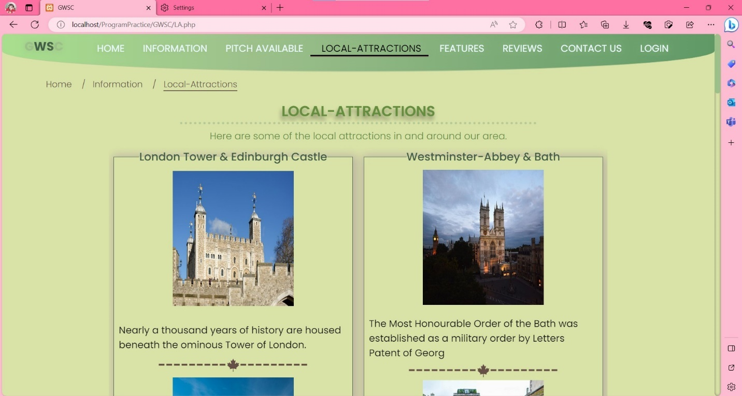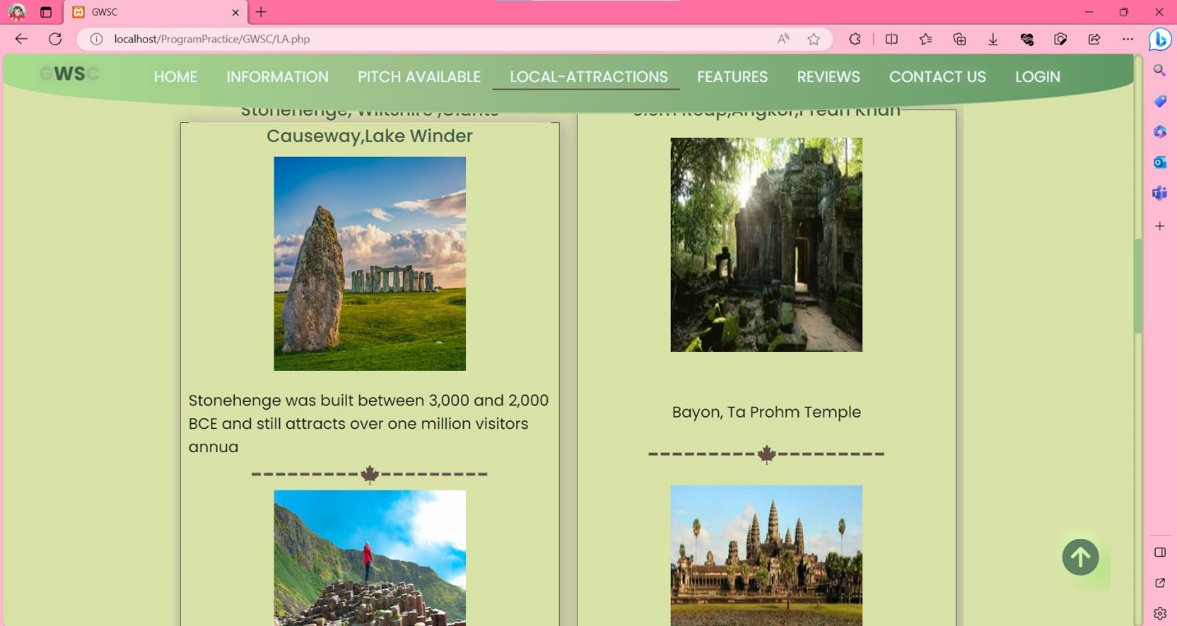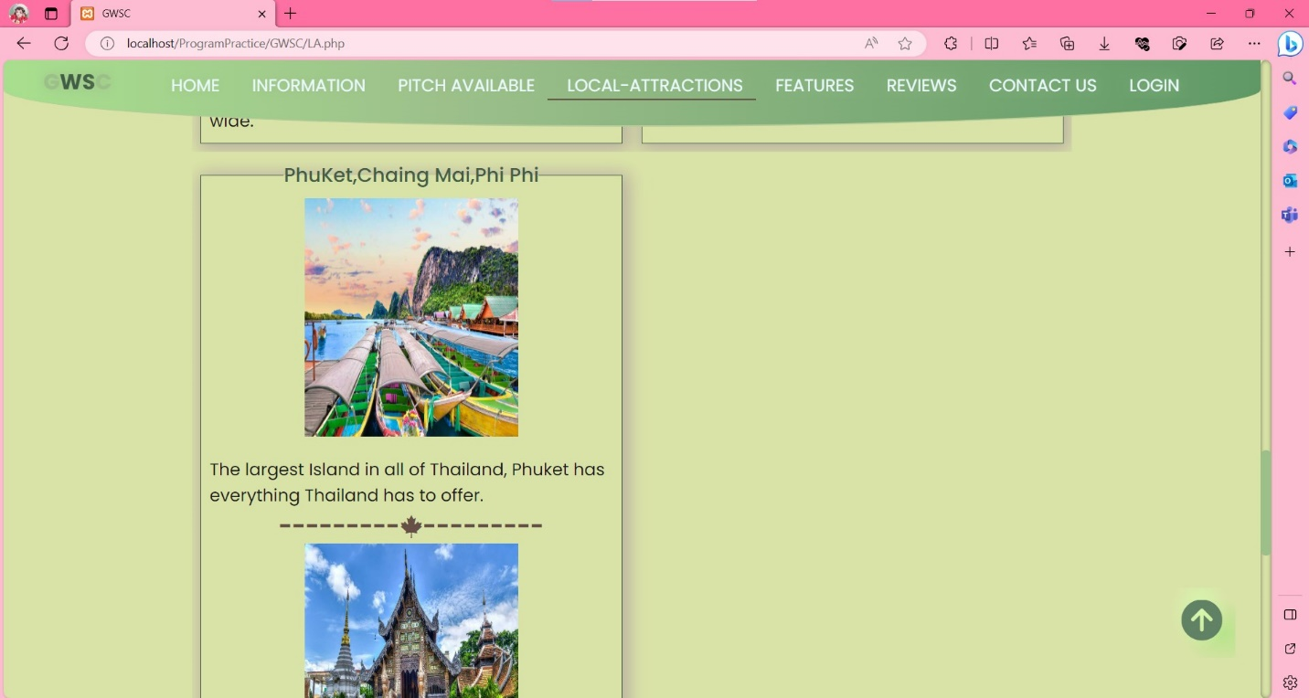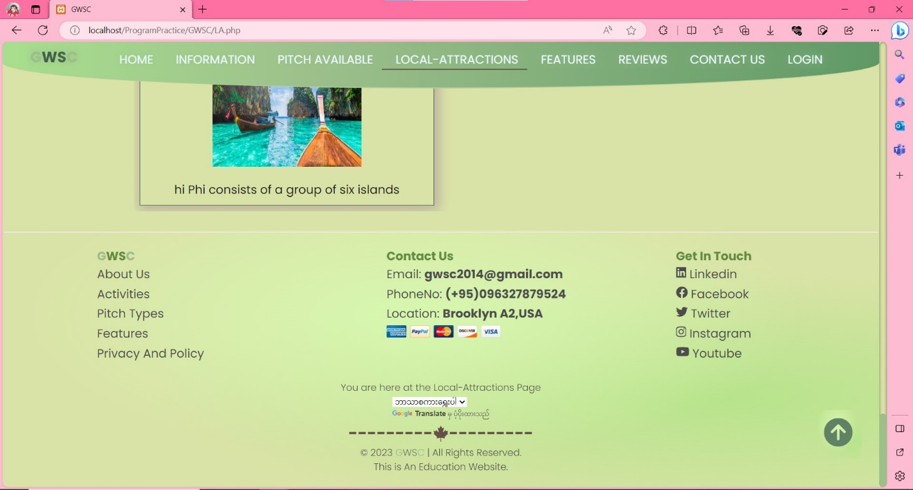

**Features**

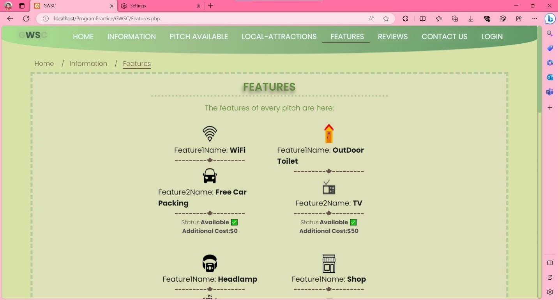

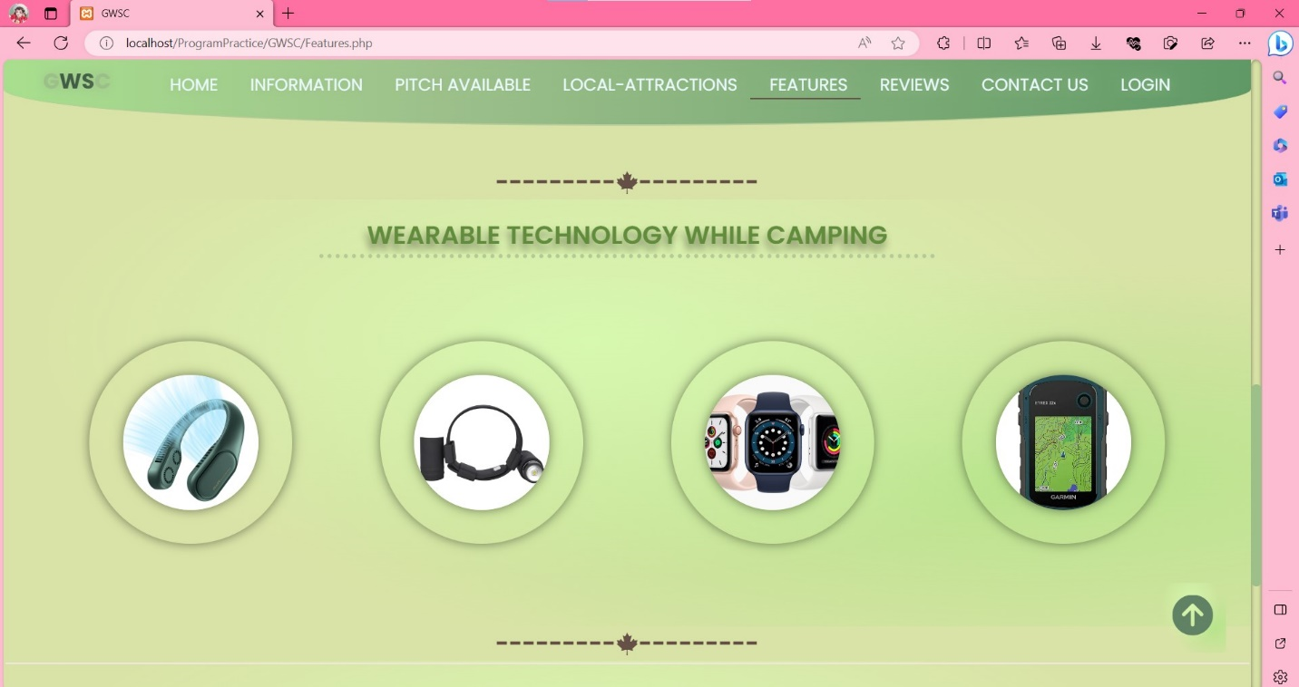

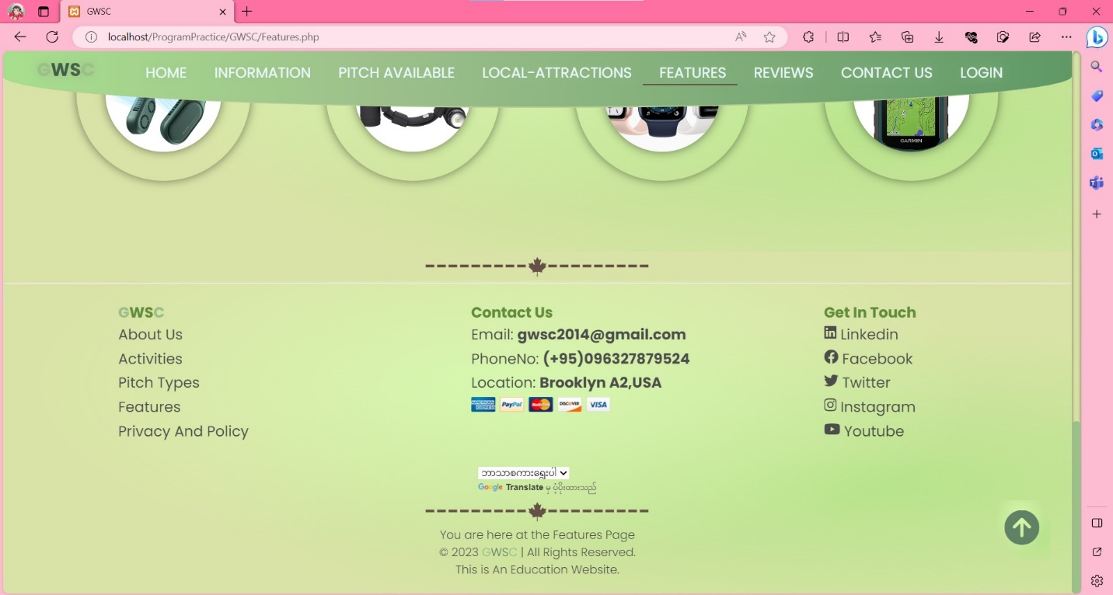

**Reviews**

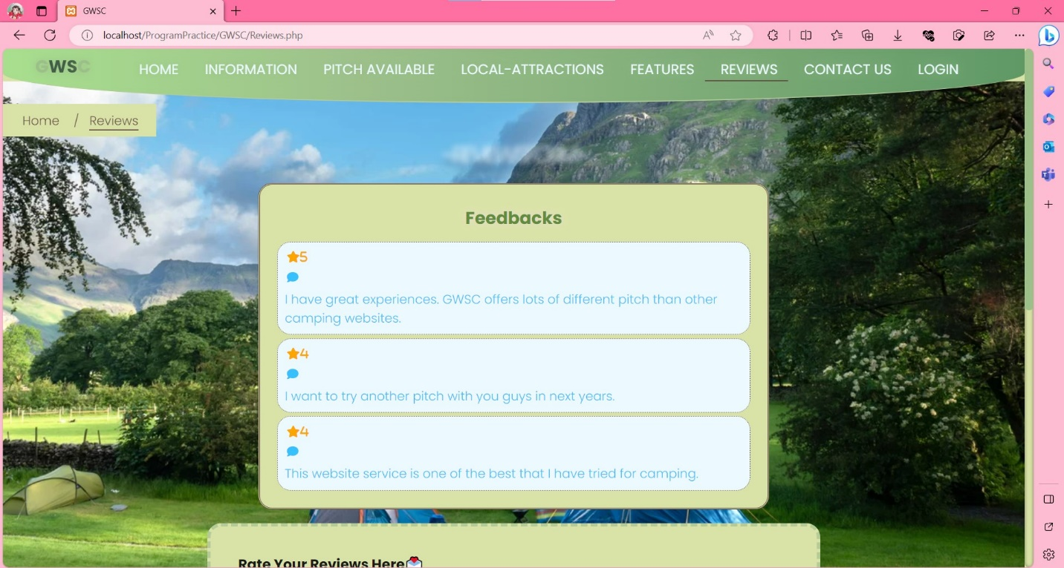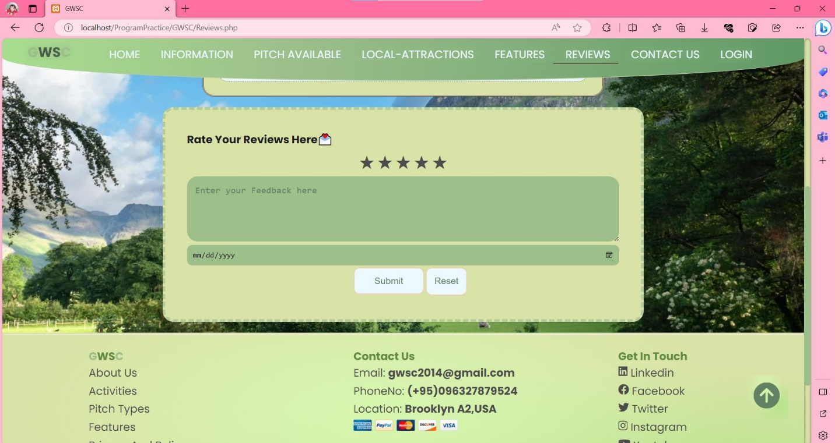

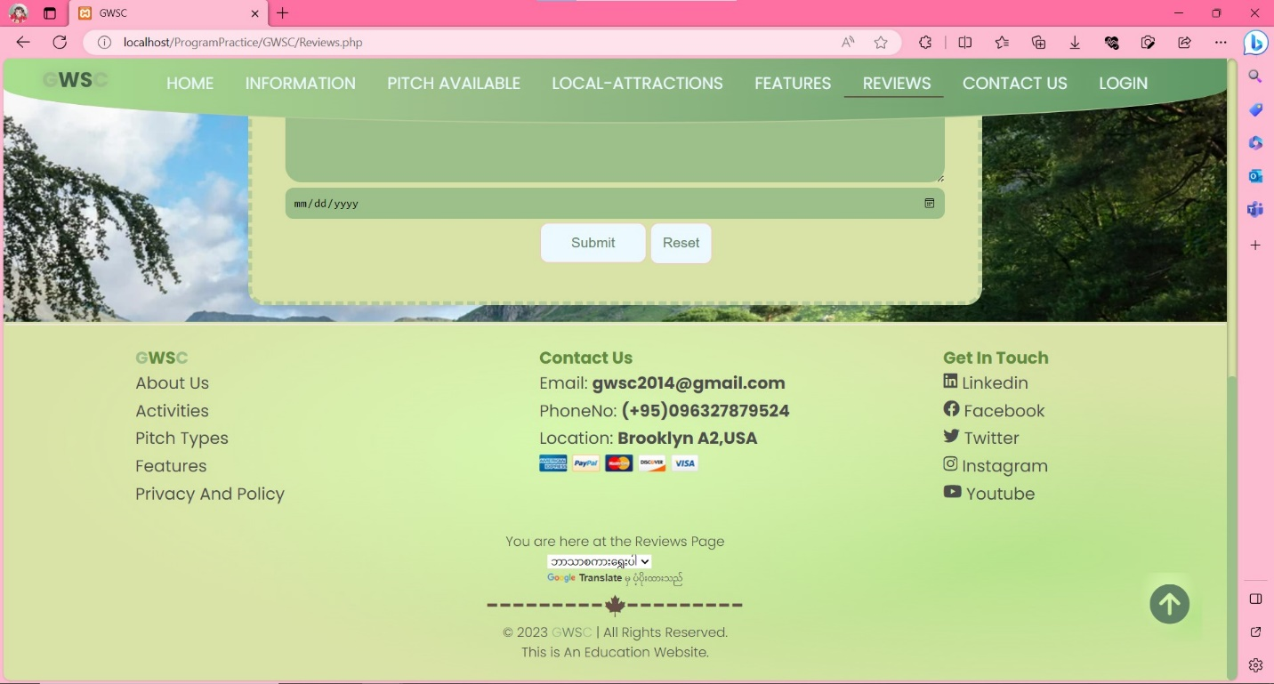

**Contact**

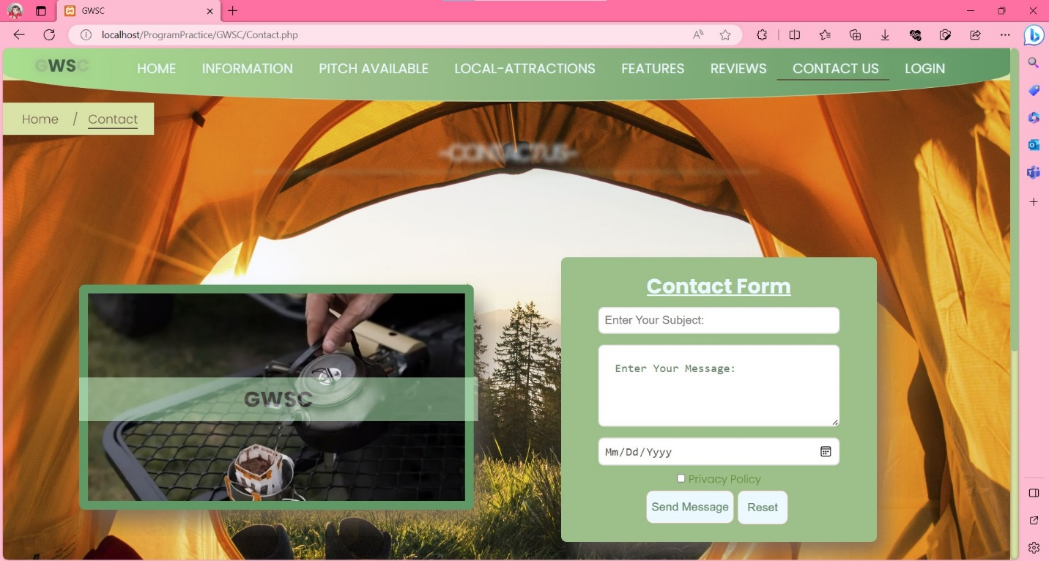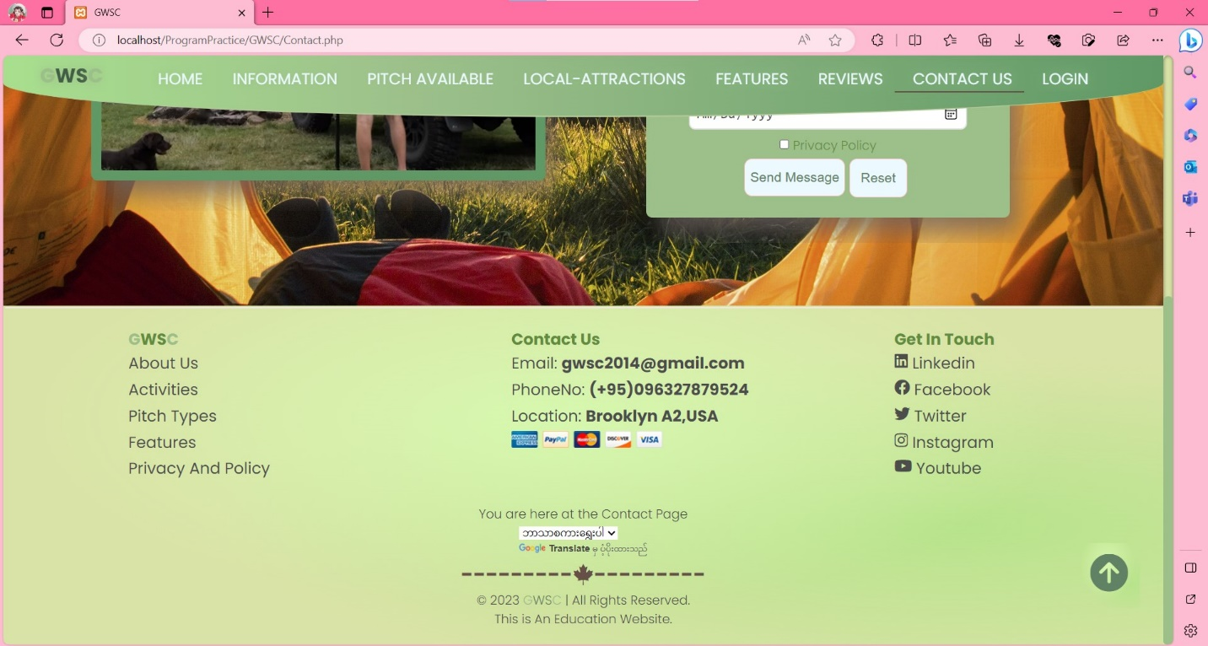

**Sign In**

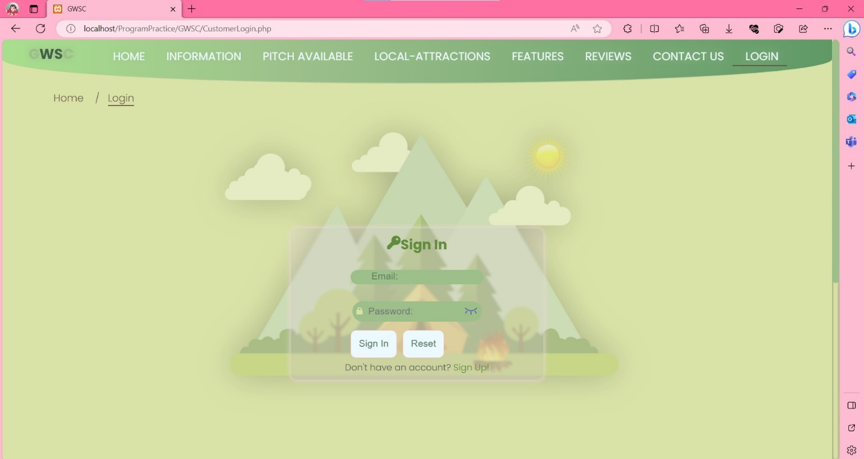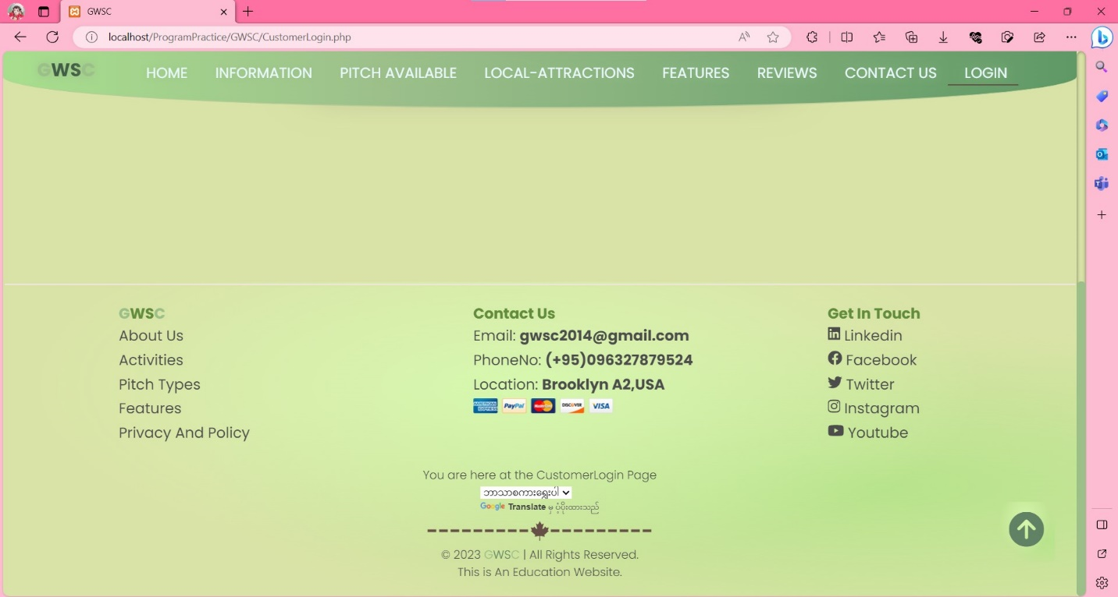

**Sign Up**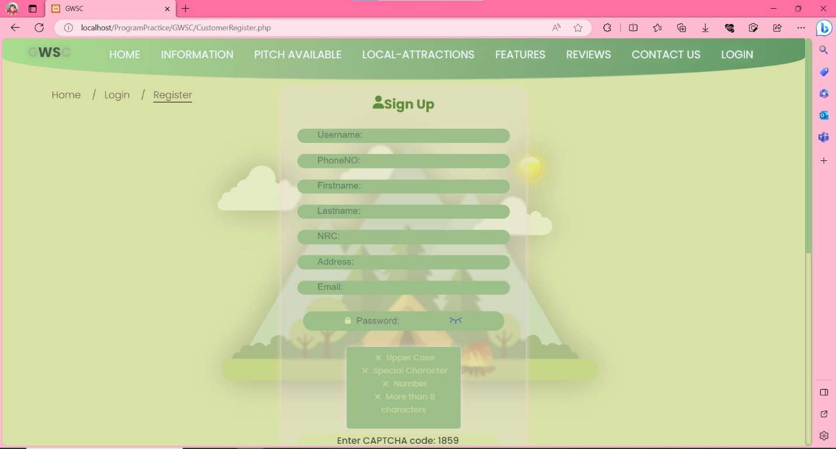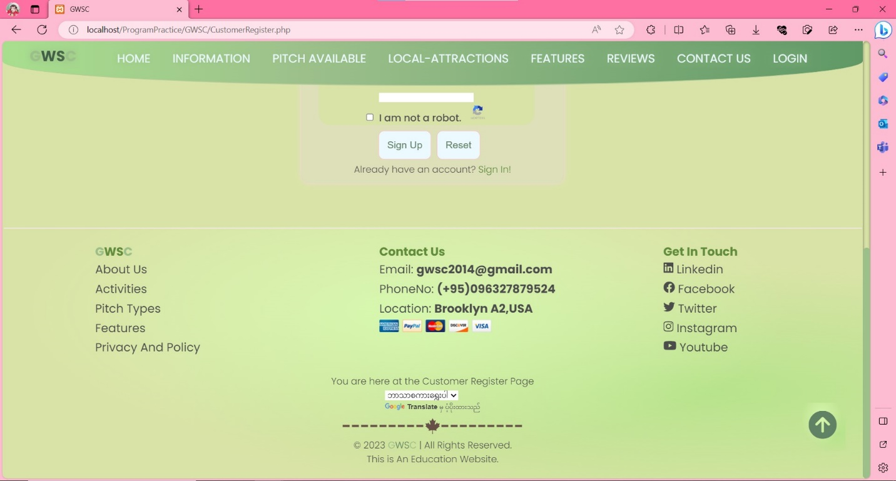

**Details**

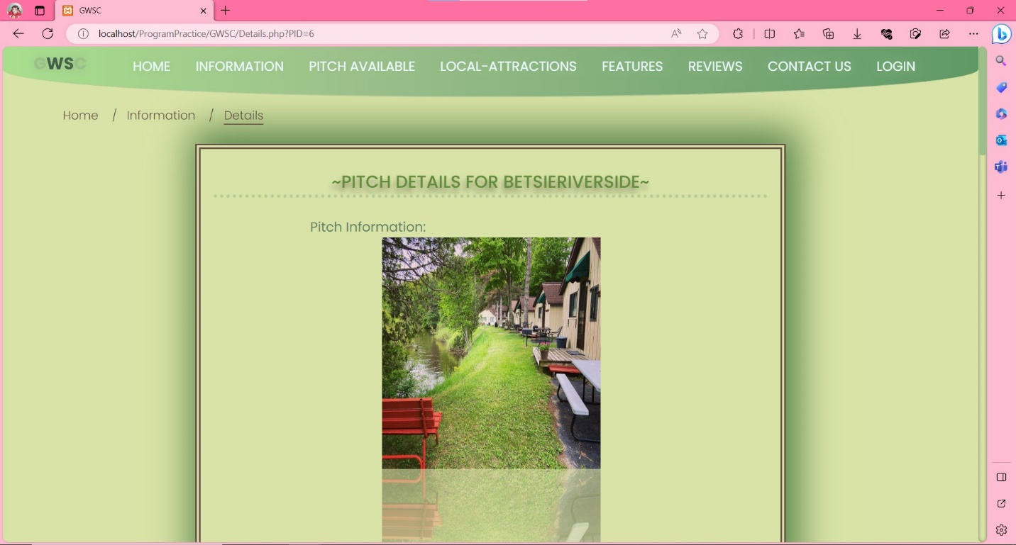

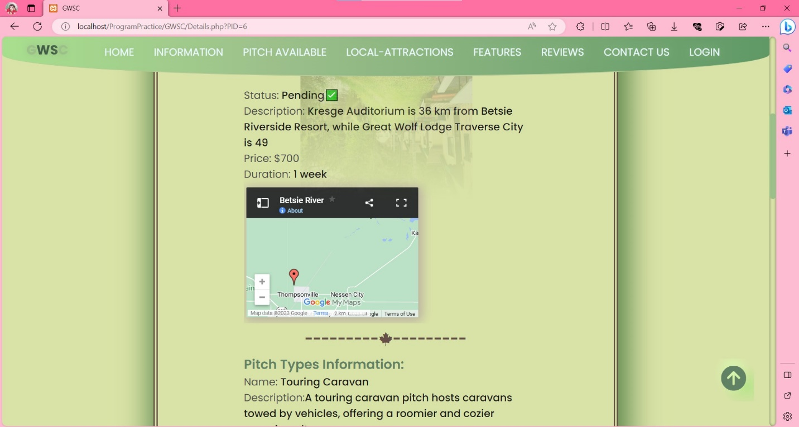

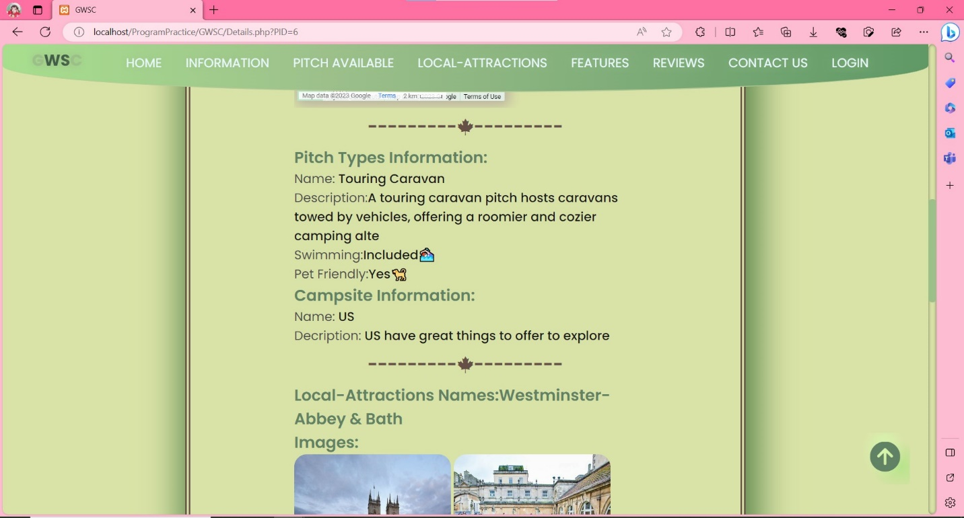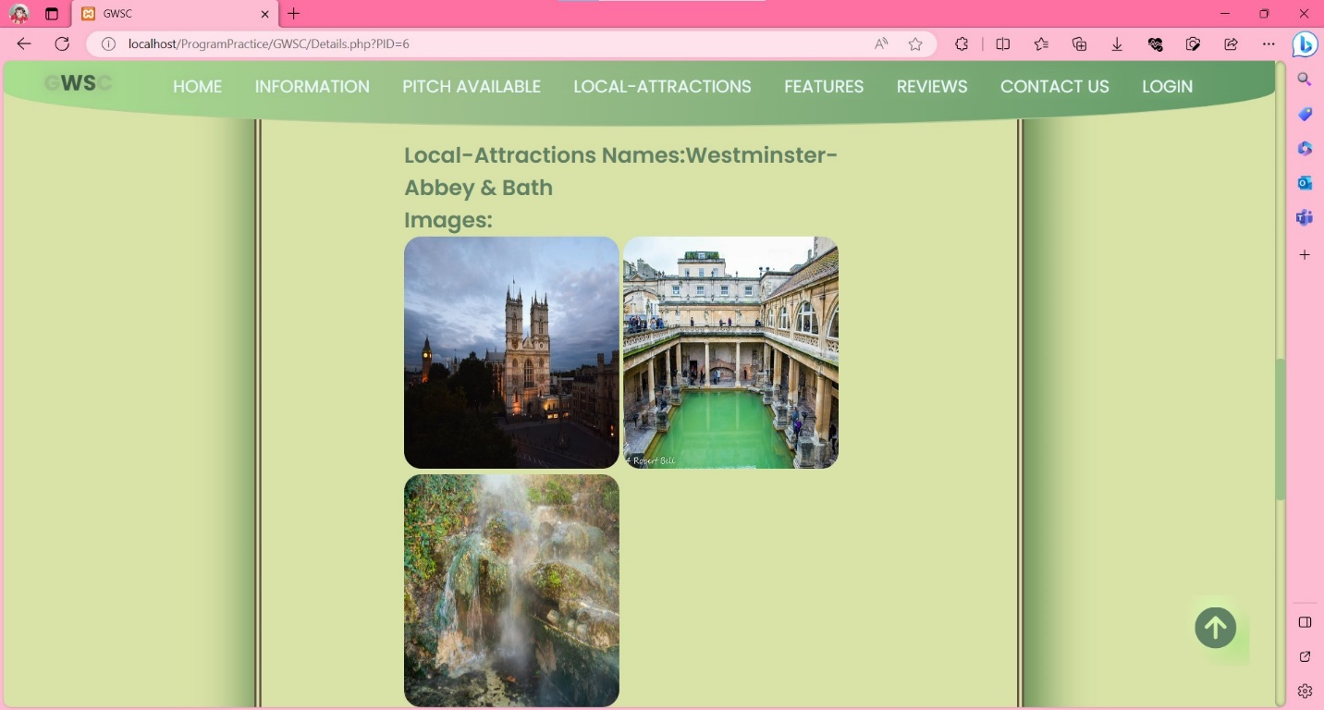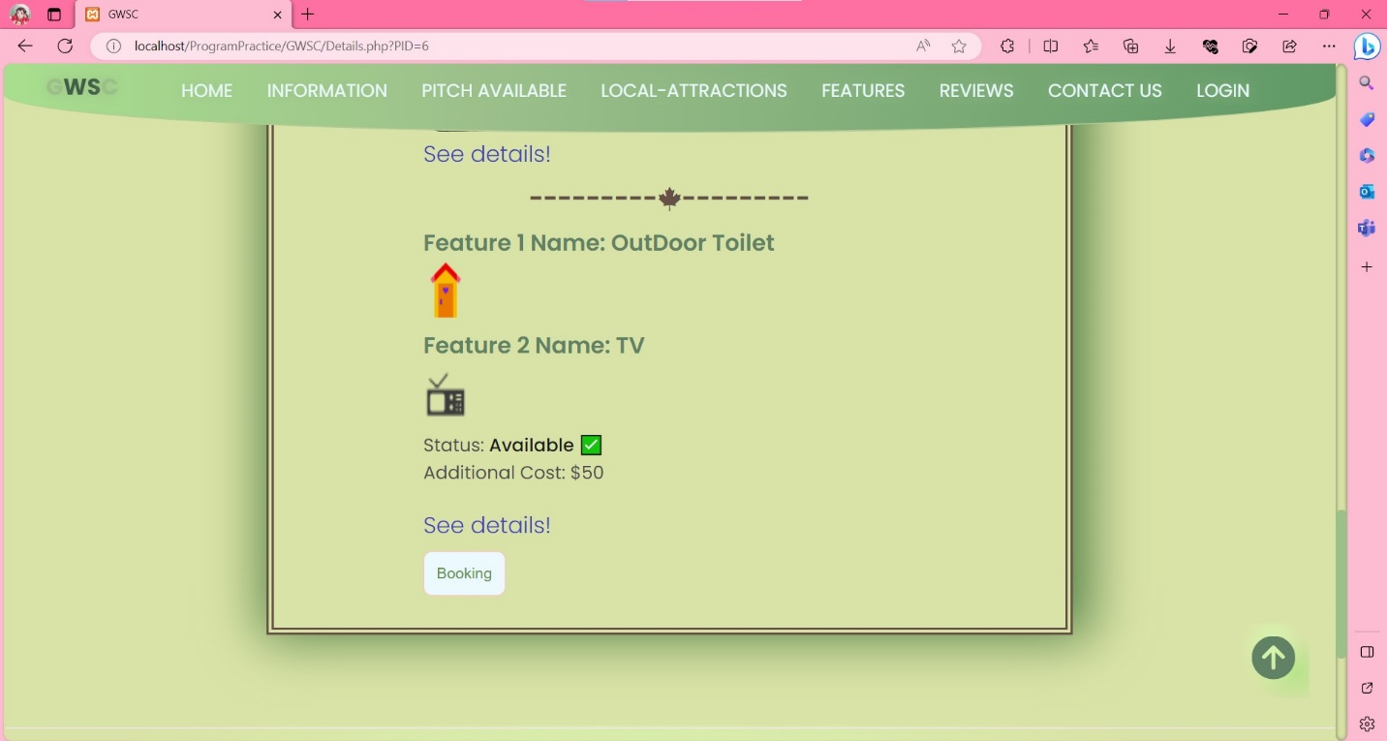

**Booking**

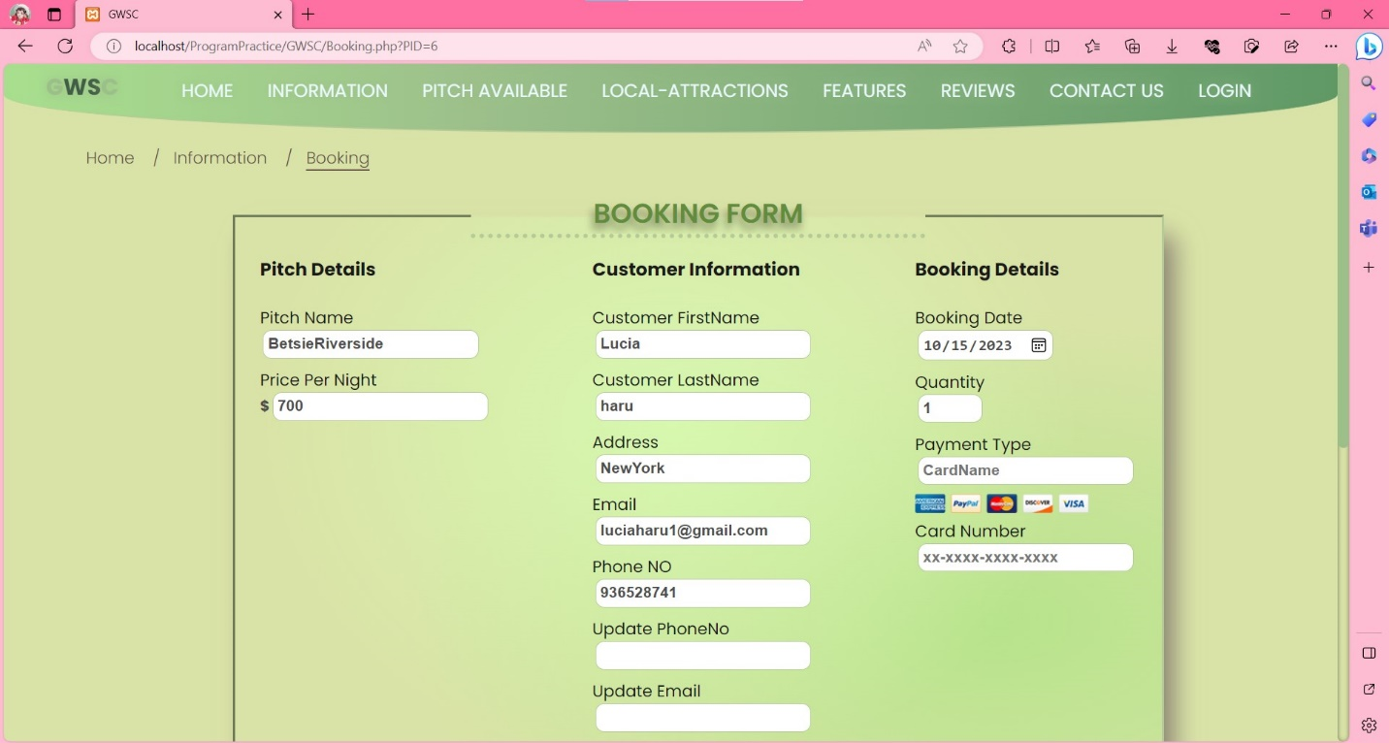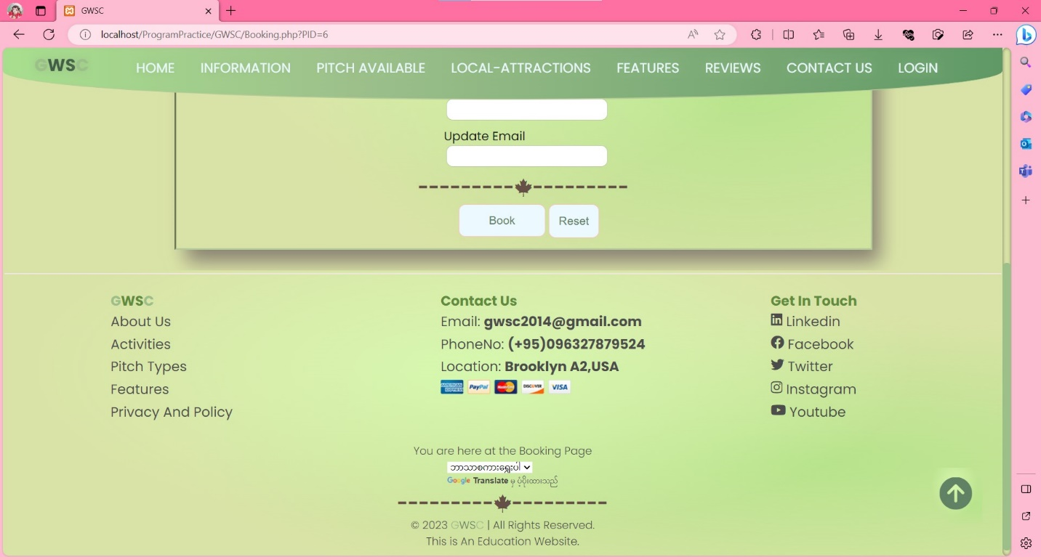

## Responsive Images and Text In GWSC

**Before**

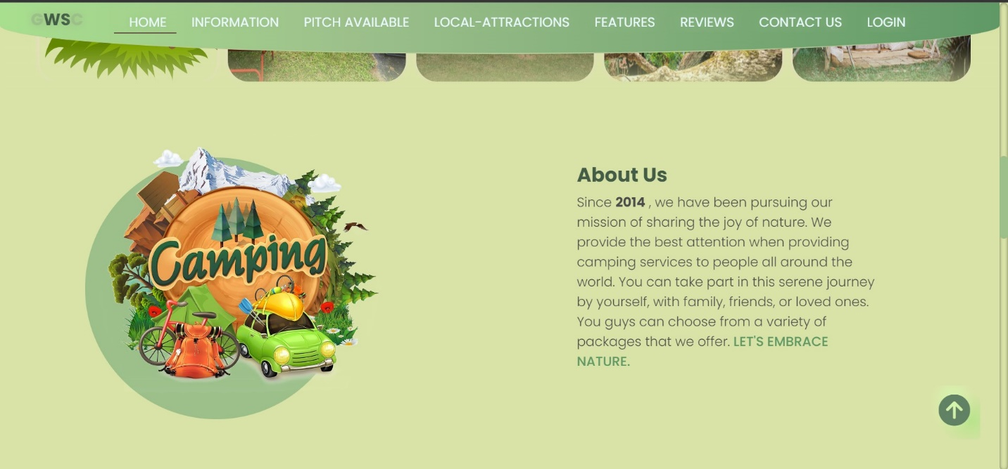

This is the image state on the Laptop screen size

On the laptop screen size, the font is 20px and on the mobile screen size

**After**

The image are responsive and change width according to its mobile view size.

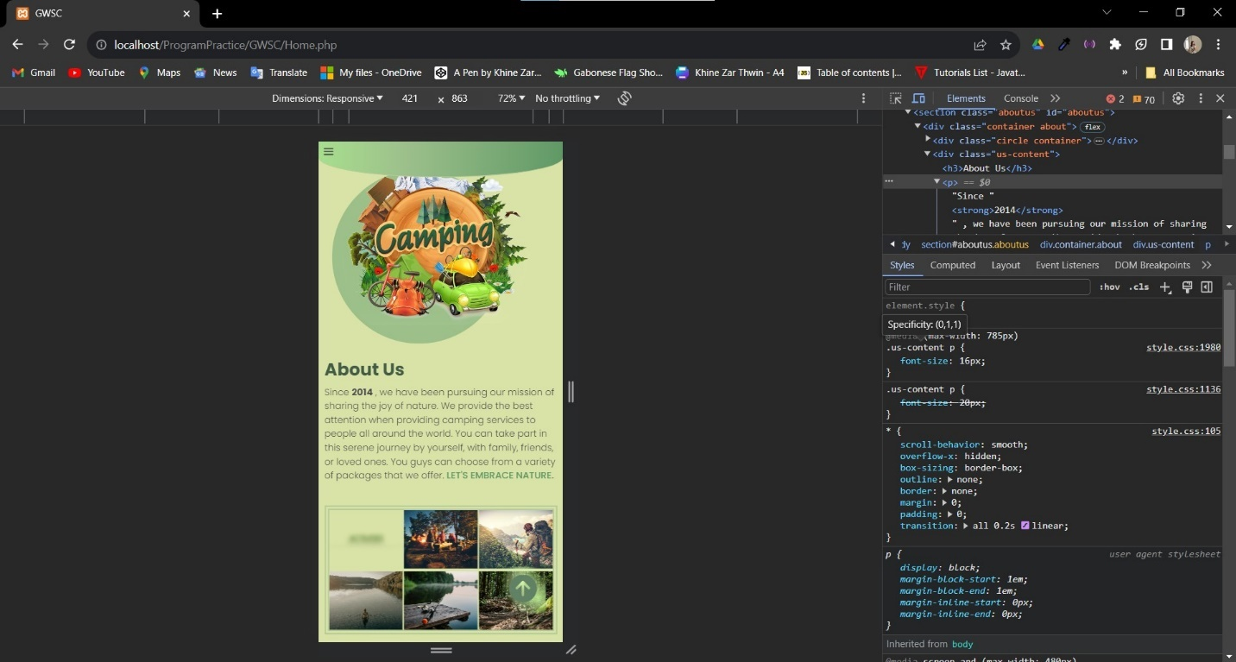

On the mobile screen size, the content font size are smaller to 16px.

### Search Bar

**Search bar in Home Page**

**Before**

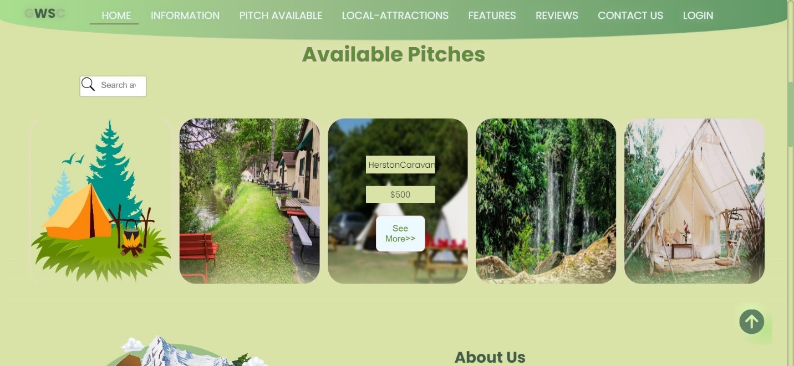

**After**

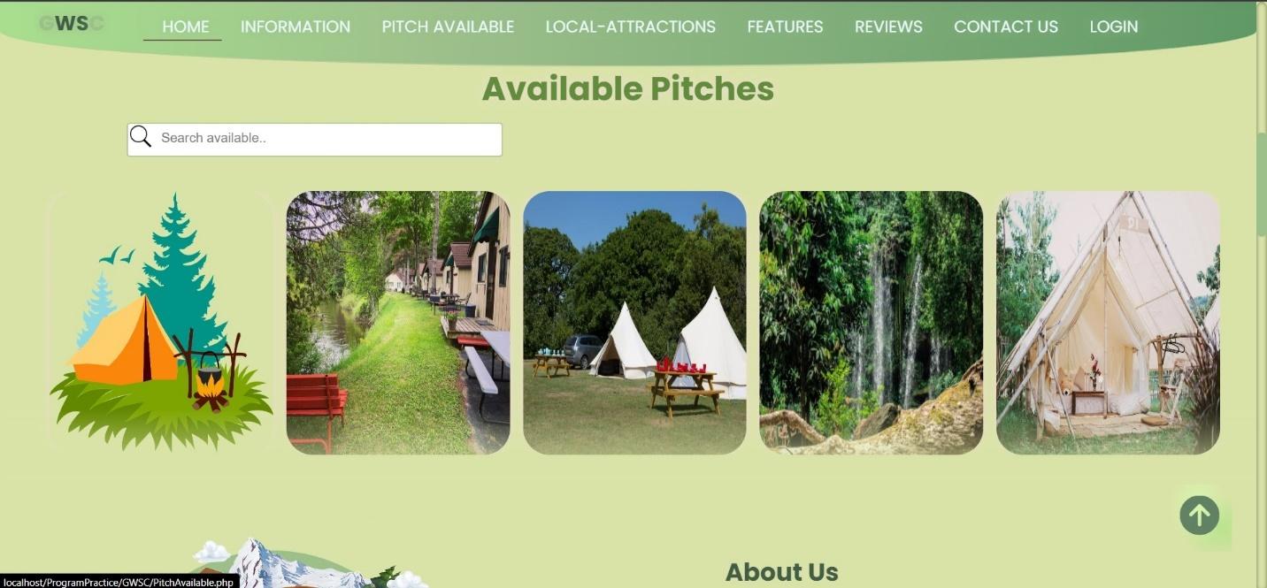

When the user hover on the search bar, its width will be changed

**Search bar in Pitch Type and Availability**

**Before**

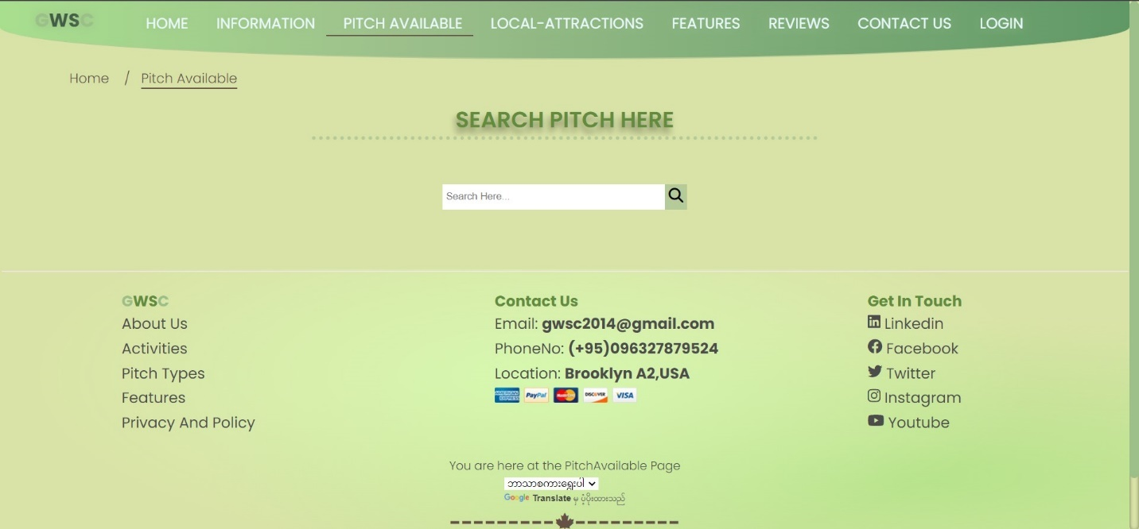

**After**

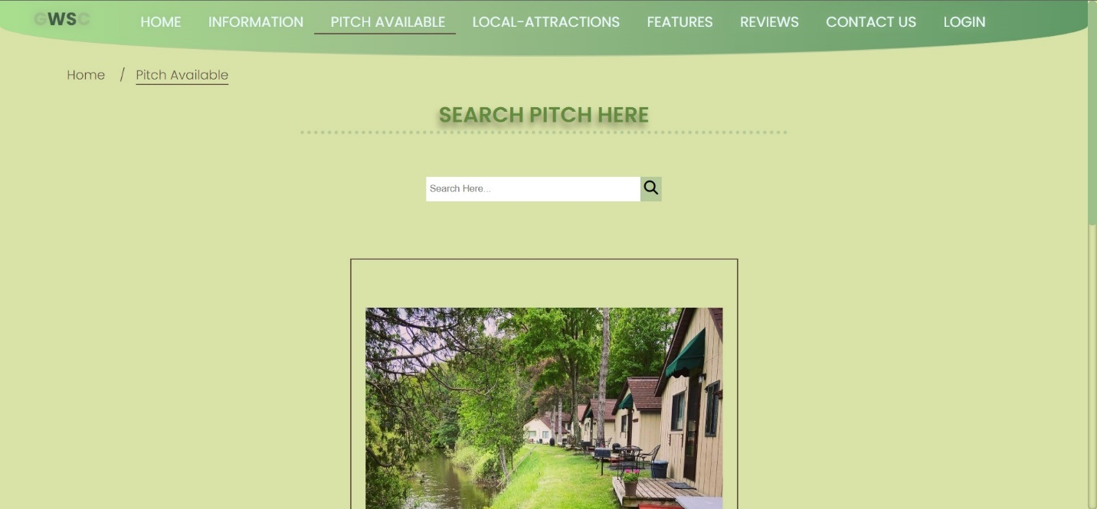

After entering the name of the pitch, the result will appear.

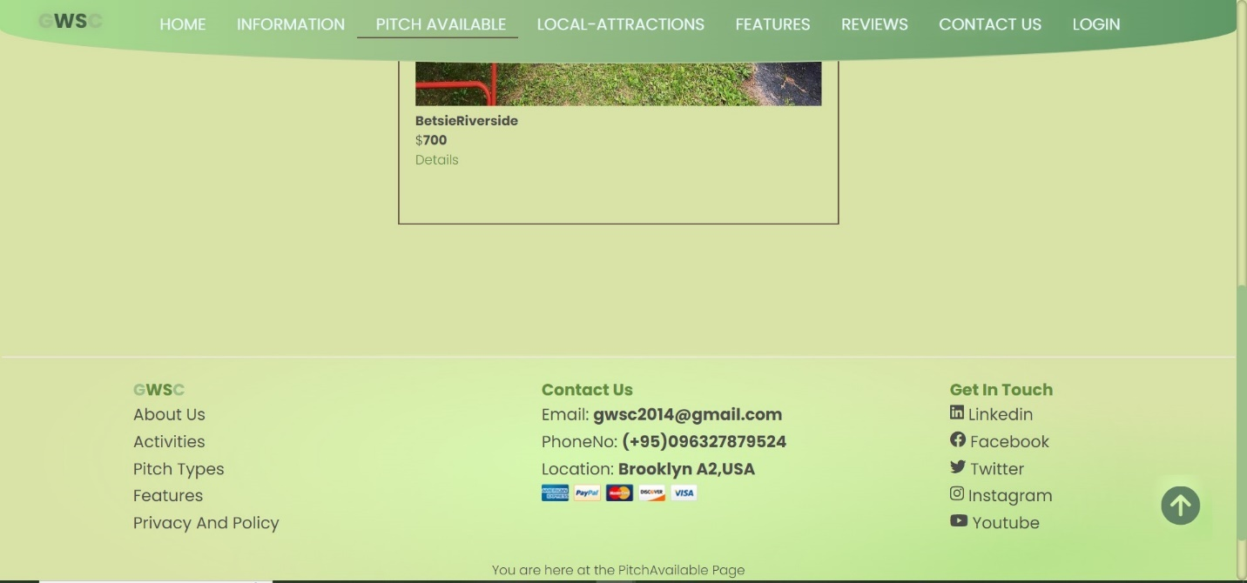

### Location Maps

Home

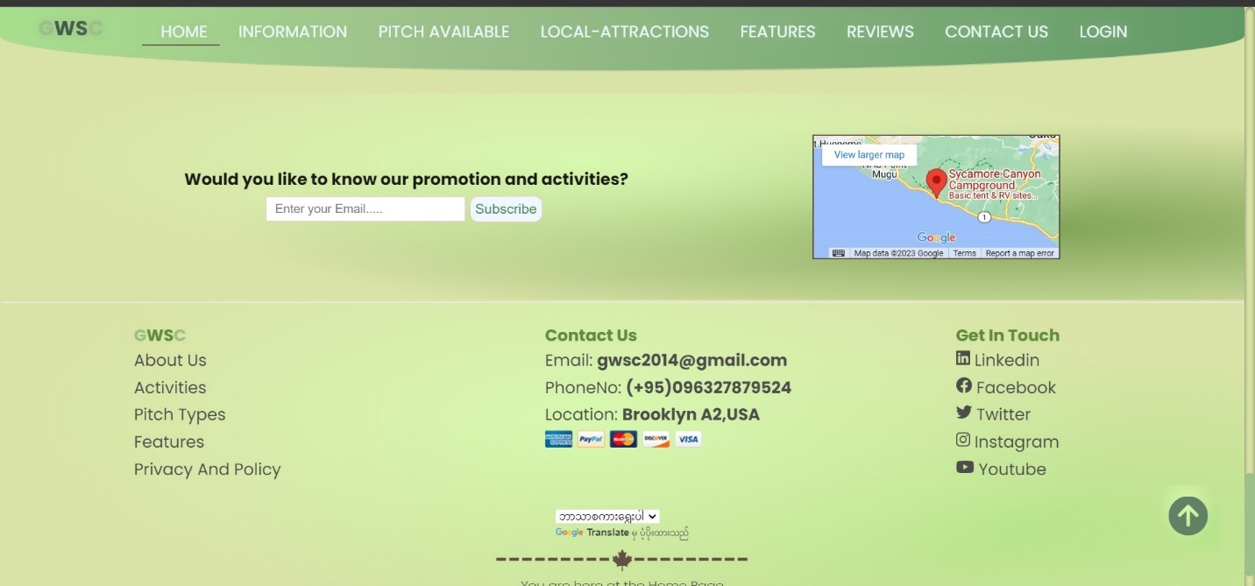

Information

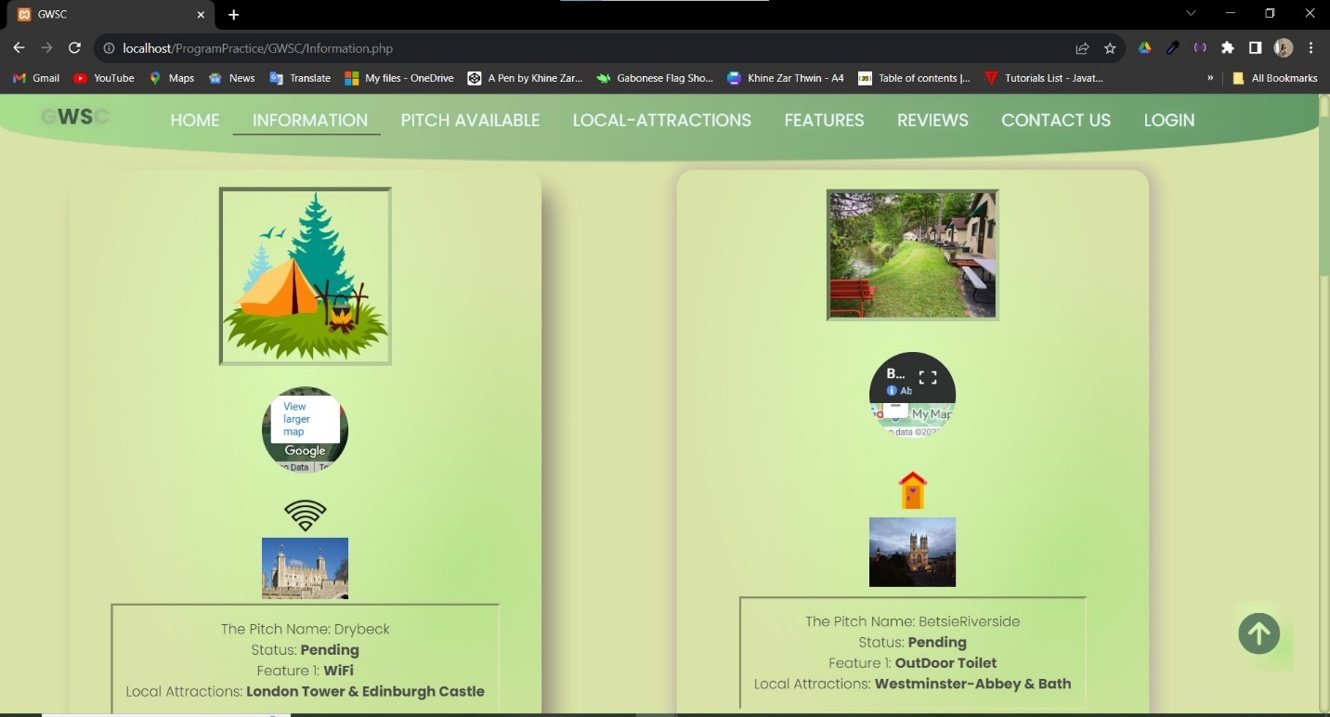

Details

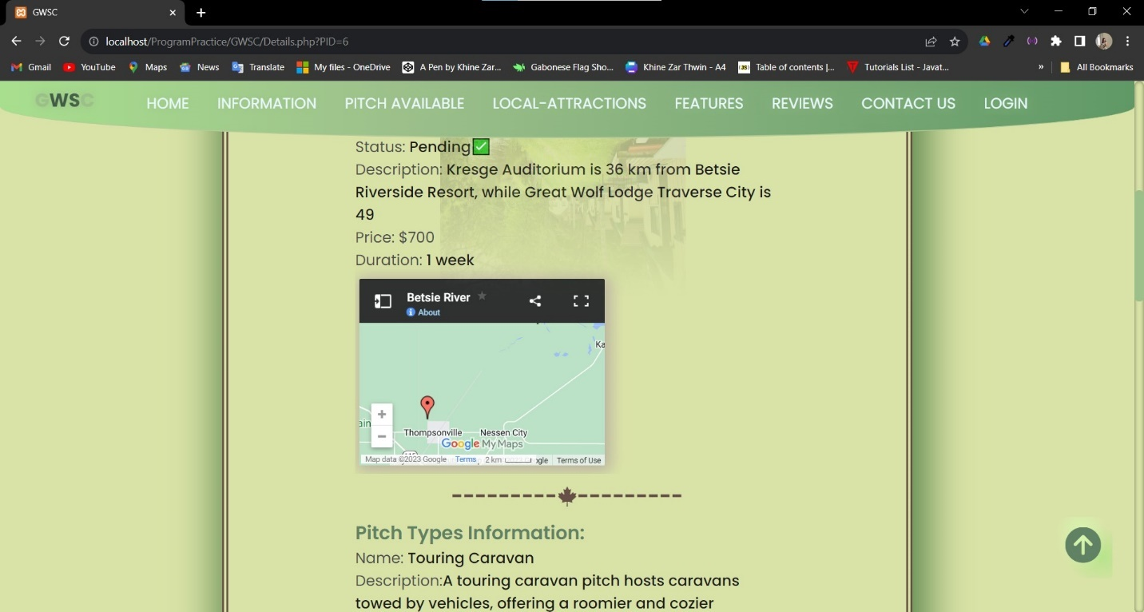

### Slide Show

Slide Show Part 1

In the banner slide show, it is also including the function of slider too. The slide will change to another slide every 6 second. This function was built with Java Script. When the slide changes, not only the pictures and content are changed but also background color of the slide will change too.

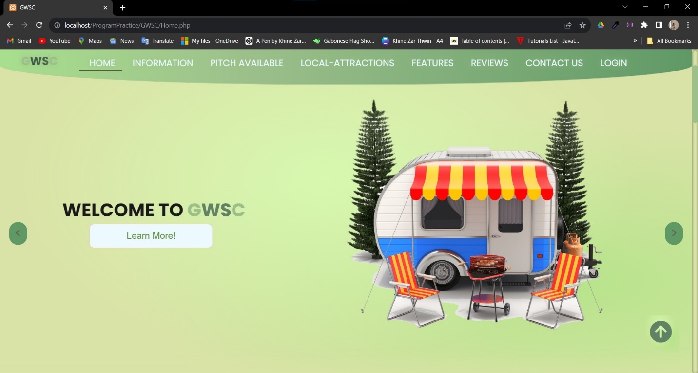

When the user click this button, it will lead to About Us section on the Home page

The next button and prev button will work for slider function

2nd Slide of slide show

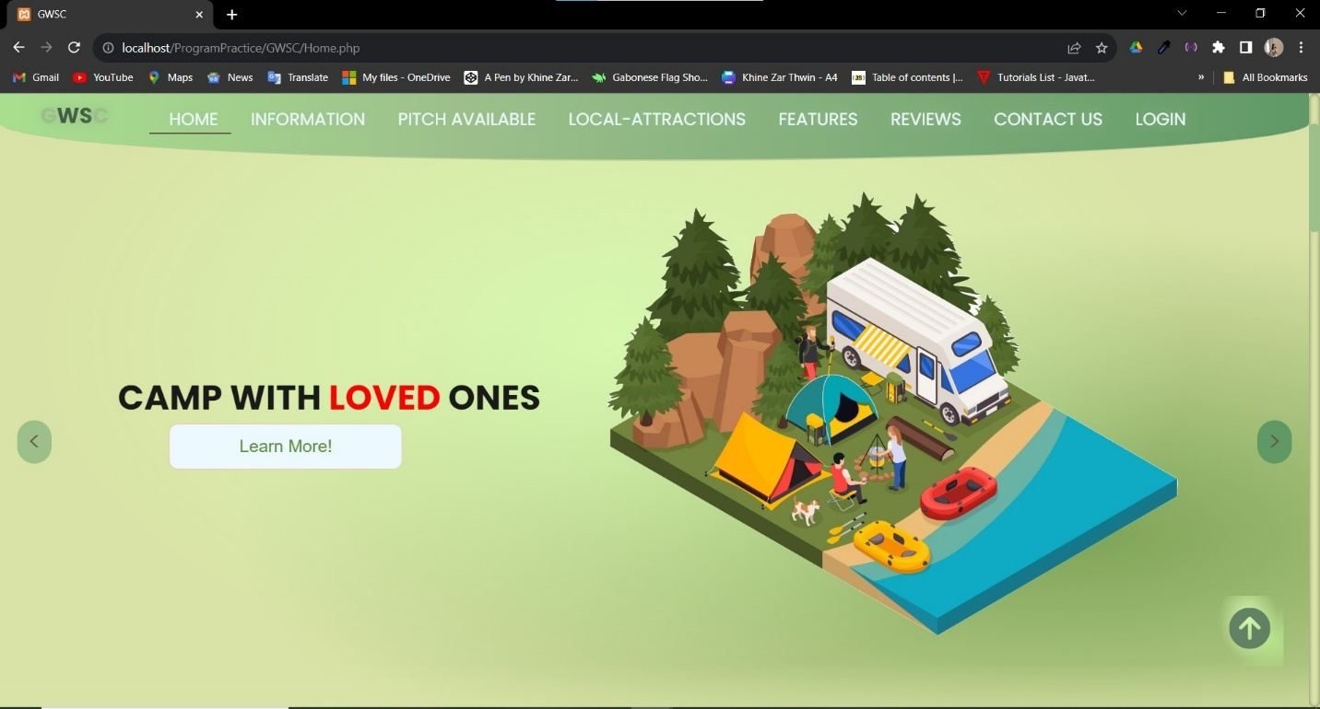

3rd Slide of slide show

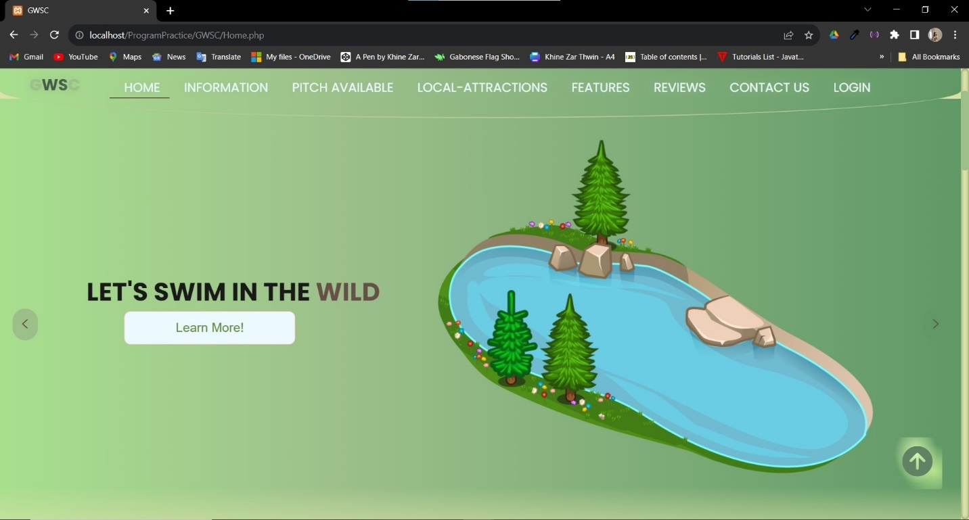

4th Slide of slide show

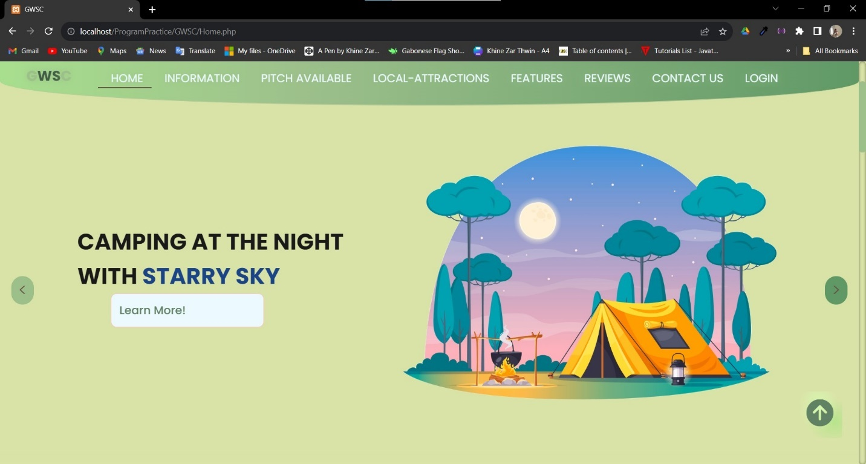

### Interactive Navigation Bar



This is the animation effect when user hover on menu

This is the active page sign

This is the view numbers of login user.This will only show when the user log in

### Number of Views Counter

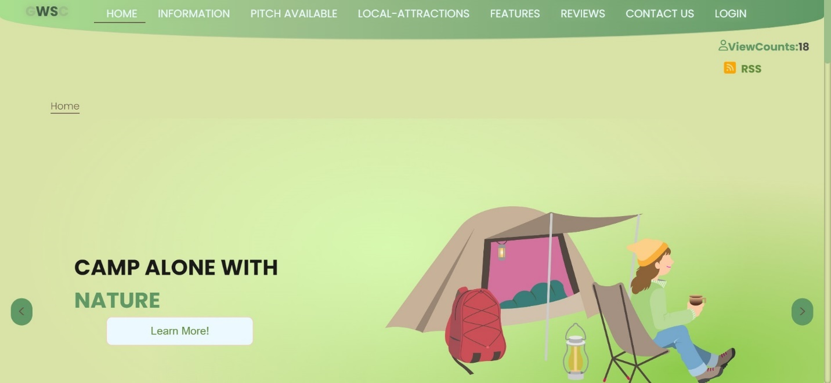

### Footer

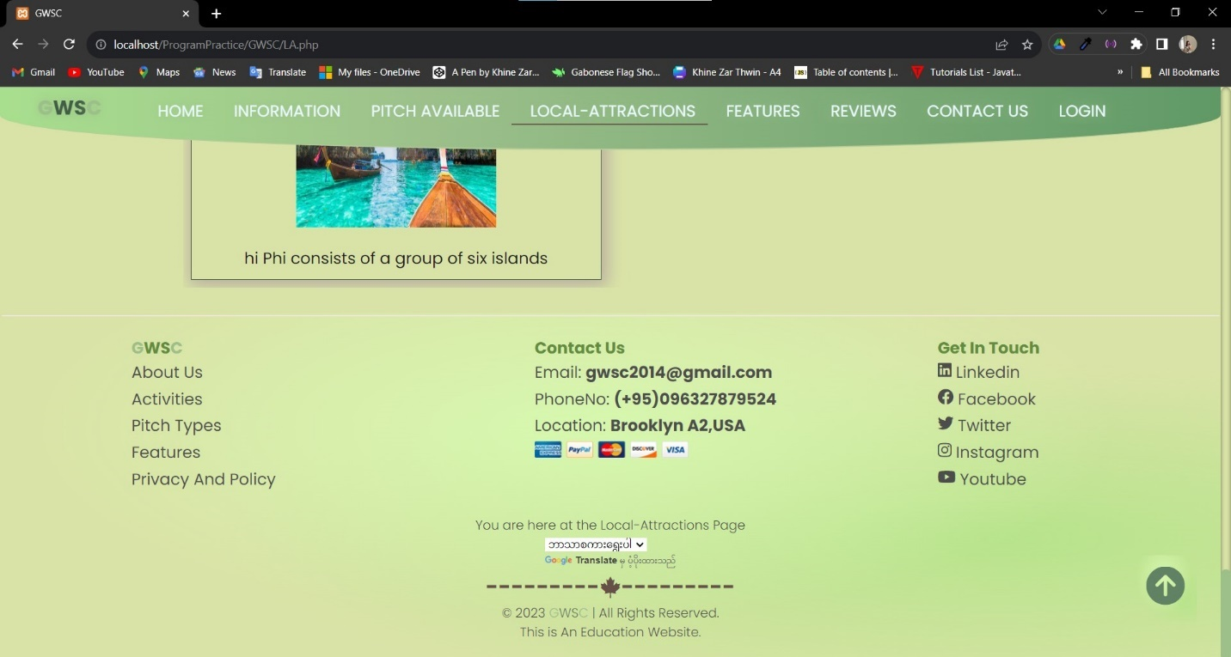

Social Icons

The footer section show the which page the user at and Copy rights

### Relevant Text and Images all across all pages

Home

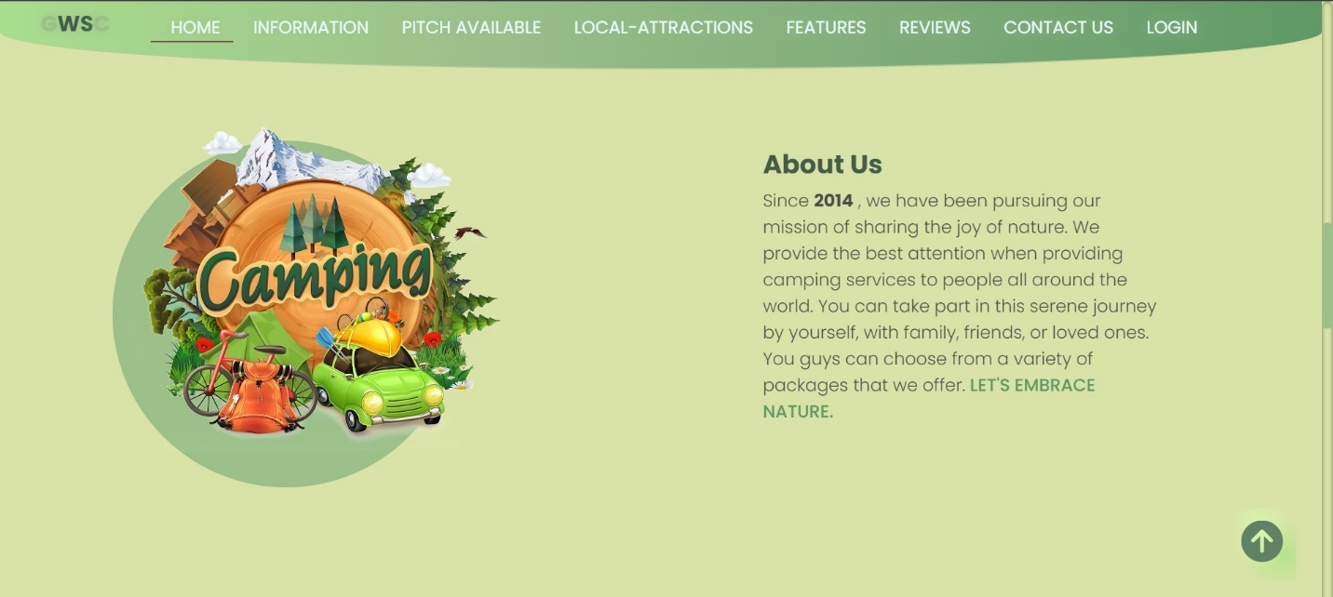

Information

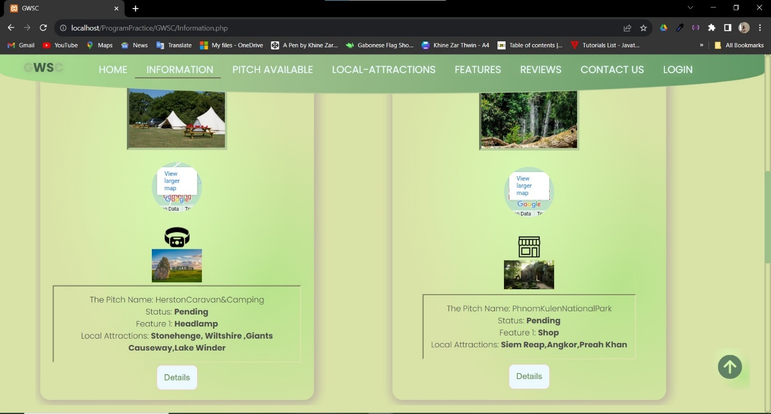

Details

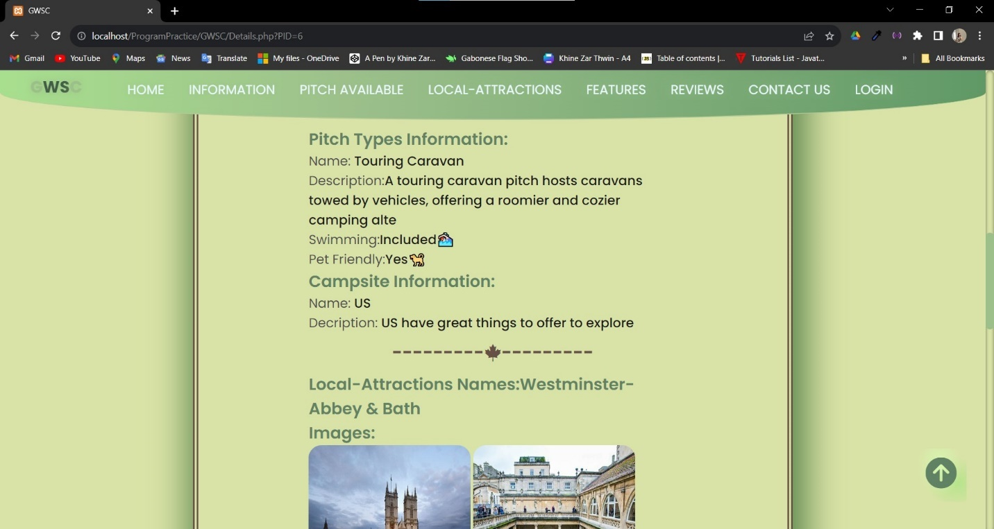

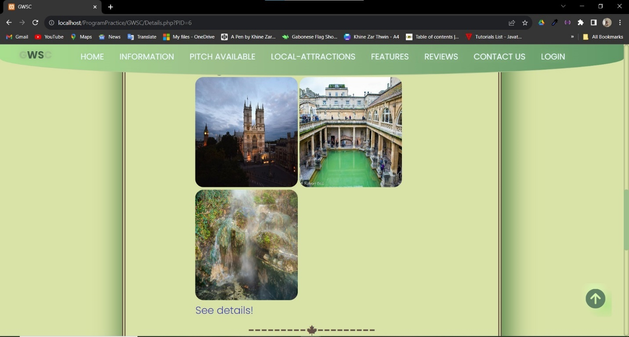

Local-Attractions



Features



Reviews

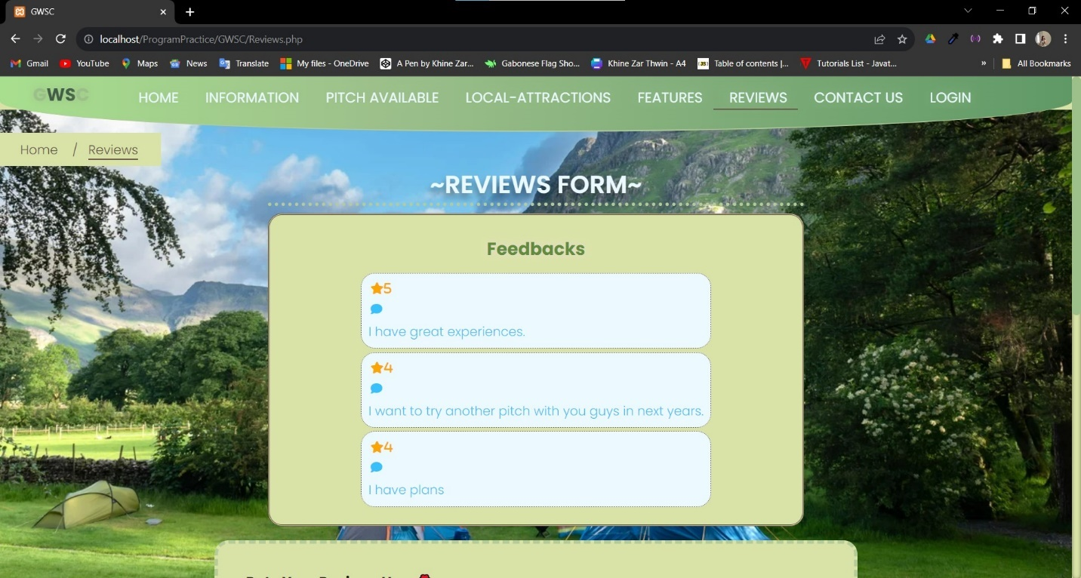

Background Image

### Contact form (required Login)

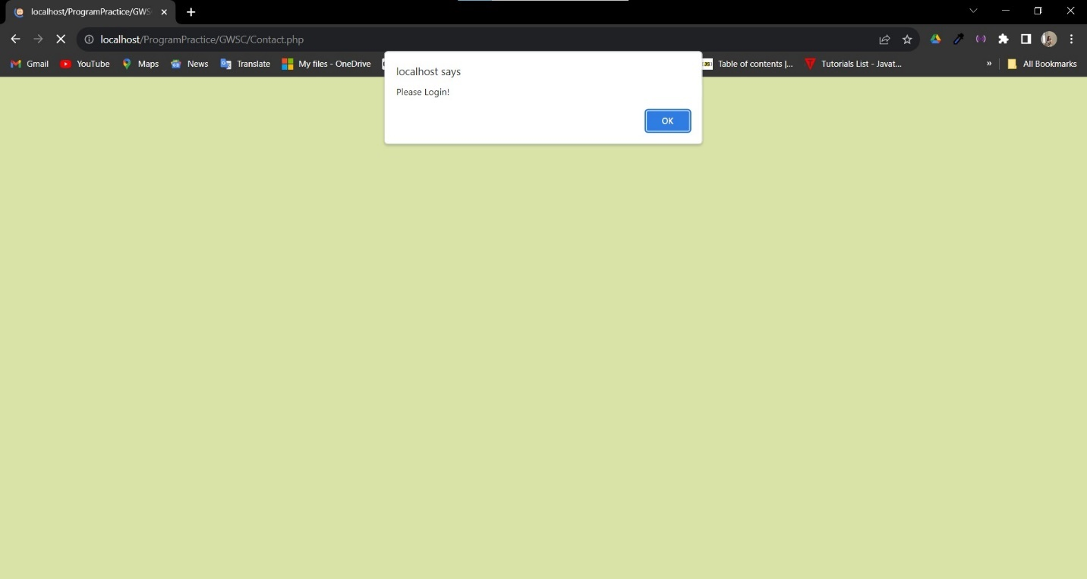

If the customer try to open the contact form without Log in to their accounts, they will be redirected to Log In form.To send a contact form, customers need to login to their account

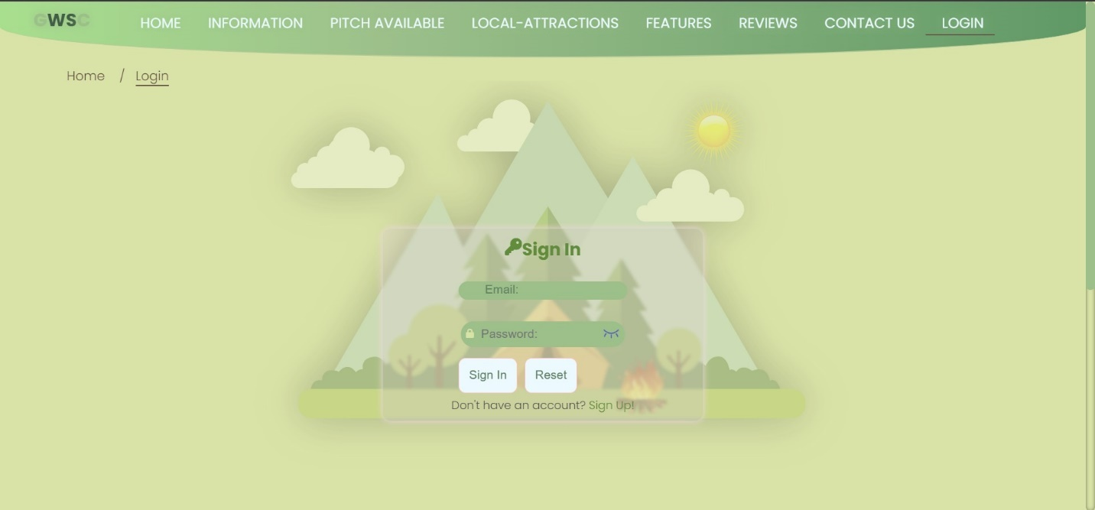

Sign In Page

### RSS

Link to Rss Feed



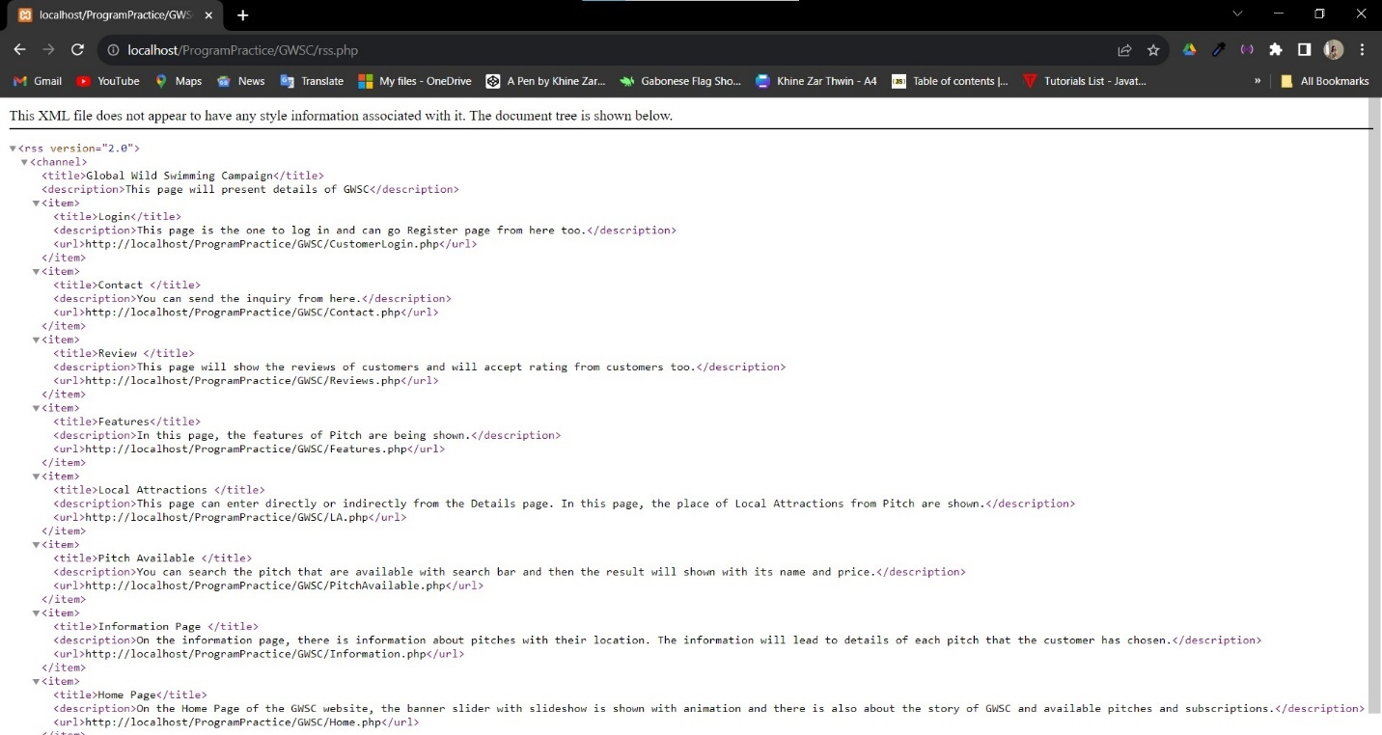

In this page, there are description of each pages

### Contact Us form including Privacy and Policy



Lead to Privacy page



**Policy Page**





### Wearable Technology while Camping in Features Page

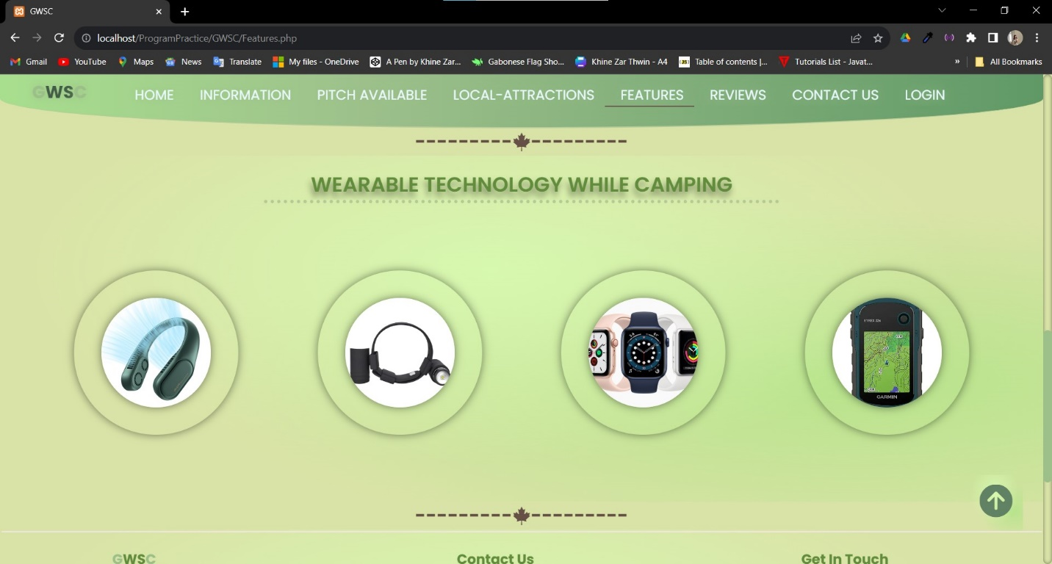

### Two of Web Services in GWSC

Embedded YouTube Video

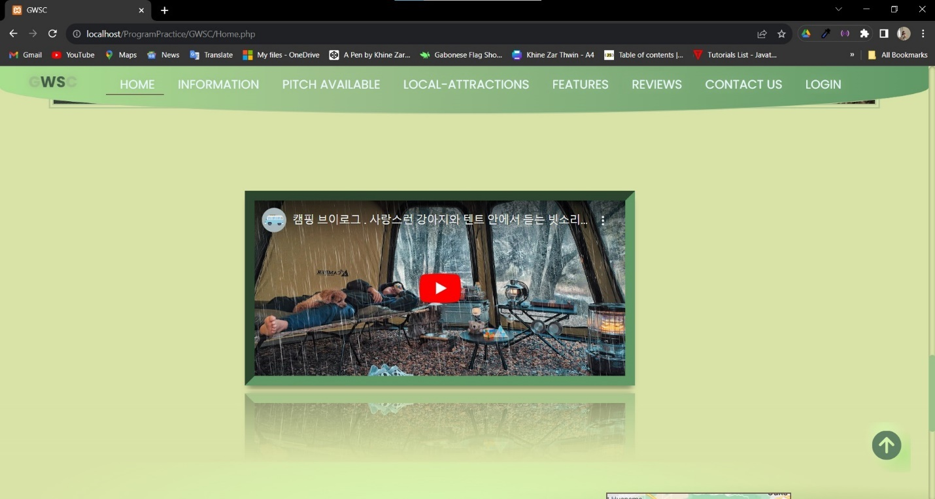

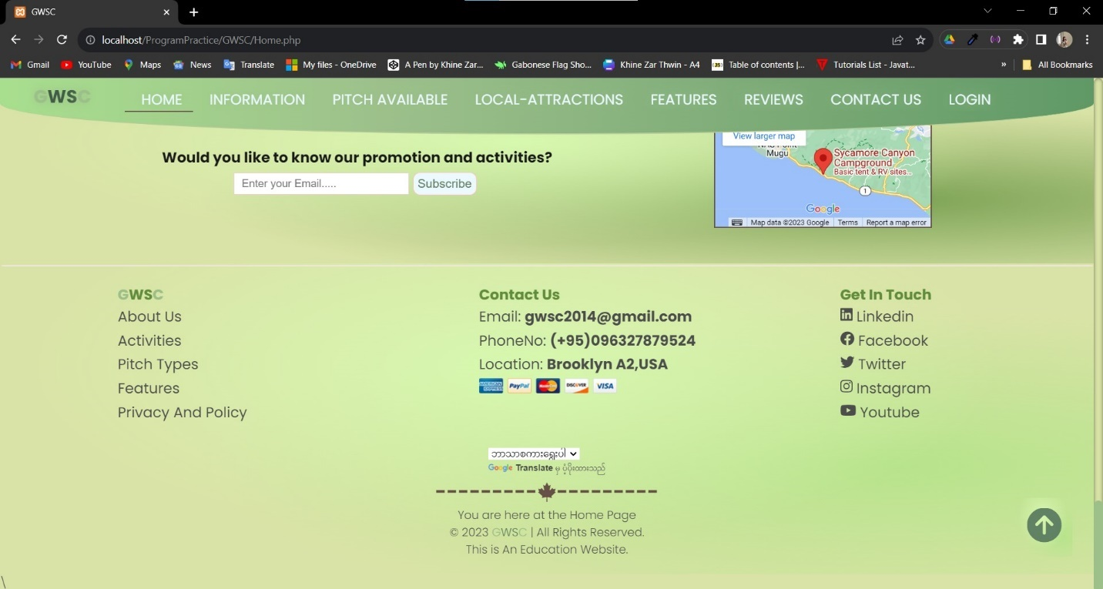

Google Translate tool for convenience for different users

Task 2

CSS and Database

# Task 2

## CSS

This is the CSS external files that is created for designing the UI and UX of GWSC web pages. First, the box model is used in this GWSC website to lay out the webpage CSS layout. Subsequently, padding and margin are redesigned to basic specifications. Additionally, CSS variables are used to hold data that is required to be used repeatedly across the whole CSS style. The web pages that GWSC wants are laid out using layout models like Grid and Flex style. It is also convenient to arrange the interface more efficiently by doing this. Position, width, and height are the primary styling parameters for the elements. GWSC uses box-shadow and text-shadow to style its interface. The interaction between the user and the web surface is primarily displayed through hover. To further enhance the interface's appearance, animation and transaction usages are included. In order to increase design and produce animation, the ::before and ::after are applied. Using Media Queries is crucial for being responsive to various screen sizes. There are two media queries used in this file: size(max-width 480px) and (max-width: 785px).

|  |
| --- |
| /* TOC  1. google fonts  2. variables  3. base  4. button  5. Nav Bar  6. Cookie  7. SignIn & SignUp  8. DashBoard  9. Input  10. breadcrumbs  11. Sidebar  12. Listing  13. Password Validator  14.Banner  15.About us  16.Video  17.Information  18.Details  19.LA & features  20.rating  21. contact  22.Booking  23.Technology  24. Activities  25. Scribe  26.Map  27. Scroll up to top  28,Policy  29.Animation  30.Contact  */  /* --------1. google fonts---------- */  @import url("https://fonts.googleapis.com/css2?family=Poppins:wght@300;400;500;600;700&display=swap");  /* 2. variables */  :root {  --brown: #665048;  --White: hsl(0, 0%, 100%);  --Black: hsl(0, 0%, 0%);  --Black-90: hsl(0, 0%, 10%);  --Black-70: hsl(0, 0%, 30%);  --Black-alpha-40: hsl(0, 0%, 0%, 0.4);  --green-light: hsl(158, 68%, 75%);  --red-light: hsl(0, 84%, 80%);  --orange-light: hsl(22, 85%, 80%);  --button-bg-color: rgb(236, 249, 255);  --border-color-3: hsl(0, 0%, 90%);  --border-color-1: #b5cb99;  --hue-value-1: 0;  --hue-value-2: 230;  --border-color-2: hsl(var(--hue-value-1), 40%, 93%);  --shadow: 0 0 10px hsl(var(--hue-value-1), 40%, 90%);  --shadow2: 7px -9px 58px 13px rgb(86, 130, 71);  --shadow3: 3px 3px 20px 5px rgba(175, 159, 159, 0.75);  --shadow4: 14px 21px 28px -3px rgba(109, 96, 96, 0.75);  --textshadow: -2px 7px 9px rgba(0, 0, 0, 0.43);  --background-image: radial-gradient(  at 47% 33%,  hsl(87.5, 84%, 83%) 0,  transparent 59%  ),  radial-gradient(at 82% 65%, hsl(90.34, 62%, 72%) 0, transparent 55%);  --background-image2: radial-gradient(  at 47% 33%,  hsl(87.5, 84%, 83%) 0,  transparent 59%  ),  radial-gradient(at 82% 65%, hsl(90, 31%, 49%) 0, transparent 55%);  --background-image3: radial-gradient(  at 47% 33%,  hsl(87.5, 84%, 83%) 0,  transparent 59%  ),  radial-gradient(at 82% 65%, hsl(89, 55%, 54%) 0, transparent 55%);  --background-image4: linear-gradient(  90deg,  rgba(168, 223, 142, 1) 0%,  rgba(157, 192, 139, 1) 35%,  rgba(96, 153, 102, 1) 100%  );  --backgroudcolor: #dae3a7;  --light-blue: rgb(236, 249, 255);  --deep-blue: rgba(8, 177, 255, 0.788);  --green: rgb(168, 223, 142);  --green2: #9dc08b;  --green3: #609966;  --green4: #445d48;  --deep-green: #628d3d;  --pale-green: #96b23c;  --deepest-green: #618264;  --light-pink: #f2cedd;  --dark-pink: rgb(255, 191, 191);  --darktheme: radial-gradient(  at 47% 33%,  hsl(162, 77%, 40%) 0,  transparent 59%  ),  radial-gradient(at 82% 65%, hsl(218, 39%, 11%) 0, transparent 55%);  }  /* 3. Base */  * {  scroll-behavior: smooth;  overflow-x: hidden;  box-sizing: border-box;  outline: none;  border: none;  margin: 0;  padding: 0;  transition: all 0.2s linear;  }  body {  background: var(--backgroudcolor);  font-family: "Poppins", sans-serif;  font-size: 16px;  font-weight: 300;  text-decoration: none;  color: var(--Black-70);  }  a {  position: relative;  color: var(--deep-green);  cursor: pointer;  text-decoration: none;  }  a:hover {  color: #40513b;  transition: all 0.2s ease-in;  }  a:hover {  color: var(--green2);  }  a::before {  content: "";  position: absolute;  left: 0;  bottom: 0;  width: 0;  height: 3px;  background-color: var(--green2);  transition: width 0.3s ease;  }  a:hover::before {  width: 100%;  }  img {  max-width: 100%;  }  ul {  list-style-type: none;  margin: 0;  padding: 0;  }  h1,  h2,  h3,  h4,  h5,  h6 {  color: var(--Black-90);  }  h3 {  font-size: 20px;  }  .gwscheader {  text-align: center;  text-transform: uppercase;  font-size: 30px;  font-weight: 600;  color: var(--deep-green);  text-shadow: var(--textshadow);  border-bottom: 5px dotted var(--border-color-1);  width: 50%;  margin: 10px auto;  }  .underdeco::before {  content: "";  position: absolute;  bottom: 0;  width: 100%;  height: 100px;  background: linear-gradient(to top, #dae3a7, transparent);  z-index: 30;  }  ::selection {  color: var(--Black-70);  background-color: var(--light-pink);  }  .container {  padding: 2px;  position: relative;  }  .gbrandlogo {  color: var(--deepest-green);  text-transform: uppercase;  }  .gbrandlogo span {  color: var(--green2);  }  ::-webkit-scrollbar {  width: 0.8rem;  }  ::-webkit-scrollbar-track {  border-radius: 1.5rem;  box-shadow: inset 0 0 5px rgba(0, 0, 0, 0.5);  }  ::-webkit-scrollbar-thumb {  background: var(--green2);  border-radius: 1rem;  }  #google_translate_element {  display: grid;  place-items: center;  }  .divider {  color: var(--brown);  display: flex;  align-items: center;  justify-content: center;  font-size: 1.7rem;  position: relative;  }  /* 4. Button */  .btn-gp {  margin: 5px;  display: flex;  }  .btn {  position: relative;  display: block;  padding: 14px;  margin: 0 5px 0;  font-weight: 500;  font-size: 17px;  color: var(--deepest-green);  border: 1px solid var(--dark-pink);  border-radius: 10px;  background-color: var(--button-bg-color);  cursor: pointer;  }  .btn-hover:hover {  color: var(--deep-green);  }  .btn-hover::before {  content: "";  position: absolute;  left: 0;  bottom: 0;  width: 0;  height: 3px;  background-color: var(--green);  transition: width 0.3s ease;  }  .btn-hover:hover::before {  width: 100%;  }  .btn-hover.btn a:hover::before {  width: 0;  }  /**send animation**/  .btn-gp .sendbtns1 {  cursor: pointer;  position: relative;  display: inline-block;  width: 8rem;  height: 3rem;  border: 1px solid var(--dark-pink);  border-radius: 10px;  background-color: var(--button-bg-color);  font-weight: 500;  font-size: 17px;  color: var(--deepest-green);  overflow: hidden;  }  .btn-gp .sendbtns1:focus {  animation: morph 1.25s forwards;  }  .btn-gp .sendbtns1 > * {  position: absolute;  top: 50%;  left: 50%;  transform: translate(-50%, -50%);  width: 100%;  }  .btn-gp .fa-paper-plane {  display: none;  }  .sent,  .sendbtns1:focus span {  opacity: 0;  visibility: hidden;  }  .sendbtns1:focus .sent {  animation: reveal 1s 1.25s forwards;  }  .sendbtns1:focus .fa-paper-plane {  display: block;  animation: takeOff 1s forwards;  }  @keyframes reveal {  100% {  opacity: 1;  visibility: visible;  }  }  @keyframes morph {  10%,  80% {  width: 5rem;  border-radius: 50%;  background-color: var(--light-blue);  color: var(--);  }  100% {  background: var(--cornsilk);  color: var(--brown);  }  }  @keyframes takeOff {  5%,  15%,  25%,  35%,  45% {  transform: translate(-47%, -50%);  }  10%,  20%,  30%,  40%,  50% {  transform: translate(-53%, -50%);  }  90% {  transform: translate(100px, -100px);  }  100% {  transform: translate(100px, -100px);  }  }  /* 5. Nav Bar */  #gnav {  width: 100%;  position: fixed;  top: 0;  border-bottom: 2px solid var(--border-color-1);  border-radius: 0 0 90% 90% / 0 0 100% 100%;  background: var(--background-image4);  transition: top 0.3s;  z-index: 999;  }  #gnav .navbar .sidebarOpen {  color: var(--Black-70);  font-size: 25px;  padding: 5px;  cursor: pointer;  display: none;  }  #gnav .navbar .menu .logo-toggle {  display: none;  }  #gnav .navbar .gsitem {  font-size: 20px;  font-weight: 400;  text-transform: uppercase;  text-shadow: 0 0 15px var(--green2);  text-align: center;  padding: 15px 15px 0px 23px;  text-decoration: none;  float: left;  display: block;  position: relative;  color: var(--light-blue);  margin-bottom: 30px;  }  #gnav .navbar .gbrandlogo {  font-size: 25px;  font-weight: 700;  padding: 7px;  margin: 0 40px;  color: var(--green4);  }  #gnav .navbar .gsitem2:hover {  color: black;  transition: all 0.2s ease-in;  }  #gnav .navbar .gsitem2::before {  content: "";  position: absolute;  left: 0;  bottom: 0;  width: 0;  height: 2px;  background-color: black;  transition: width 0.3s ease;  }  #gnav .navbar .gsitem2:hover::before {  width: 100%;  }  #gnav .navbar .gbrandlogo:hover::before {  width: 0;  }  /* 6.Cookie */  .cookiewrapper {  position: fixed;  top: 60%;  right: -370px;  max-width: 345px;  width: 100%;  background: var(--light-blue);  border-radius: 8px;  padding: 15px 25px 22px;  transition: all 0.3s ease;  box-shadow: var(--shadow4);  z-index: 100;  min-height: 30vh;  }  .cookieicon {  display: flex;  align-items: center;  justify-content: center;  }  .cookieicon i,  .cookieicon h2 {  font-size: 25px;  color: var(--deep-green);  }  .gcookiedata p {  font-size: 18px;  color: var(--Black-70);  padding: 5px;  }  .cookiewrapper.show {  left: 20px;  }  .rss:hover::before {  width: 0;  }  .fa-square-rss {  font-size: 25px;  color: orange;  padding: 0 10px;  cursor: pointer;  }  .fa-square-rss:hover {  color: var(--green3);  }  .view,  .rss {  font-weight: bold;  position: relative;  left: 87%;  display: flex;  padding: 5px 3px;  font-size: 20px;  }  .view h3,  .view .fa-user {  padding: 0;  font-size: 20px;  color: var(--green3);  }  /* 7. SignIn & SignUp */  .card {  display: flex;  align-items: center;  justify-content: center;  margin: 5px;  padding: 20px;  position: relative;  }  .card::before {  content: "";  position: absolute;  top: 0%;  right: 0;  left: 0;  bottom: 0;  opacity: 0.3;  width: 100%;  padding: 5px;  background-image: url(./GWS/bg.png);  background-repeat: no-repeat;  background-position: center;  background-size: 50%;  filter: drop-shadow(0 0 30px #333);  z-index: -1;  }  .ccard {  margin-top: 4rem;  min-height: 100vh;  }  .GWSCcard {  margin: 20px;  display: flex;  align-items: center;  justify-content: center;  flex-direction: column;  box-shadow: var(--shadow);  width: 450px;  height: 100%;  border-radius: 15px;  padding: 10px;  backdrop-filter: blur(2px) saturate(71%);  -webkit-backdrop-filter: blur(2px) saturate(71%);  background-color: rgba(248, 198, 198, 0.06);  border-radius: 12px;  border: 1px solid rgba(209, 213, 219, 0.3);  margin-bottom: 50px;  }  .GWSCcard fieldset {  padding-top: 1rem;  border: 0;  text-align: center;  }  .GWSCcard h2 {  padding: 0 1rem;  color: var(--deep-green);  font-size: 1.5rem;  font-weight: 800;  }  .GWSCfield {  margin: 10px;  }  .GWSCfield input,  .GWSCfield .newinput {  padding: 5px 37px;  width: 100%;  background: var(--green2);  border: none;  border-radius: 20px;  margin-bottom: 10px;  }  .GWSCfield input::placeholder {  font-size: 17px;  color: var(--deepest-green);  }  .gwslabelimg {  font-size: 20px;  font-weight: 500;  }  textarea {  width: 100%;  height: 120px;  background: var(--green2);  border-radius: 20px;  resize: vertical;  }  textarea::placeholder {  padding: 15px;  font-size: 17px;  color: var(--deepest-green);  }  textarea:focus {  padding: 20px;  outline: none;  }  .capcha {  font-size: 17px;  font-weight: 500;  margin: 10px;  width: 90%;  height: 50%;  background-color: var(--backgroudcolor);  border-radius: 20px;  }  .capcha img {  padding: 3px;  width: 30px;  height: 30px;  }  .sign-up .btn-gp {  position: relative;  left: 25%;  }  /* 8. DashBoard */  .Manage {  margin: 40px;  }  .sub h2,  .sub h3 {  font-size: 40px;  color: var(--deep-green);  text-shadow: var(--shadow);  text-align: center;  margin: 10px 0;  }  .Manage h3 {  color: var(--Black-90);  text-align: center;  border-bottom: var(--pale-green);  margin-bottom: 20px;  }  .prosec {  display: flex;  align-items: center;  justify-content: space-around;  }  .prosec-wrapper {  margin-left: 1rem;  position: relative;  width: 30rem;  height: 20rem;  border-radius: 2rem;  overflow: hidden;  transition: all 0.3s linear;  box-shadow: var(--shadow);  }  .M-Image {  width: 100%;  height: 100%;  border-radius: 2rem;  transition: all 0.3s ease-in-out;  z-index: 20;  box-shadow: var(--shadow);  }  .prosec-wrapper:hover .M-Image {  filter: blur(1.5px);  transform: scale(1.5);  overflow: hidden;  transition: all 0.3s linear;  box-shadow: inset -6px -1px 32px 0px rgba(108, 107, 107, 0.75);  }  .prosec-wrapper:hover .prosec-bottom {  transform: translate(0%, -50%);  transition: all 0.8s ease;  background-color: var(--hue-value-1);  }  .prosec-top {  position: relative;  width: 100%;  height: 100%;  z-index: 5;  overflow: hidden;  }  .prosec-bottom {  width: 100%;  position: absolute;  z-index: 20;  top: 50%;  background-color: var(--hue-value-1);  padding: 40px;  transform: translate(100%, -50%);  display: flex;  flex-direction: column;  align-items: center;  justify-content: center;  }  .prosec-bottom p {  color: var(--Black-90);  background: var(--backgroudcolor);  width: 70%;  padding: 5px;  text-align: center;  }  .prosec-bottom .btn {  width: 50%;  }  .pitch {  display: flex;  }  /* 9. Input */  .dashboard {  display: flex;  align-items: center;  justify-content: center;  position: relative;  }  .process {  width: auto;  padding: 4rem 2rem;  border-radius: 1rem;  box-shadow: var(--shadow);  margin: 20px;  }  /* 10. breadcrumbs */  .bread {  position: relative;  top: 5em;  }  .c-bread,  .abread {  position: relative;  top: 0;  }  .bread .breadcrumbs {  padding: 10px 16px;  }  .bread.breadcrumbs {  list-style: none;  }  .bread .breadcrumbs li {  position: relative;  top: 5%;  left: 5%;  display: inline;  font-size: 18px;  text-transform: capitalize;  margin: 3px;  z-index: 9;  }  .bread .breadcrumbs li + li::before {  padding: 10px;  color: var(--brown);  content: "/\00a0";  }  .bread .breadcrumbs li a {  color: var(--brown);  text-decoration: none;  }  .bread .breadcrumbs li a:hover {  color: var(--Black-90);  transition: color 0.4s ease;  }  .active {  border-bottom: 2px solid var(--brown);  }  /* 11. Sidebar */  .sbar {  position: fixed;  top: 0;  left: 0;  width: 80px;  height: 100%;  display: flex;  align-items: center;  flex-direction: column;  backdrop-filter: blur(2px) saturate(71%);  -webkit-backdrop-filter: blur(2px) saturate(71%);  background-color: rgba(248, 198, 198, 0.06);  border-right: 2px solid rgba(255, 255, 255, 0.7);  box-shadow: var(--shadow);  transition: width 0.3s ease;  z-index: 10;  }  .sbar:hover {  width: 160px;  }  .sbar .logo {  padding: 50px 5px 15px;  }  .sbar .logo .brandlogo {  font-size: 20px;  display: block;  }  .sbar .adminlinks {  margin-top: 10px;  overflow-y: auto;  scrollbar-width: none;  height: calc(100% - 140px);  font-size: 15px;  cursor: pointer;  }  .sbar .adminlinks::-webkit-scrollbar {  display: none;  }  .sbar .adminlinks li {  display: flex;  padding: 10px;  }  .sbar .adminlinks li a {  display: none;  padding: 0 2px;  }  .sbar:hover .adminlinks li a {  display: block;  }  .adminlinks:hover li {  cursor: pointer;  color: var(--deep-green);  }  .sbar:hover .adminlinks {  display: block;  }  .sbar .adminlinks li i,  .sbar .logout i {  margin-top: 5px;  }  .sbar .logout {  display: flex;  }  .sbar .logout a {  font-size: 15px;  display: none;  padding-left: 2px;  }  .sbar:hover .logout a {  display: block;  }  /* 12. Listing */  .infolisting {  margin-bottom: 20px;  }  .infolisting fieldset {  display: grid;  place-items: center;  border: 1px solid var(--deepest-green);  z-index: 6;  margin: 5em;  padding: 2em;  }  .infolisting legend {  text-align: center;  font-size: 25px;  color: var(--brown);  font-weight: bolder;  padding: 10px;  }  .alllist {  width: 100%;  }  .listing {  display: flex;  }  .Title,  .items {  padding: 3px;  border: 1px solid var(--brown);  font-size: 17px;  width: 100%;  gap: 0;  background-color: var(--backgroudcolor);  }  .Title {  color: var(--Black-90);  font-weight: bolder;  }  /* 13. Password Validator */  .passcontainer,  .passbox {  display: flex;  justify-content: center;  align-items: center;  }  .passcontainer {  flex-direction: column;  }  .passbox {  background: var(--green2);  width: 90%;  border: none;  border-radius: 20px;  overflow: hidden;  margin: 10px;  }  .passbox .fa-lock {  color: var(--backgroudcolor);  font-size: 13px;  position: relative;  margin-right: 5px;  }  #pass {  position: relative;  width: 170px;  margin-right: 5px;  }  .pass {  outline: none;  display: inline;  font-size: 17px;  padding: 8px 5px;  background: none;  transition-delay: 0.2s;  }  .showpass {  position: relative;  margin-left: 5px;  cursor: pointer;  }  .showPass .eye-open {  margin-top: -1px;  width: 20px;  height: 15px;  transition: all 0.2s ease;  cursor: pointer;  }  .showPass .eye-close {  margin-top: 5px;  width: 25px;  height: 13px;  cursor: pointer;  }  .passvalidator {  margin-top: 20px;  width: 210px;  position: relative;  height: 150px;  border-radius: 5px;  box-shadow: var(--shadow);  padding: 7px 20px 0px;  background-color: var(--green2);  }  .passvalidator p {  opacity: 0.6;  transition: all 0.3s ease-out;  }  .passvalidator p span {  font-size: 15px;  color: var(--backgroudcolor);  margin-left: 25px;  font-weight: 500;  }  .passvalidator p i {  position: absolute;  width: 20px;  line-height: 26px;  font-size: 15px;  border-radius: 50%;  color: var(--backgroudcolor);  }  .fa-check {  opacity: 0;  }  .fa-times {  opacity: 1;  }  /* Home */  /* 14.Banner */  .s-container {  position: relative;  }  .s-container .slide-container .slide {  min-height: 100vh;  display: flex;  align-items: center;  flex-wrap: wrap;  gap: 15px;  padding: 20px 9%;  padding-bottom: 70px;  }  .s-container .slide-container .slide .s-content {  flex: 1 1 350px;  animation: slideContent 0.4s linear 0.6s backwards;  }  @keyframes slideContent {  0% {  opacity: 0;  transform: translateX(-50px);  }  }  .s-container .slide-container .slide .banner-img {  flex: 1 1 500px;  }  .s-container .slide-container .slide .banner-img img {  width: 100%;  animation: slideimg 0.4s linear;  }  @keyframes slideimg {  0% {  opacity: 0;  transform: translateY(-50px);  }  }  .s-container .slide-container .slide .s-content h3 {  font-size: 40px;  font-weight: bold;  color: var(--Black-90);  text-transform: uppercase;  }  .s-container .slide-container .slide .s-content h3 .s-2 {  color: red;  }  .s-container .slide-container .slide .s-content h3 .s-3 {  color: var(--green3);  }  .s-container .slide-container .slide .s-content h3 .s-4 {  color: var(--brown);  }  .s-container .slide-container .slide .s-content h3 .s-5 {  color: rgb(27, 69, 138);  }  .s-container .slide-container .slide .s-content .btn {  width: 50%;  margin-left: 60px;  font-size: 20px;  }  .s-container .slide-container .slide .s-content .btn:hover {  background: var(--button-bg-color);  }  .s-container .slide-container {  display: none;  }  .s-container .slide-container.active2 {  display: block;  }  .s-container .slide-container:nth-child(1) .slide {  background: var(--background-image);  }  .s-container .slide-container:nth-child(2) .slide {  background: var(--background-image2);  }  .s-container .slide-container:nth-child(3) .slide {  background: var(--background-image3);  }  .s-container .slide-container:nth-child(4) .slide {  background: var(--background-image4);  }  .s-container .slide-container:nth-child(5) .slide {  background: var(--background-image5);  }  #prev,  #nex {  display: none;  }  .s-container #prev,  .s-container #nex {  display: block;  position: absolute;  top: 50%;  transform: translateY(-50%);  color: var(--brown);  background-color: var(--green3);  height: 50px;  width: 40px;  line-height: 50px;  font-size: 30px;  text-align: center;  cursor: pointer;  border-radius: 20px;  }  .s-container #prev:hover,  .s-container #nex:hover {  background-color: var(--green2);  }  .s-container #prev {  left: 20px;  }  .s-container #nex {  right: 20px;  }  /* Search */  .spackage input[type="text"] {  width: 130px;  border: 2px solid var(--border-color-1);  border-radius: 4px;  font-size: 16px;  background-color: white;  background-image: url("./GWS/icons8-search-50.png");  background-size: 30px;  background-repeat: no-repeat;  padding: 8px 20px 12px 40px;  -webkit-transition: width 0.4s ease-in-out;  transition: width 0.4s ease-in-out;  position: relative;  left: 10%;  }  /* When the input field gets hover, change its width to 100% */  .spackage input[type="text"]:hover {  width: 30%;  }  .spackage a:hover::before {  width: 0;  }  /* 15. About US */  .about {  display: flex;  justify-content: space-evenly;  align-items: center;  }  .circle {  position: relative;  right: 5%;  }  .cir-img {  max-width: 500px;  margin: auto;  position: relative;  z-index: 1;  }  .circular-img-inner {  text-align: center;  border-radius: 0 0 180px 180px;  overflow: hidden;  }  .circular-img-circle {  height: 400px;  width: 400px;  position: absolute;  left: 3%;  bottom: 0;  border-radius: 50%;  background-color: var(--green2);  }  .circular-img img {  position: relative;  z-index: 1;  }  .us-content {  width: 30%;  }  .us-content h3 {  color: var(--green4);  font-size: 30px;  font-weight: 900;  margin-bottom: 5px;  }  .us-content p {  font-size: 20px;  }  .us-content p span {  color: var(--green3);  text-transform: uppercase;  font-weight: 500;  }  /* 16. Video */  .v-container {  display: flex;  align-items: center;  justify-content: center;  padding: 10px;  position: relative;  height: 70vh;  }  .video {  width: 100%;  max-width: 800px;  position: relative;  -webkit-box-reflect: below 0px  linear-gradient(to bottom, rgba(0, 0, 0, 0), rgba(0, 0, 0, 0.4));  margin-bottom: 4rem;  }  .v-container .video iframe {  width: 80%;  height: 20rem;  position: relative;  left: 5%;  border: 1rem inset var(--green3);  box-shadow: 0 10px 10px -5px rgba(0, 0, 0, 0.4);  }  /* 17.Information & available */  .information {  padding: 50px;  min-height: 100vh;  background: var(--backgroudcolor);  z-index: -2;  }  .information .pinfo {  margin: 20px;  display: grid;  grid-template-columns: repeat(2, 1fr);  grid-template-rows: repeat(1, 1fr);  grid-column-gap: 20px;  grid-row-gap: 20px;  }  .map {  width: 100px;  height: 100px;  border-radius: 50%;  }  embed {  width: 100px;  }  div.pit img {  width: 200px;  border: 5px inset var(--border-color-1);  }  div.infodes {  padding: 15px;  text-align: center;  }  .pit {  display: grid;  place-items: center;  width: 80%;  margin: 10px;  padding: 20px;  background: var(--background-image);  border-radius: 20px;  box-shadow: var(--shadow3);  position: relative;  }  .pit:hover {  box-shadow: var(--shadow4);  cursor: pointer;  }  .pit .fimg {  width: 50px;  }  .infodes {  border: 3px inset var(--backgroudcolor);  margin: 5px;  }  .Available {  position: relative;  margin: 5rem;  display: grid;  place-items: center;  }  .Available .search {  margin-top: 50px;  width: 100%;  height: 50%;  }  .Available .bar-row {  display: flex;  flex-direction: row;  align-items: center;  justify-content: center;  box-shadow: var(--shadow4);  }  .search .bar-row input[type="text"] {  width: 300px;  height: 35px;  padding: 5px;  }  .search .bar-row button {  background-color: var(--border-color-1);  cursor: pointer;  }  .search .bar-row i {  font-size: 20px;  padding: 5px;  border-radius: 30px;  background-color: var(--border-color-1);  }  .allsearch {  margin: 5rem;  border: 2px solid var(--brown);  padding: 20px;  display: flex;  align-items: center;  justify-content: center;  flex-direction: column;  min-height: 100vh;  }  .allsearch img {  width: 500px;  height: 500px;  }  /* Deatils */  .deatils {  margin: 20px;  }  .deatils form {  padding: 5em;  }  .detailinfo {  display: grid;  place-items: center;  position: relative;  left: 15%;  width: 70%;  padding: 20px;  border: 8px double var(--brown);  box-shadow: var(--shadow2);  }  .detailinfo h2 {  font-size: 26px;  font-weight: 500;  width: 100%;  }  .detailstop {  padding: 10px;  width: 70%;  }  .pdetails .pimg {  -webkit-box-reflect: below 0px  linear-gradient(to bottom, rgba(0, 0, 0, 0), rgba(0, 0, 0, 0.4));  margin-bottom: 8rem;  }  .pdetails img {  width: 330px;  height: 350px;  position: relative;  left: 20%;  }  .pdetails iframe {  width: 330px;  height: 250px;  border-radius: 2px;  margin: 10px 5px 5px;  box-shadow: var(--shadow3);  }  .pdetails .pdata {  font-size: 20px;  font-weight: 400;  color: var(--deepest-green);  }  .detailstop .data {  font-size: 20px;  font-weight: 400;  color: var(--Black-70);  }  .detailstop .status,  .detailstop .pdatalist {  font-size: 20px;  font-weight: 500;  color: var(--Black-90);  }  .detailstop .names {  font-size: 25px;  font-weight: 600;  color: var(--deepest-green);  }  .detailstop .d-all {  margin: 10px;  }  .detailstop .d-all a {  font-size: 25px;  color: rgb(65, 65, 190);  }  .detailstop .Ladetails img {  width: 250px;  height: 270px;  border-radius: 20px;  }  .detailstop .Fdetails img {  width: 50px;  height: 70px;  }  /* 19.LA & Features*/  .LA {  position: relative;  top: 5rem;  min-height: 100vh;  margin-bottom: 7rem;  }  .Feat {  height: 150vh;  display: grid;  place-items: center;  position: relative;  border: 6px dashed var(--border-color-1);  margin: 5em;  backdrop-filter: blur(2px) saturate(71%);  -webkit-backdrop-filter: blur(2px) saturate(71%);  background-color: rgba(248, 198, 198, 0.06);  }  .lacolumn,  .Fcolumn {  position: relative;  left: 15%;  display: grid;  grid-template-columns: repeat(2, 1fr);  grid-template-rows: 1fr;  grid-column-gap: 3px;  grid-row-gap: 2px;  width: 70%;  }  .Feat .Fcolumn {  left: 0;  width: 50%;  }  .la-container,  .feat-container {  border: 1px solid var(--green4);  display: grid;  place-items: center;  margin: 10px;  box-shadow: var(--shadow3);  padding: 10px;  }  .feat-container {  background: transparent;  box-shadow: none;  border: none;  }  .Fcolumn .divider {  font-size: 17px;  }  .feat-container:hover {  transition: 0.3s ease;  cursor: pointer;  box-shadow: var(--shadow4);  background: var(--background-image2);  border: 3px inset var(--border-color-1);  }  .la-container .des,  .feat-container .des {  font-size: 23px;  font-weight: 500;  color: var(--green4);  text-align: center;  }  .la-container .des2,  .feat-container .des2 {  font-size: 20px;  font-weight: 400;  color: var(--Black-90);  }  .la-container img {  width: 250px;  height: 280px;  }  .feat-container img {  width: 40px;  height: 60px;  }  .gwspara {  font-size: 20px;  color: var(--deep-green);  text-align: center;  }  /* 20.rating */  .rbread {  background: var(--backgroudcolor);  width: 15%;  }  .reviewbg {  background-image: url(./GWS/bgcover2.webp);  background-size: cover;  background-position: center center;  background-repeat: no-repeat;  background-blend-mode: overlay;  background-attachment: fixed;  display: grid;  place-items: center;  }  .greviews {  padding: 40px;  margin: 20px;  width: 60%;  background-color: var(--backgroudcolor);  border: 5px dashed var(--border-color-1);  border-radius: 20px;  }  .reviewbg .gwscheader,  .main_contact .gwscheader {  color: var(--light-blue);  font-size: 35px;  margin-top: 5rem;  }  .greviews input[type="date"] {  background-color: var(--green2);  width: 100%;  padding: 10px;  border-radius: 10px;  }  .greviews .btn-gp {  position: relative;  left: 38%;  }  .rating {  unicode-bidi: bidi-override;  direction: rtl;  text-align: center;  }  .rating > input {  display: none;  }  .rating > label {  cursor: pointer;  font-size: 35px;  }  .rating > label::before {  content: "\2605"; /* Star */  }  .rating > input:checked ~ label {  color: orange;  }  .r-result {  padding: 20px;  background-color: var(--backgroudcolor);  border-radius: 20px;  border: 3px double var(--brown);  width: 50%;  }  .r-result h3 {  font-size: 25px;  }  .ratingreseult {  display: flex;  align-items: center;  justify-content: space-around;  }  .reviewcontainer {  border: 1px dotted var(--brown);  margin: 5px;  padding: 10px;  background-color: var(--light-blue);  border-radius: 20px;  }  .reviewcontainer i {  font-size: 17px;  margin: 3px;  }  .reviewcontainer .fa-star {  color: orange;  }  .reviewcontainer .fa-comment,  .reviewcontainer p {  color: var(--deep-blue);  }  .reviewcontainer p {  font-size: 18px;  }  /* 21.Contact */  .main_contact {  min-height: 100vh;  background-image: url(./GWS/a1.jpg);  background-size: cover;  background-position: center center;  background-repeat: no-repeat;  background-blend-mode: overlay;  }  .contactform {  display: flex;  align-items: center;  gap: 2rem;  flex-wrap: wrap;  padding-bottom: 3rem;  padding: 5rem;  }  .contactform .cvideo-container {  position: relative;  flex: 1 1 40rem;  padding: 2rem;  }  .contactform .cvideo-container video {  width: 100%;  border: 0.8rem solid var(--green3);  border-radius: 0.5rem;  box-shadow: var(--shadow4);  height: 100%;  object-fit: cover;  }  .contactform .cvideo-container h3 {  position: absolute;  top: 50%;  transform: translateY(-50%);  font-size: 2rem;  background: var(--deepest-green);  width: 91%;  padding: 0.5rem 1rem;  text-align: center;  mix-blend-mode: screen;  }  .g-contact {  flex: 1 1 40rem;  padding: 2rem;  }  .g-contact form {  width: 80%;  display: grid;  place-items: center;  padding: 20px 10px;  box-shadow: var(--shadow4);  border: 0.1rem solid vrgba(0, 0, 0, 0.1);  border-radius: 0.5rem;  margin-left: 2rem;  background: var(--green2);  }  .g-contact form h3 {  font-size: 30px;  color: var(--light-blue);  text-decoration: underline;  }  .g-contact form .box {  border: 0.1rem solid rgba(0, 0, 0, 0.1);  padding: 8px;  text-transform: capitalize;  margin: 8px 0;  width: 80%;  color: var(--Black-70);  border-radius: 0.5rem;  font-size: 17px;  }  .g-contact form textarea {  background-color: var(--White);  }  /* 22.Booking */  .booking {  position: relative;  left: 15%;  min-height: 100vh;  margin-top: 4rem;  }  .booking fieldset {  border: 3px inset var(--border-color-1);  background: var(--background-image);  margin: 30px;  padding: 10px;  width: 70%;  box-shadow: var(--shadow4);  }  .booking h3 {  color: var(--Black-90);  font-size: 20px;  }  .booking .bcontainer {  display: flex;  align-items: flex-start;  justify-content: space-around;  gap: 20px;  }  .dividerhidden b {  display: none;  }  .blabel {  color: var(--Black-90);  font-size: 18px;  font-weight: 400;  }  .bcontainer input {  padding: 5px;  font-size: 17px;  color: var(--Black-70);  font-weight: 600;  border: 1px solid var(--border-color-1);  border-radius: 10px;  margin: 0 3px 10px;  }  .booking .btn-gp {  position: relative;  left: 40%;  }  /* 23.Technology */  .wtswrapper {  padding: 10px;  background: var(--background-image);  position: relative;  }  .wtscontainer {  display: flex;  flex-wrap: wrap;  display: flex;  align-items: center;  justify-content: space-around;  padding: 40px;  }  .wtscontainer .wts {  width: 15rem;  height: 15rem;  border-radius: 50%;  margin: 3rem 1.5rem;  display: flex;  align-items: center;  justify-content: center;  position: relative;  box-shadow: 0 0 0.8rem rgba(0, 0, 0, 0.5);  transition: 0.4s ease;  z-index: 4;  }  .wtscontainer .wts:hover {  border-radius: 2rem;  height: 22rem;  }  .wtscontainer .wts img {  width: 10rem;  height: 10rem;  object-fit: cover;  object-position: center;  border-radius: 50%;  cursor: pointer;  box-shadow: 0 0 0.8rem rgba(0, 0, 0, 0.5);  z-index: 10;  transition: 0.4s;  }  .wtscontainer .wts:hover img {  border-radius: 2rem;  margin-top: -8rem;  z-index: 23;  }  .wtscontainer .wts .wts-info {  position: absolute;  text-align: center;  transition: 0.4s;  color: var(--green4);  text-decoration: underline;  text-shadow: var(--textshadow);  font-size: 17px;  font-weight: 800;  }  .wtscontainer .wts:hover .wts-info {  top: 70%;  }  /* 24.Activities */  .awrapper {  display: grid;  grid-template-columns: repeat(3, 1fr);  grid-template-rows: repeat(2, 1fr);  grid-column-gap: 3px;  grid-row-gap: 5px;  position: relative;  place-items: center;  margin: 5rem;  border: 8px double var(--border-color-1);  }  .awrapper .acontainer {  width: 100%;  height: 100%;  position: relative;  overflow: hidden;  cursor: pointer;  }  .awrapper .acontainer img {  width: 100%;  height: 100%;  object-fit: cover;  }  .awrapper .alay {  position: absolute;  top: 0;  bottom: 0;  left: 0;  right: 0;  opacity: 0;  transition: 0.3s ease;  backdrop-filter: blur(5px);  }  .acontainer:hover .alay {  opacity: 1;  }  .acontainer i {  color: var(--green2);  font-size: 100px;  position: absolute;  top: 50%;  left: 50%;  transform: translate(-50%, -50%);  -ms-transform: translate(-50%, -50%);  text-align: center;  z-index: 1; /* Add this to position the icon above the image */  }  .acontainer i:hover {  color: var(--deepest-green);  }  /* 25.Subscribe */  .scribecontainer {  display: grid;  place-items: center;  }  .scribe {  display: flex;  align-items: center;  justify-content: center;  }  .scribe input {  padding: 10px;  font-size: 15px;  color: var(--Black-70);  width: 100%;  height: 30px;  border: 1px solid var(--light-pink);  }  .scribe .sendbtns1 {  height: 2rem;  }  /* 26.Map */  .gsm {  display: flex;  align-items: center;  justify-content: space-evenly;  background: var(--background-image2);  }  .gmap {  display: grid;  place-items: center;  margin: 50px 0;  position: relative;  }  .gmap iframe {  width: 100%;  height: 100%;  border: 2px solid var(--brown);  box-shadow: var(--shadow4);  }  /* 27.scroll to top */  .fa-circle-arrow-up {  color: var(--deepest-green);  font-size: 3rem;  }  #topbtn {  display: none;  position: fixed;  bottom: 3rem;  right: 30px;  z-index: 99;  font-size: 18px;  border: none;  outline: none;  background: var(--background-image);  cursor: pointer;  padding: 15px;  border-radius: 4px;  }  .fa-circle-arrow-up:hover {  color: var(--green2);  }  /* 28. Policy */  .gwscpolicy {  margin: 4rem;  }  .pcontent {  margin: 4rem;  background: var(--background-image2);  padding: 25px;  border: 0.5rem dashed var(--brown);  box-shadow: var(--shadow3);  }  /* 29.Animation */  .gfocus-in-expand {  -webkit-animation: focus-in-expand 5s cubic-bezier(0.25, 0.46, 0.45, 0.94) 2  both;  animation: focus-in-expand 5s cubic-bezier(0.25, 0.46, 0.45, 0.94) 2 both;  }  @-webkit-keyframes focus-in-expand {  0% {  letter-spacing: -0.5em;  -webkit-filter: blur(12px);  filter: blur(12px);  opacity: 0;  }  100% {  -webkit-filter: blur(0px);  filter: blur(0px);  opacity: 1;  }  }  @keyframes focus-in-expand {  0% {  letter-spacing: -0.5em;  -webkit-filter: blur(12px);  filter: blur(12px);  opacity: 0;  }  100% {  -webkit-filter: blur(0px);  filter: blur(0px);  opacity: 1;  }  }  /* 30.Contact */  .noticontainer {  display: grid;  place-items: center;  }  .notiwrapper {  width: 70%;  height: 50vh;  margin: 4rem;  }  /* Footer */  footer {  padding: 2px;  background: var(--background-image);  }  footer .container {  font-size: 20px;  text-transform: capitalize;  font-weight: 400;  display: grid;  grid-template-columns: repeat(3, 1fr);  grid-template-rows: 1fr;  grid-column-gap: 10px;  grid-row-gap: 2px;  padding: 0 10px;  position: relative;  top: 2%;  left: 10%;  }  .footer-top {  padding: 25px 0 20px;  border-top: 2px solid var(--border-color-2);  }  .footer-item {  margin: 0 0 30px;  }  .footer-item h3 {  color: var(--deep-green);  }  .footer-item ul li:not(:last-child) {  margin-bottom: 3px;  }  .footer-item ul a {  text-transform: capitalize;  color: var(--Black-70);  transition: color 0.3s ease;  position: relative;  }  .footer-item ul a:hover {  color: var(--deep-green);  }  .footer-item ul a::before {  /* Adding animation of hovering with width */  content: "";  position: absolute;  left: 0;  bottom: 0;  width: 0;  height: 1px;  background-color: var(--pale-green);  transition: width 0.3s ease;  }  .footer-item ul a:hover::before {  width: 100%;  }  .footer-item ul a .social-icon {  margin-right: 5px;  }  .footer-item .cs {  text-transform: lowercase;  }  footer p {  text-align: center;  font: 400;  font-size: 16px;  }  .admin-footer {  padding-top: 20px;  }  /* Media Query */  @media (max-width: 785px) {  section {  padding: 1rem;  transition: 0.1s ease;  }  body {  font-size: 14px;  }  h2 {  font-size: 20px;  }  h3 {  font-size: 16px;  }  .us-content p {  font-size: 16px;  }  .divider {  font-size: 18px;  width: 100%;  }  .gwscheader {  font-size: 30px;  width: 50%;  }  .header .headerlogo a {  font-size: 30px;  }  .rbread {  width: 50%;  }  footer .container {  display: grid;  grid-template-columns: repeat(1, 1fr);  grid-template-rows: repeat(2, 1fr);  grid-column-gap: 2px;  grid-row-gap: 4px;  margin-left: 20px;  }  .footer-item {  margin: 0 0 5px;  }  .footer-item b {  font-size: 15px;  }  #gnav .navbar .sidebarOpen {  display: block;  height: 60px;  }  .menu {  position: fixed;  left: -100%;  top: 0;  padding: 20px;  background: var(--background-image4);  z-index: 100;  transition: all 0.3s ease;  }  #gnav .navbar .gbrandlogo span {  color: var(--light-blue);  }  #gnav.active .menu {  left: -0%;  }  #gnav.active .navbar a {  transition: all 0.3s ease;  }  #gnav .navbar .menu {  display: flex;  align-items: center;  justify-content: center;  flex-direction: column;  }  #gnav .navbar .menu .logo-toggle {  display: block;  width: 100%;  cursor: pointer;  }  #gnav .logo-toggle .sidebarClose {  color: var(--Black-90);  font-size: 24px;  cursor: pointer;  float: right;  }  .view,  .rss {  left: 40%;  }  .bread .breadcrumbs li {  z-index: 9;  }  .s-container .slide-container .slide .s-content {  text-align: center;  }  .s-container .slide-container .slide .s-content h3 {  font-size: 30px;  }  .s-container .slide-container .slide .s-content .btn {  margin-left: 8em;  }  .prosec {  display: grid;  grid-template-columns: repeat(2, 1fr);  grid-template-rows: repeat(3, 1fr);  grid-column-gap: 5px;  grid-row-gap: 20px;  }  .prosec-wrapper {  width: 15rem;  height: 15rem;  }  .about {  display: flex;  flex-direction: column;  }  .us-content {  width: 100%;  margin: 20px;  }  .awrapper {  margin: 10px;  }  .awrapper .gwscheader {  font-size: 15px;  }  .gsm {  flex-direction: column;  }  .information {  margin-top: 1rem;  }  .information .pinfo {  display: flex;  flex-direction: column;  margin: 0;  }  .pit {  width: auto;  }  .pdetails img {  left: 0;  }  .detailinfo {  width: 100%;  left: 0;  box-shadow: var(--shadow);  padding: 0;  }  .detailstop .names {  font-size: 20px;  }  .detailstop .Ladetails img {  width: 100%;  height: 100%;  }  .lacolumn {  left: 0;  width: 100%;  }  .Feat {  height: 30%;  }  .Feat .Fcolumn {  left: 0;  width: 100%;  }  .feat-container {  padding: 4px;  }  .feat-container img {  width: 30%;  height: auto;  }  .Fcolumn .divider {  font-size: 8px;  }  .booking {  left: 0;  }  .booking fieldset {  width: 90%;  }  .booking .bcontainer {  display: flex;  flex-direction: column;  align-items: center;  justify-content: center;  }  .dividerhidden b {  display: block;  }  .booking .btn-gp {  position: relative;  left: 25%;  }  .greviews .btn-gp {  position: relative;  left: 25%;  }  .sign-up .btn-gp {  position: relative;  left: 25%;  }  .greviews {  width: 100%;  }  .contactform {  padding: 0;  }  .sign-up {  margin-top: 5rem;  }  .deatils form {  padding: 0;  margin-top: 4rem;  }  .Title,  .items {  font-size: 8px;  }  }  /* Phone */  @media screen and (max-width: 480px) {  section {  padding: 0.5rem;  transition: 0.1s ease;  }  body {  font-size: 13px;  }  h3 {  font-size: 15px;  }  .divider {  font-size: 13px;  width: 100%;  }  .prosec {  display: flex;  flex-direction: column;  row-gap: 20px;  }  .circle {  margin-left: 20px;  }  .circular-img-circle {  width: 300px;  height: 300px;  }  .gwscheader {  font-size: 30px;  width: 100%;  }  .booking .btn-gp {  position: relative;  left: 20%;  }  .header .headerlogo a {  font-size: 23px;  }  .infolisting legend {  font-size: 23px;  }  .list,  .s-list {  font-size: 12px;  }  .s-container #prev {  left: 0px;  top: 60%;  }  .s-container #nex {  right: 0px;  top: 60%;  }  .s-container .slide-container .slide .s-content h3 {  font-size: 23px;  }  .s-container .slide-container .slide .s-content .btn {  margin-left: 4rem;  }  .information {  display: flex;  flex-direction: column;  }  .deatils form {  padding: 3rem 1rem;  }  .detailinfo h2 {  font-size: 20px;  }  .pdetails p {  font-size: 13px;  }  .detailstop {  width: 100%;  }  .lacolumn {  left: 0;  width: 100%;  display: flex;  flex-direction: column;  align-items: center;  justify-content: center;  }  .Feat .column {  width: 100%;  height: 100%;  left: 0;  }  .feat-container .des2 {  font-size: 12px;  }  .greviews .btn-gp {  position: relative;  left: 0;  }  .search .bar-row input[type="text"] {  width: auto;  }  .allsearch {  margin: 20px;  }  .allsearch img {  width: 100%;  height: 100%;  }  .pcontent {  margin: 0;  }  .infolisting fieldset {  margin: 0;  padding: 0;  }  .Title,  .items {  font-size: 8px;  font-weight: 800;  }  } |

## Database

Given that databases are crucial to the construction of GWSC websites, they store the necessary data and give the site greater dynamic functionality.For GWSC, the open-source, free MYSQL database is the preferred option. For web developers that are already experienced with SQL, in particular, it can save development time and effort and be very user-friendly. There are tables in this database with names like Customer for Customer, Admin for Admins, Campsite for Campsite, PitchType for PitchType, and so forth.To prevent data duplication and provide consistency, the tables required for the GWSC website are constructed and related to one another. The data can be added, deleted, retrieved and updated.The tables are built using the required attributes for each tables.The following are the query to create tables for GWSC database in MySQL database. The images of success query of related tables and the table structures pictures.

Database Query for Admins

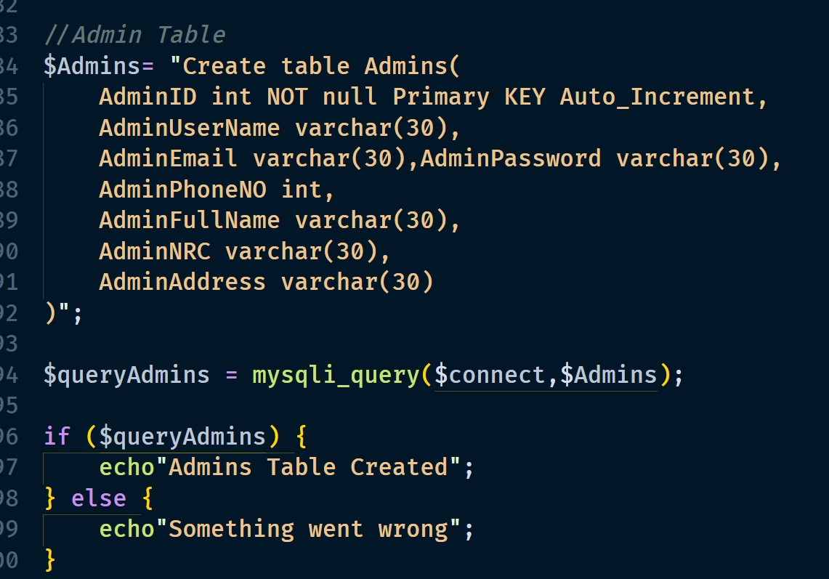

Admins Success Query

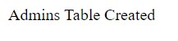

Admin Table Structure

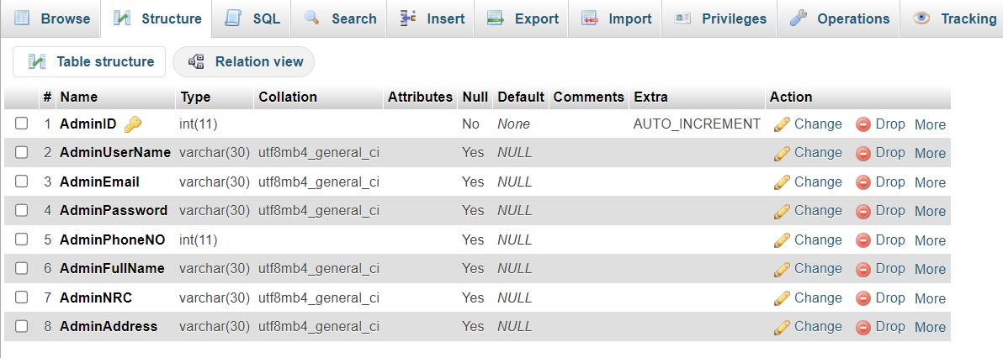

Database Query for Customer

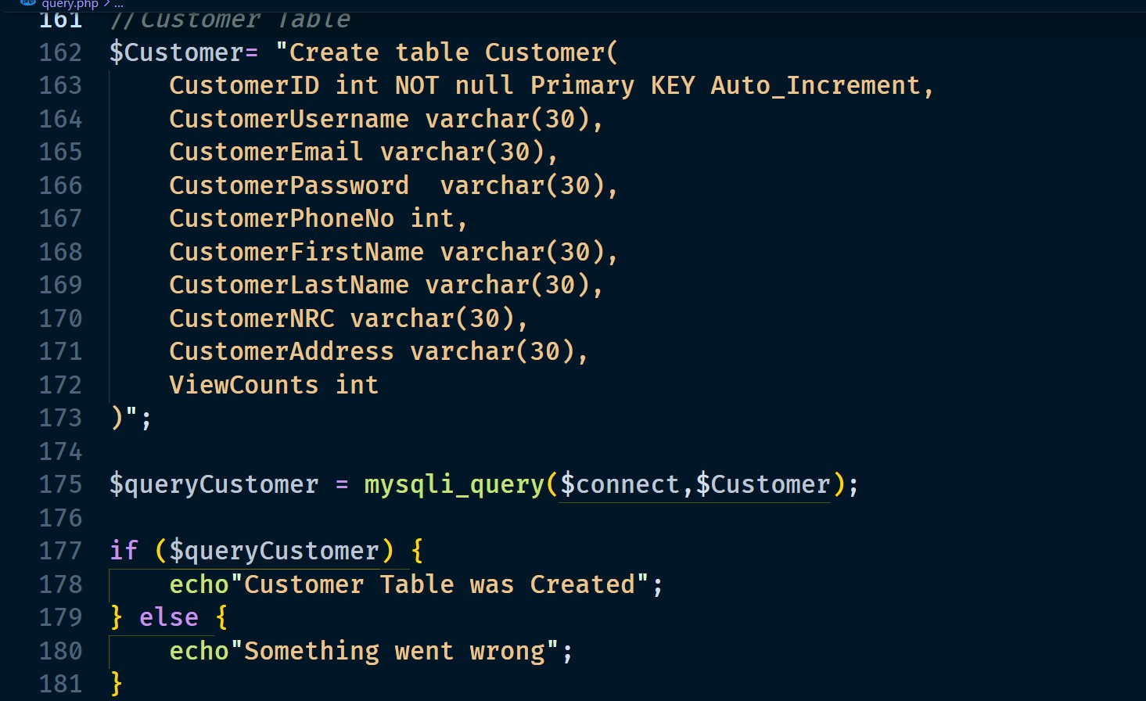Customer Success Query

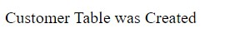

Customer Table Structure

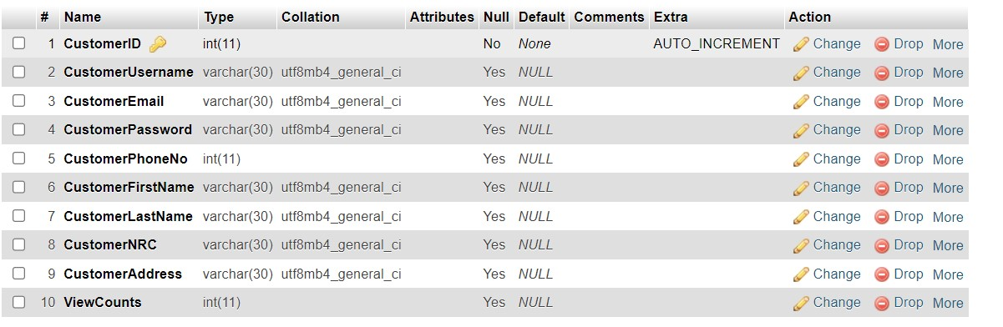

Database Query for PitchType

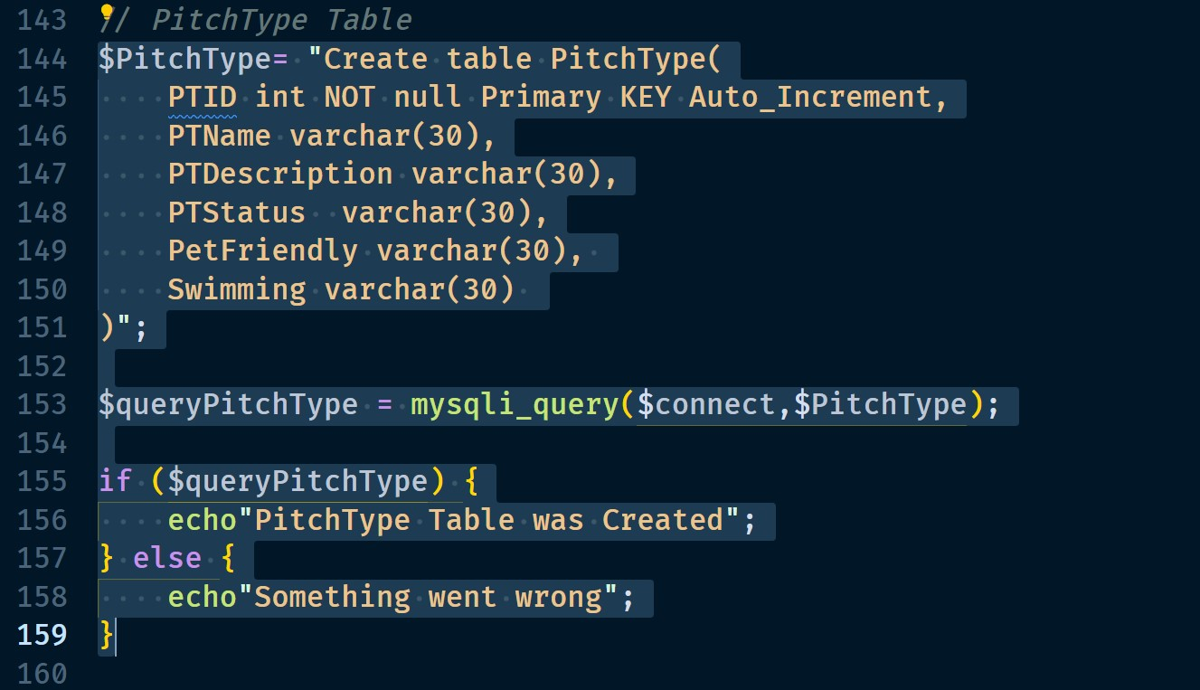

PitchType Success Query

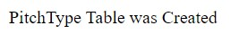

PitchType Table Structure

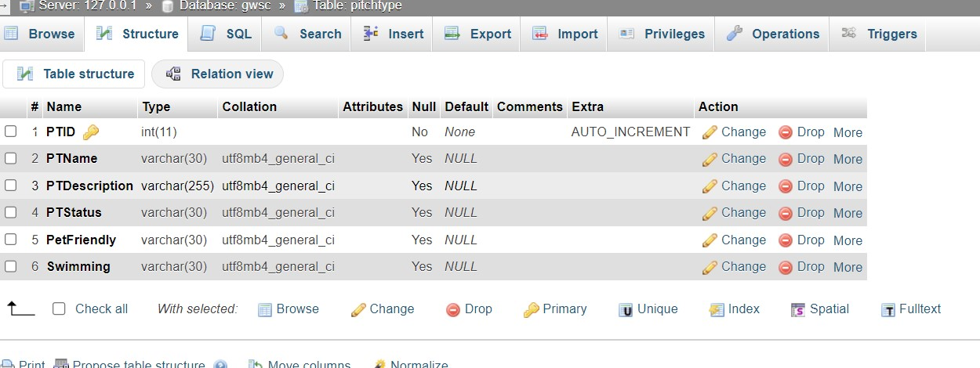

Database Query for Campsite

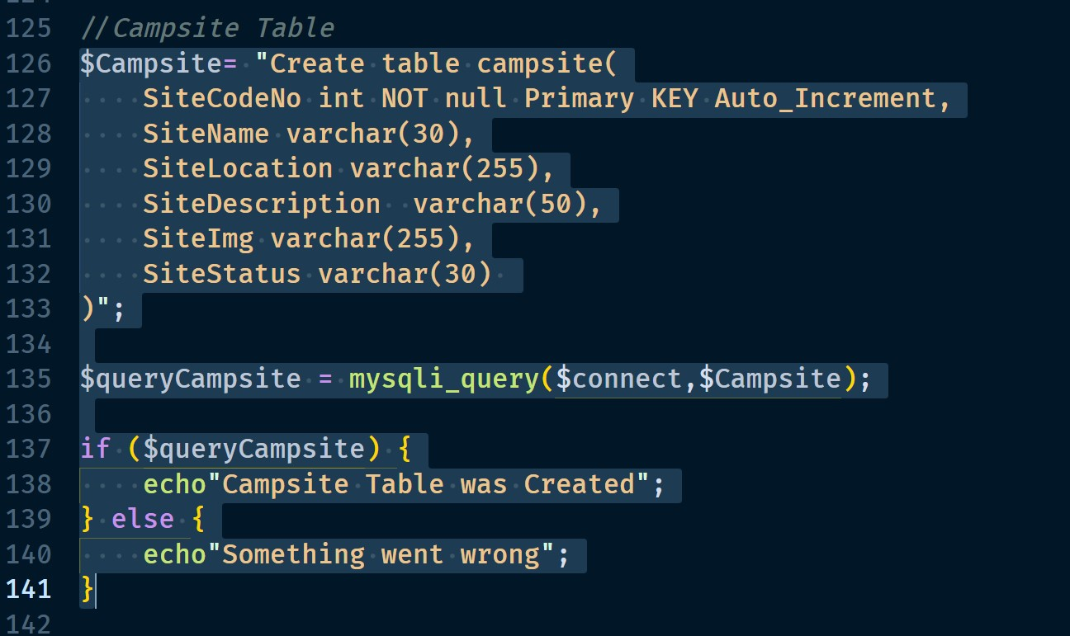

Campsite Success Query

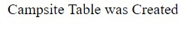

Campsite Table Structure

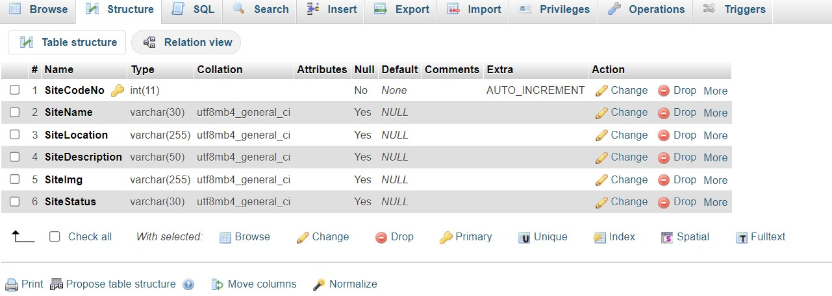

Database Query for Contact

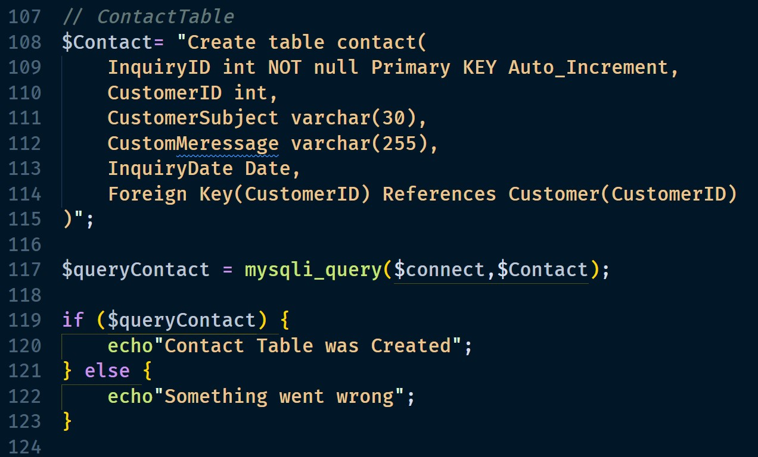

Contact Success Query

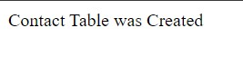

Contact Table Structure

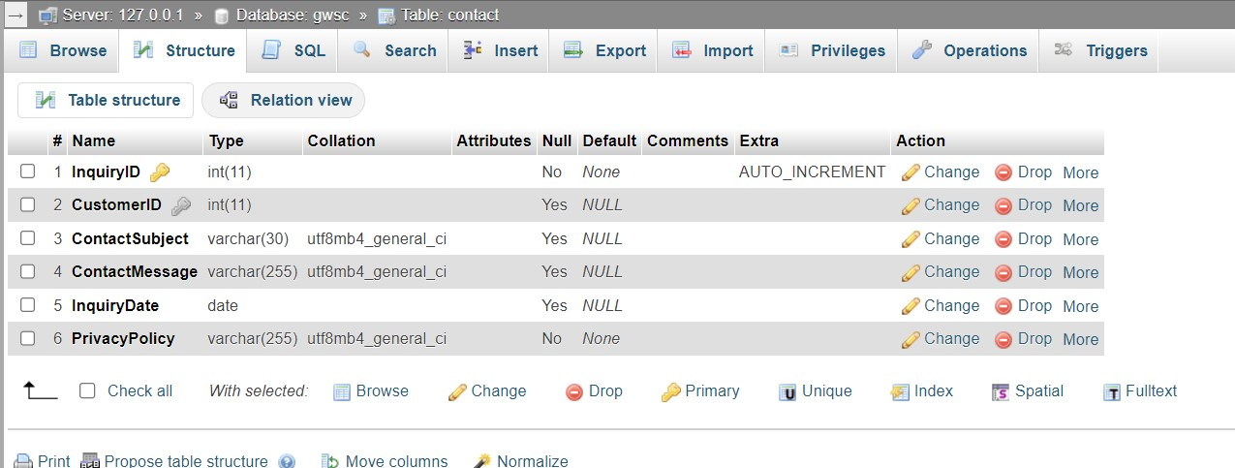

Database Query for Reviews

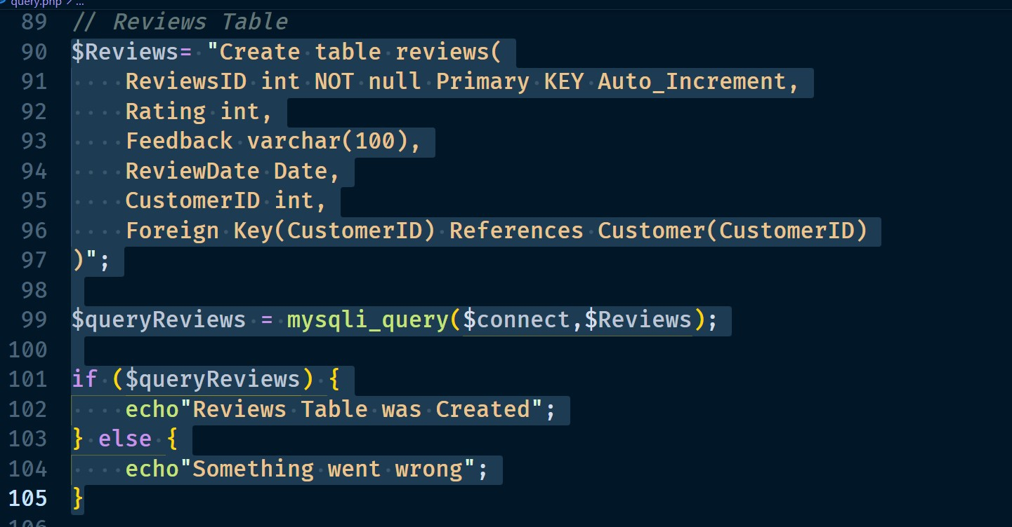

Reviews Success Query

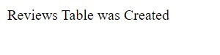

Reviews Table Structure

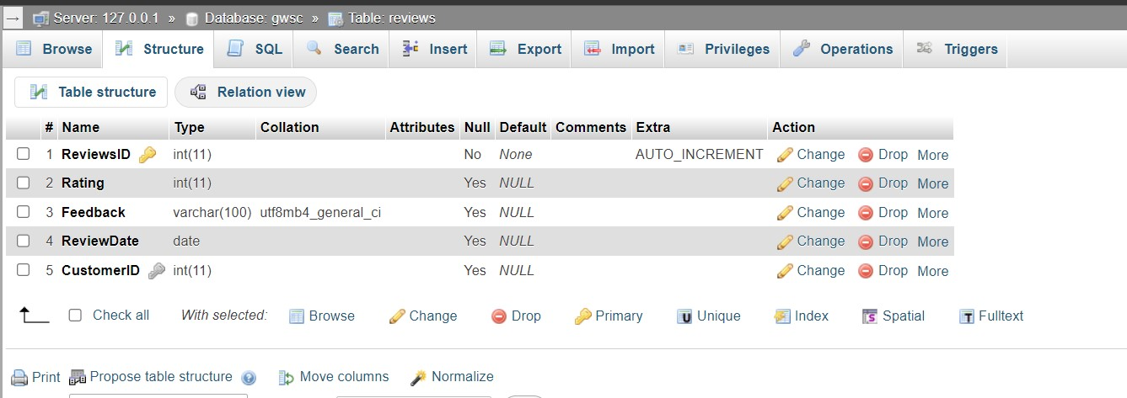

Database Query for Pitch

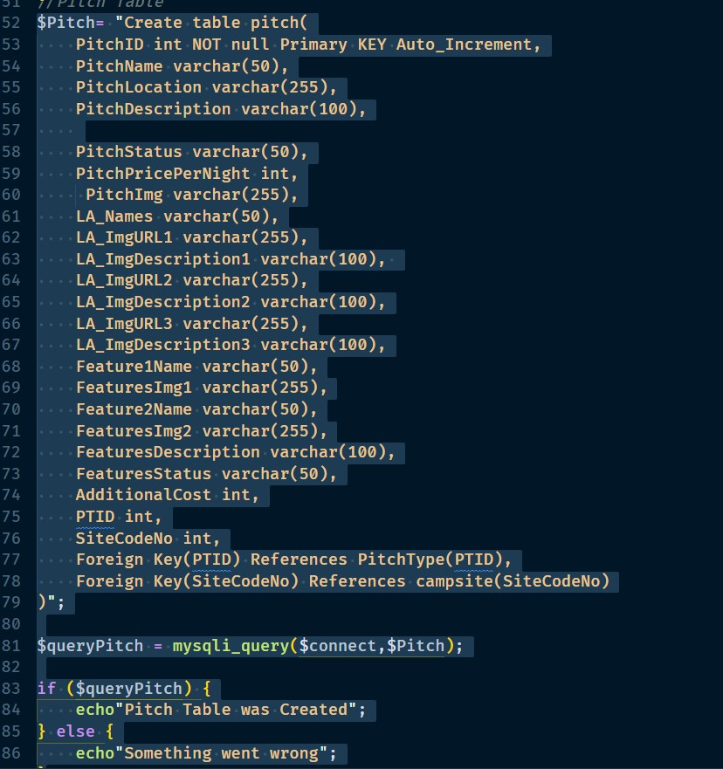

Pitch Success Query

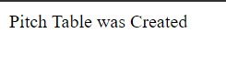

Pitch Table Structure

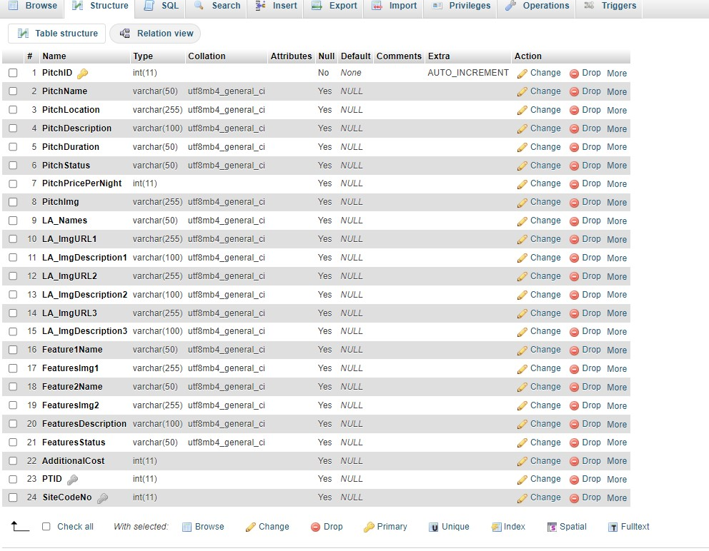

Database Query for Booking

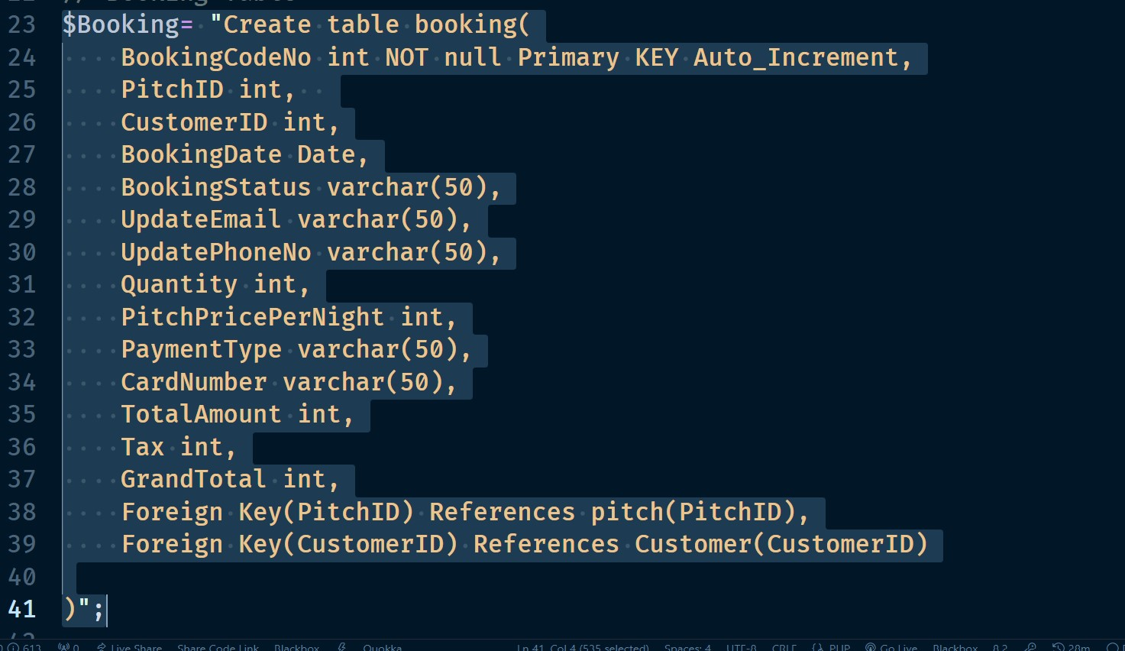

Booking Success Query

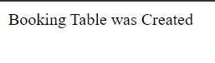

Booking Table Structure

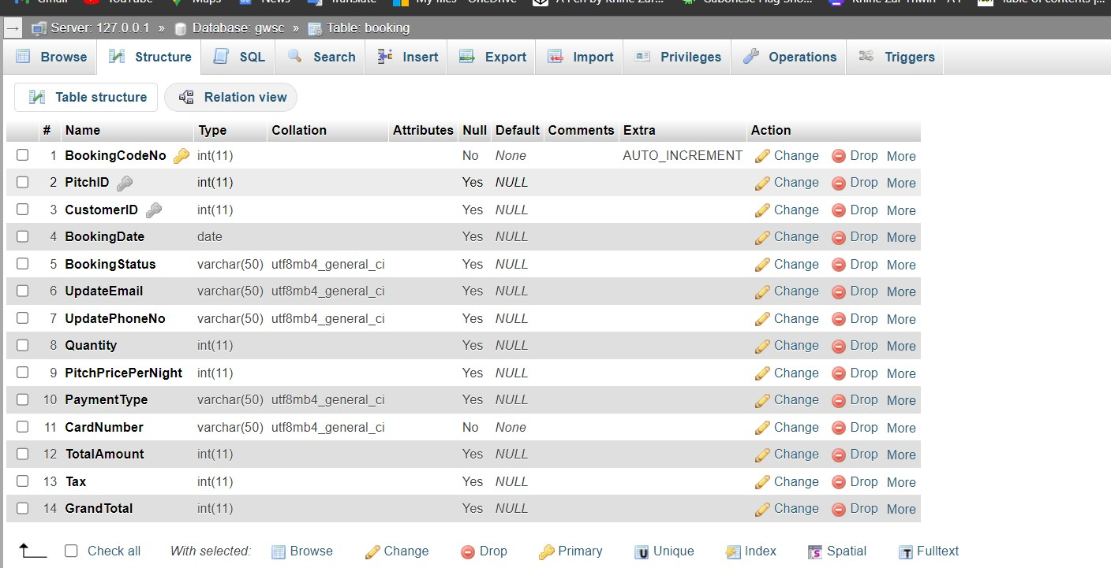

Database Query for RSS

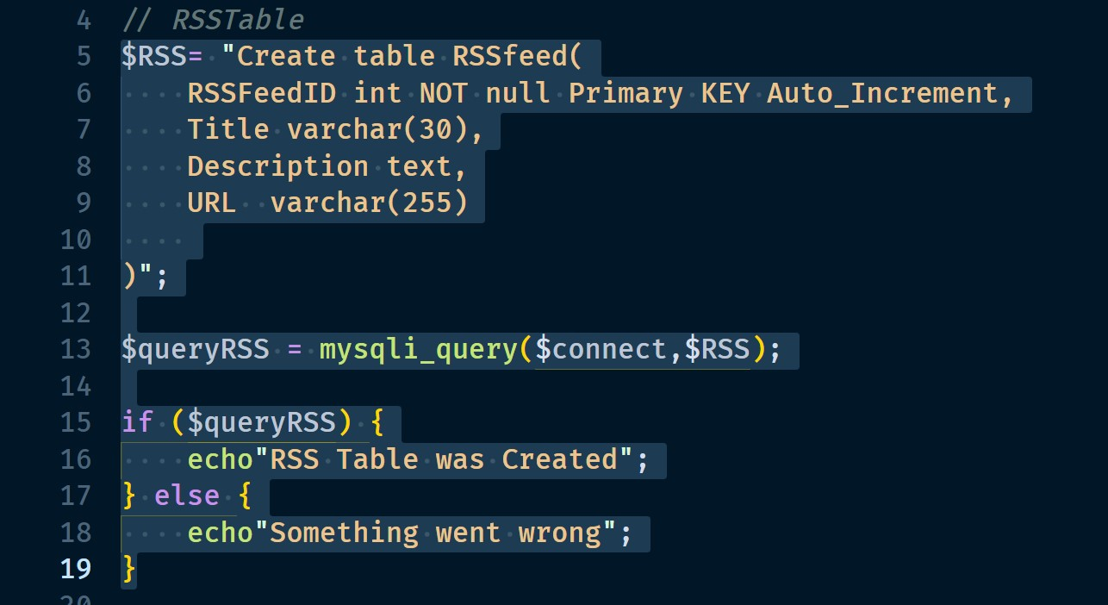

RSS Success Query

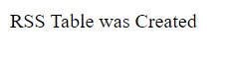

RSS Table Structure

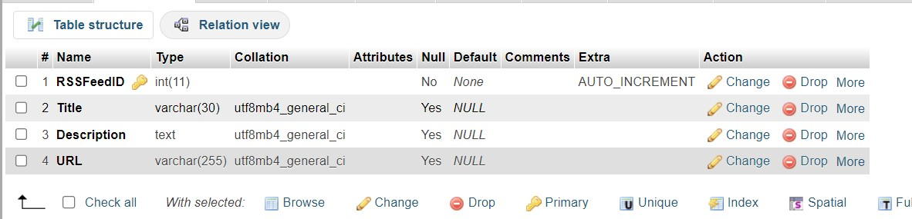

### Personal Details of Customer



This table, titled "Customer," contains information about the customer, including email addresses, last names, and other details that are crucial to company activities in the real world. The PHP language is used to link the database for the GWSC website, and when the customer submits data, the MySQL database is saved in the back of the website. To enable customers to log in to their accounts using their email addresses, data must be retained, particularly emails.

### Pitch Type and Availability

Before



After

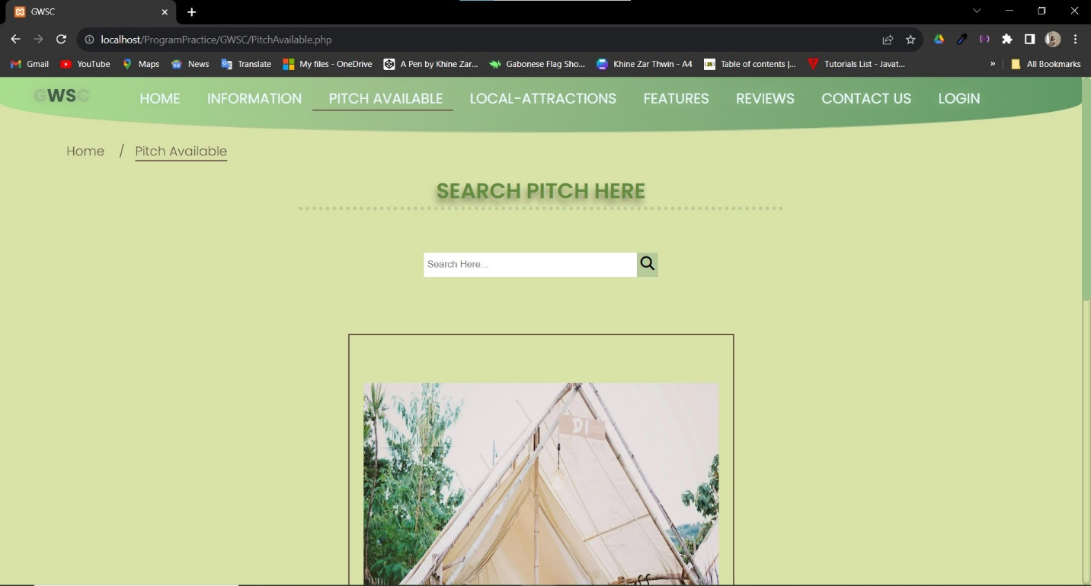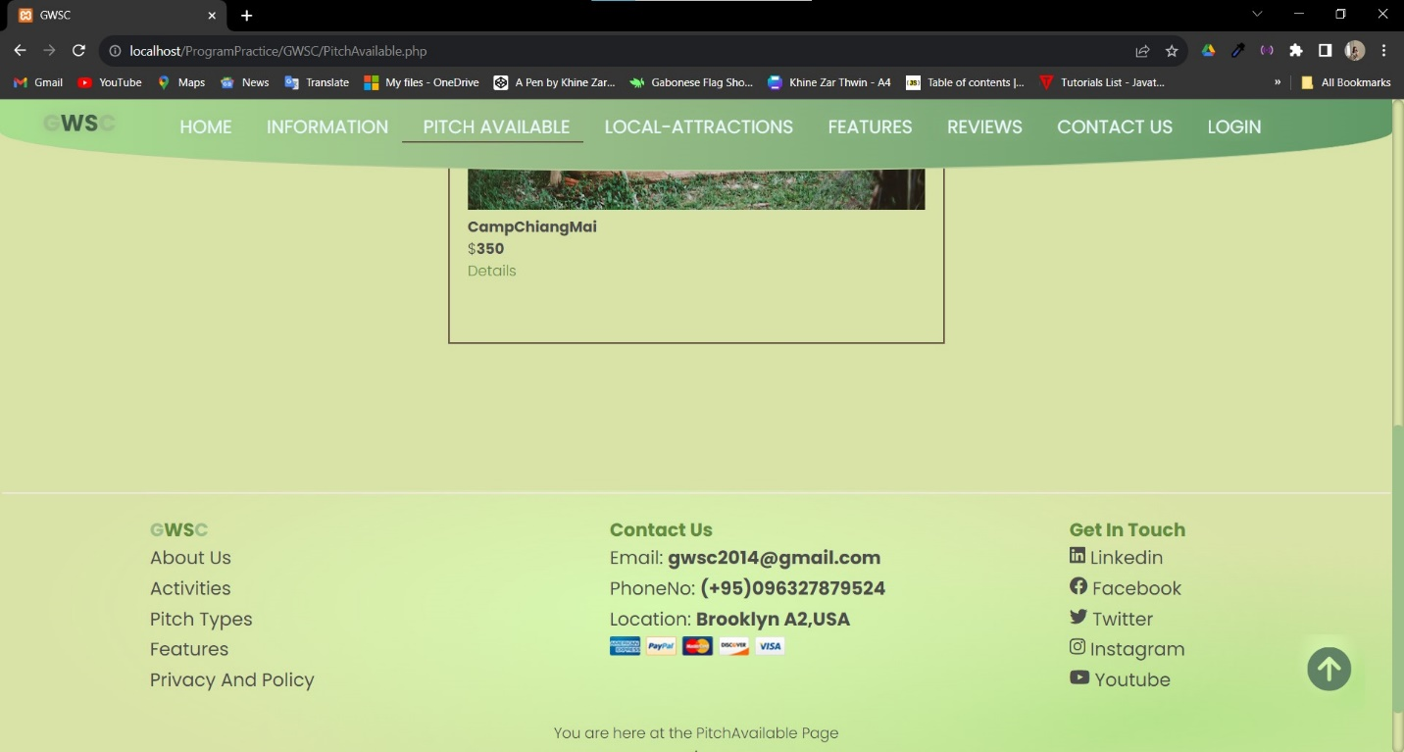

This is the result that shows up when a customer searches for a specific name. The data is retrieved from the Mysql database containing Pitch data.

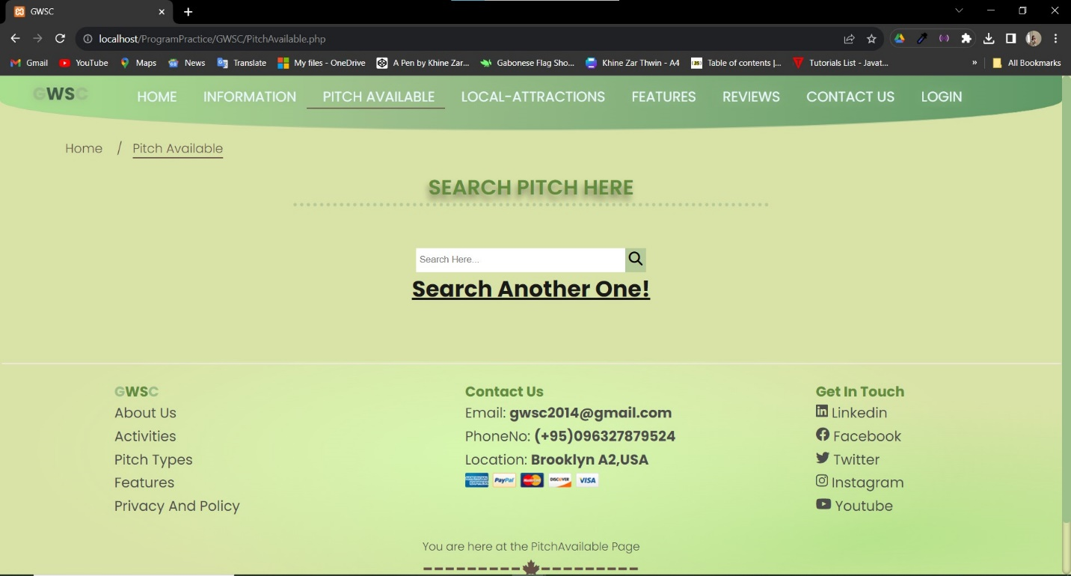

In the event that no name matches the information in the database, a message stating "Search another one" will appear.

### Login Fails

Before

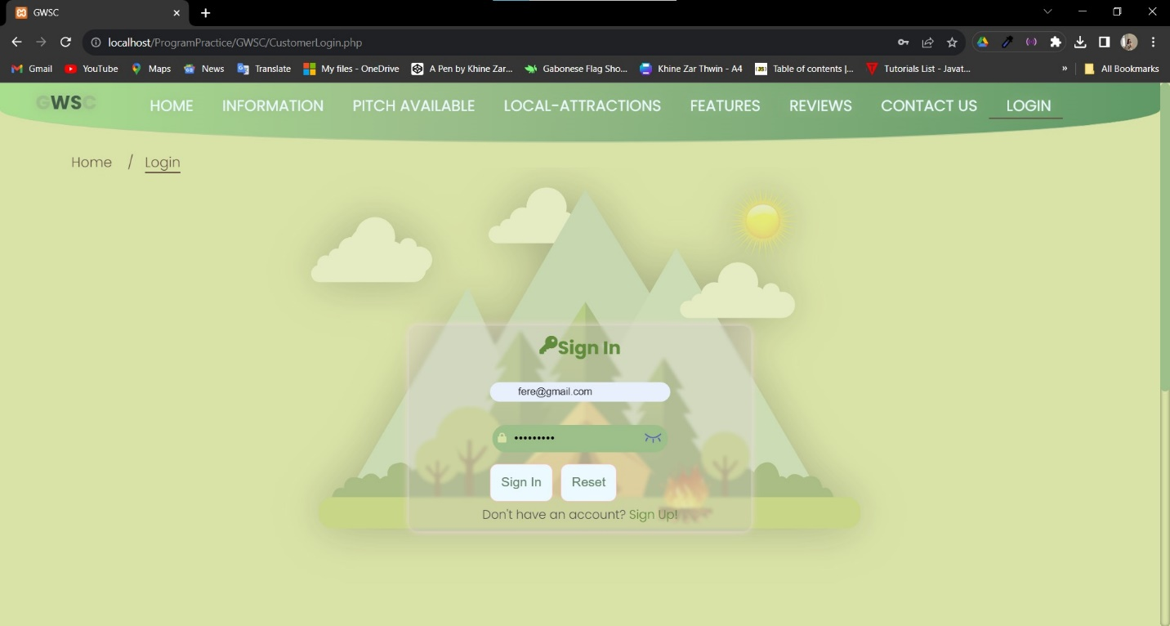

Login Fail Attempt 1

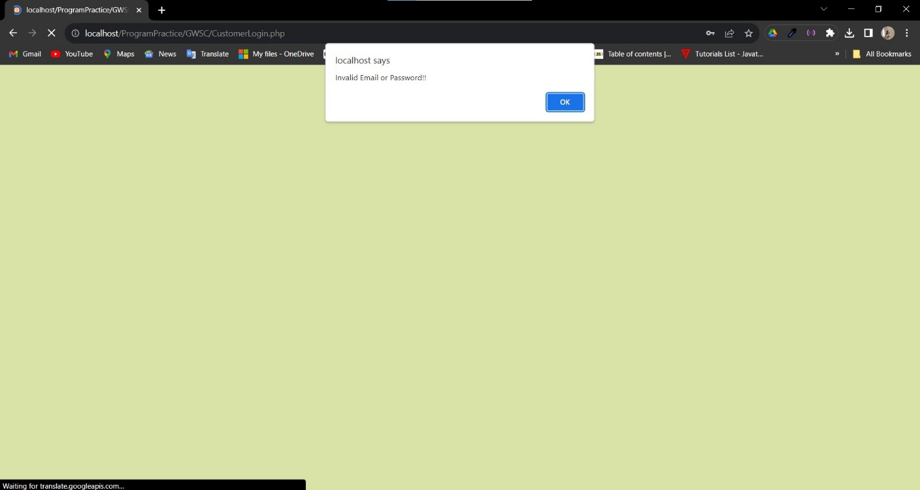

Login Attempt Fail 2

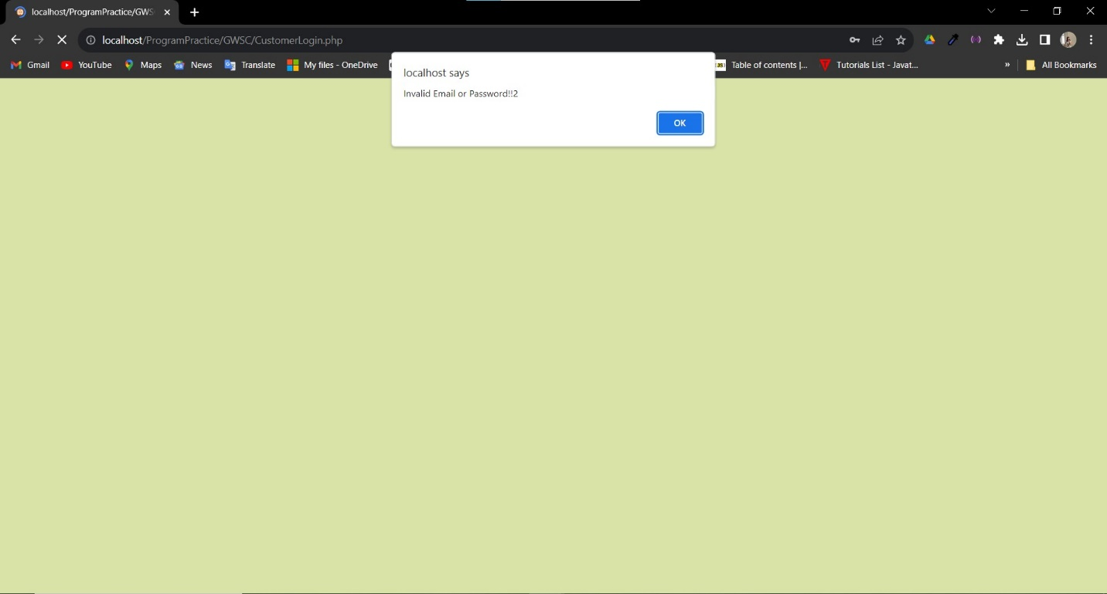

Login Attempt Fail 3 (wait 10 minutes)

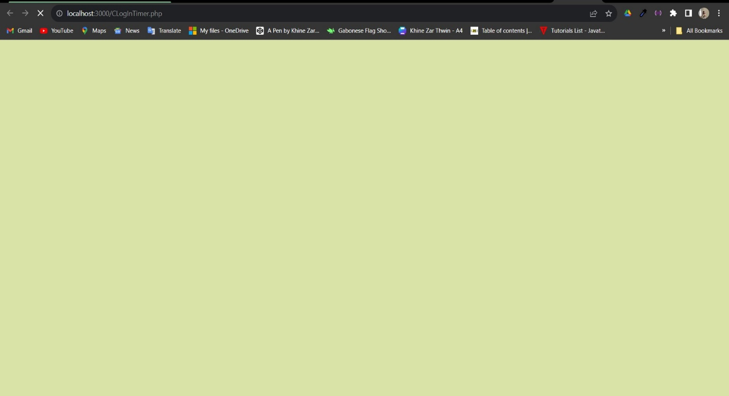

After this attempt fail, the users have to wait for ten minutes for to be directed to Log In page again.

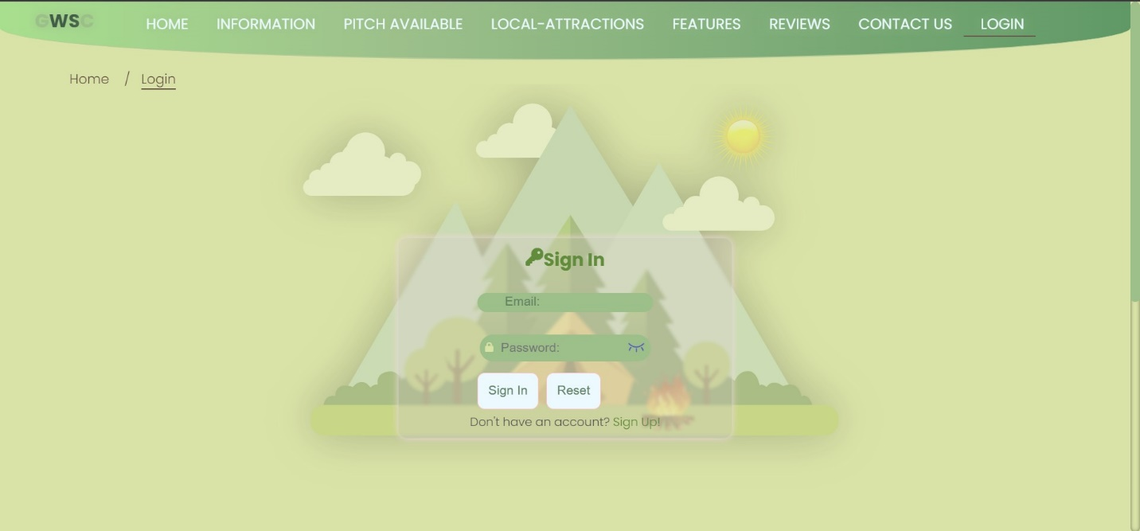

The user will be redirected to this page.

**Task 3**

**Critical Evaluation**

# Task 3 Critical Evaluation of GWSC

### Web Services in GWSC

These days, the majority of websites make use of various online services to improve efficiency and connectivity. The GWSC website is made more convenient by the usage of web services like YouTube and Google Translate. The Google Translation tool is ideal for GWSC because it is a global website that can be used by people from different countries. When users select their preferred language on the Google Translate Widget located in the footer portion of every webpage, Google Translate will automatically translate every sentence to that language. Users will find it easier to use GWSC in this way, which will increase income. (Madill, n.d.)YouTube is an excellent tool for GWSC because it offers rich multimedia content. Direct video hosting is not essential, which could result in slow loading times and excessive storage needs. The ability to integrate YouTube videos allows for a reduction in these problems as well as improved SEO and simple video administration. (Admin, 2023)

### Usage of HTML for GWSC

The language known as HTML, or Hyphertext Markup, is used to specify the content's structure. Every website is constructed using elements like <section>, <headings>(<h1>,<h2>,etc), <div>, and so forth. The GWSC uses <a> element known as a Hypherlinks element is used to for accessing more information and navigate the pages. This way, pages of GWSC are connected each other. <img> elements are utilized to display images on the web surface. <iframe> elements are used throughout the webpage for location. There is also <video> element and <iframe> elements for showing video and to embed YouTube video. Additionally, <button> elements are present for buttons and are utilized alongside <a> elements to enhance efficiency. CSS is integrated with <style> elements in HTML to customize how web pages are presented. Additionally, JavaScript is used with the <script> element. The primary purpose of the <form> elements in GWSC is to be used in alongside the PHP language. (Calvello, 2023)

### Design the GWSC Web Pages with CSS

Cascading Style Sheets, or CSS, are used to style and design the surface of websites. The primary purpose of CSS is to style HTML elements. The only external CSS file linked to HTML exists in GWSC. Since CSS may be used repeatedly, it helps save time while building web pages. It will follow by the DRY Codes principle, which is Don't Repeat Your Codes. GWSC web pages were standardized using CSS. First of all, the entire website has uniform styling, which improves user experience. Headings, buttons, font size, family, weight, and other elements all have the same appearance. Second, media queries were utilized to create responsive design for two different screen sizes. Third, to guarantee that the same colors are utilized across the website, color variables and custom properties (CSS variables) can be employed. Color variables that are applied across the GWSC website are located at the top of the CSS style file. Finally, the elements are styled for animation using @keyframes. (Thorndyke, 2021)

### Meets The Objectives In The Scenario

This section will demonstrate how the GWSC will satisfy the scenario's criteria.

**Home Page**

View counters for users who have visited and an RSS feed are present on the home page and are requirements for this project. The interactive navigation bar can display the user's active form because it is responsively built. A slide show and slider with relevant pictures and contents are combined in the banner section. There's an animated search bar after that, which can take users to Available Pitch (Pitch Type and Availability).There is pitch options with interactive pop-up button designs in that section that can direct users to the information page. The About Us section then satisfies the necessary criteria for relevant image and content. One of the webservices used in the website for user convenience is the embedded YouTube video. Following that, second one , GWSC's Location Map is added to the subscribe area. Third, Google Translation, is located in the footer section. In addition, social media buttons alongside copyright information might indicate which page the user is visiting(You are here). For navigation section, <header> tag was used as the requirement and <footer> for footer section.

**Information**

Pitch details are taken from the MySQL database and displayed on the information page. They are shown using a card design that includes relevant images and text. From this page, the users will be directed to Detail page which will show the details of Pitch including which pitch type along with the price and duration. There is also location map on both Information Page and Detail Page. When the users click the Booking button , the user will be directed to Booking Page for booking sessions which is one of the requirements of the scenario.

**Pitch Type and Availability**

The user can use the search box on this page to look up available pitches.The information will be obtained from the database and shown, along with a Details button that takes users to the Detail Page.

**Local Attractions**

The details of local attraction alongside with their locations of each pitch has been pulled from the database and shown on this page.

**Features**

The details of Features of each pitch has been pulled from the database and shown on this page. There is one more section of Wearable Technology which is one of the requirements of this assignment.

**Review**

In addition to sending feedback to GWSC, users can rank the stars. This page also displays ratings for the feedback that has been submitted.

**Contact**

Contacting GWSC can be facilitated by using this page. Additionally, there is a link to the privacy policy that takes users to the policy page.

**Login Page & Register Page**

The Login page allows existing users to access their accounts, while new users can access the Register page by clicking the Sign up link. When users register their accounts, a captcha and password verification are present on the register page.

Every one of these pages is designed with scenario requirements in regard and responsive to various screen sizes. For the convenience of the user, webservices are used throughout these pages.

Task 4

Reflection

# Task 4

## Reflection of GWSC

Rather than using the SUBLIME Text tool, this GWSC website was created using Visual Studio Code known as IDE. Numerous factors exist. First off, there are a number of useful and efficient extensions for coding, like Prettier, IntelliSense, and others. The integrated terminal, debugging tools, and Git integration are the second, built-in feature. Third, Sublime is not free and open-source, whereas it is. The fourth feature is live sharing, which allows users to open the code directly from the Visual Studio code. (McCandless, 2018)

This journey has given me a great deal of unfamiliar website and coding experiences, including how to develop a dynamic, interactive website with javascript and PHP, connect a website's MySQL database using PHP, understand how backend websites operate, and much more. Additionally, new knowledge in User Experience (UX) design is being applied to improve user accessibility on websites. My debugging skill has improved throughout this journey too. Lastly, my understanding of these languages such as HTML,CSS,JS and PHP have becoming more deep and clear.

There will be similar projects in the future. At that point, it will be important to carefully plan the process and manage time to conduct in-depth research on the topic relevant to the project, consult with senior or professional employees about the process, and seek feedback from users to make the website better. Future websites will be built with greater efficiency by utilizing OOP and adding more dynamic functions to the projects.

# References

Admin, 2023. *Call on JO.* [Online]   
Available at: https://www.callonjo.com.au/the-benefits-of-embedding-videos-on-your-site-rather-than-video-hyperlinks/  
[Accessed 13 October 2023].

Calvello, M., 2023. *g2.* [Online]   
Available at: https://www.g2.com/articles/what-is-html  
[Accessed 13 October 2023].

Madill, W., n.d. *Localize.* [Online]   
Available at: https://localizejs.com/articles/the-pros-cons-of-using-google-translate-for-your-website/  
[Accessed 13 October 2023].

McCandless, K., 2018. *Code Cademy.* [Online]   
Available at: https://www.codecademy.com/resources/blog/visual-studio-code-sublime-text/  
[Accessed 14 October 2023].

Thorndyke, K., 2021. *CodeCademy.* [Online]   
Available at: https://www.codecademy.com/resources/blog/what-is-css-used-for/  
[Accessed 14 October 2023].

# Candidate Checklist

Please use the following checklist to ensure that your work is ready for submission.



Have you read the NCC Education documents 'What is Academic Misconduct? Guidance for Candidates' and 'Avoiding Plagiarism and Collusion: Guidance for Candidates' and ensured that you have acknowledge all the sources that you have used in your work?

Have you completed the 'Statement and Confirmation of Own Work' form and attached it to your assignment? You must do this.



Have you ensured that your work has not gone over or under the recommended word count by more than 10%?



Have you ensured that your work does not contain viruses and can be run directly?

